Economics of Business Strategy (ECBS) Module Assignment

GROUP REPORT (BLUE 1)

Appendix – Section B
BioTech Case Study – Immunocore: Similar or different from GSK?
Company Brief
Immunocore is a commercial-stage biotechnology company pioneering the development of a novel class of TCR bispecific immunotherapies called ImmTAX – Immune mobilizing monoclonal TCRs Against X disease – designed to treat a broad range of diseases, including cancer, infectious and autoimmune. Leveraging our proprietary, flexible, off-the-shelf ImmTAX platform, it is developing a deep pipeline in multiple therapeutic areas, including five clinical stage programs in oncology and infectious disease, advanced pre-clinical programs in autoimmune disease and multiple earlier pre-clinical programs.
Immunocore has received FDA approval for its lead product.
Collaborated with GSK’s GSK Intellectual Property Development from 2013 to 2021 on the development of certain pharma compounds.
Company Strategy
The company’s vision is to build a global immune-therapy business with a portfolio of therapeutics that have the potential to beneficially impact the clinical outcomes of patients across a broad range of diseases, with a near-term focus on the treatment of cancer, infectious and autoimmune diseases.
Immunocore does the R&D and develops the product formulation. It does not undertake the actual production; it uses contract manufacturing organisations which handle the production. DHL and Integrated Commercialization Solutions provide the storage, global distribution, packaging and labelling services.
It recognises that dues to its more limited financial capabilities and size, it may be overtaken to market in its core areas by other better funded large organisations, or smaller organisations with strong financial partnerships.
Steps to Realise Strategy
Permitting
- Immunocore intends to seek regulatory approval in Europe and beyond for its lead product (KIMMTRAK).
- It has submitted marketing authorisation applications in the UK, Canada, and Australia.
Product Development
- It is progressing clinical trials on other oncology pharmaceuticals in its portfolio.
- It is developing solutions for infectious diseases including HIV and Hep. B.
Financing
- Immunocore raised around $300 million in 2021 from an IPO and private placement.
- In discussions to obtain third-party payor coverage policies from US commercial underwriters.
Intellectual Property
- Seeks to protect its proprietary position by filing patent applications in territories that are commercially important to it.
Sales and Marketing
Done using a hybrid model that includes in-house and contracted resources in the United States and Europe. It entered into a strategic partnership with Syneos Health, Inc. and an exclusive multi-regional agreement with Medison Pharma to help seek regulatory authorization and commercialize Immunocore’s KIMMTRAK in Canada, twenty markets across Central Eastern Europe and Israel.
In the News
Immunocore launched on Nasdaq at a value of more than $250 million, Freeline Therapeutics and Allergy Therapeutics over $150 million, and Compass Pathways and Vaccitech at more than $100 million (Bhandari et al., 2021)

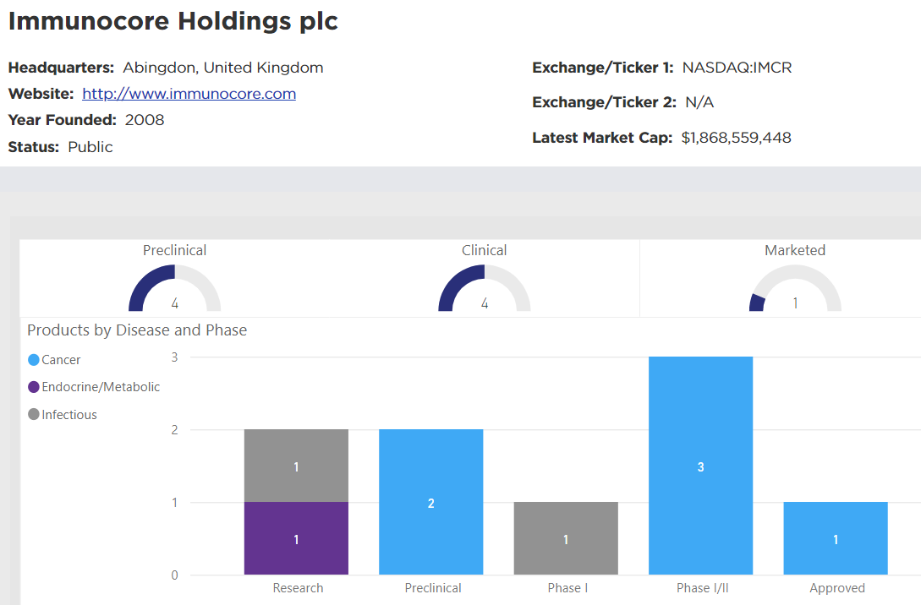

Smaller Biotech Pharma as Competitors to GSK (Big Pharma)
For the purpose of this analysis, pharmaceutical companies are categorized by size according to their annual revenue profiles with medium sized companies having annual revenues of US$ 1 billion to US$ 10 billion. Companies with annual revenues less than US$ 1 billion and those with annual revenues greater than US$ 10 billion are categorized as smaller and large pharmaceutical companies respectively (Research and Markets, 2018).
The concentration ratio in section 1.2.1 indicates that the market structure could be a loose oligopoly or a monopolistic competition, leaning more towards a loose oligopoly as more conditions for an oligopoly are satisfied than a monopolistic competition (Nellis & Parker, 2006).
Nellis and Parker (2006) describe the main feature of oligopolistic markets as the fact that the likely actions and reactions of competitive firms influence the management of a firm’s decisions on price and output. Table 1 shows that while GSK and smaller biotech pharma companies may be generally classified as pharmaceutical companies, the number of products common to a product range is little, and the output of small biotechs is not sufficient to influence GSK’s decisions on output and thus not regarded as competitive firms to GSK. Competing firms in an Oligopolistic market structure are able exercise market power due to the barriers to market entry; smaller biotechs are unable to exercise market power relative to the oligopolists.

Table 1 GSK vs Small Biotech Pharma - Product Range
Product Range | Vaccines | General Medicines | Specialty Medicines (cancer, HIV, respiratory) | Consumer Healthcare
GSK | 20+ | 56 | 24 | ~23
Smaller Biotech Pharma
Immunocore | - | - | 1 | -
Kymab | - | - | - | -

Immunocore and Kymab are used as representative cases for small biotech pharma companies. Small biotech companies usually play a supplier role in the pharmaceuticals market rather than competing with the oligopolists. UKBiotech (UK Biotech Database, n.d.) states that large pharma companies depend (to an extent) on smaller biotech companies for origination of pipelines of novel compounds which may then be licensed. This market strategy is further borne out in Immunocore’s partnership with GSK and others for the development of certain pharma compounds and Kymab’s business strategy as a clinical stage biotech pharma company.

References
Bhandari, M., Cooney, D., Devereson, A., Moss, R., & Thaker, S. (2021, December 3). The UK biotech sector: The path to global leadership. McKinsey’s Life Sciences Practice. https://www.mckinsey.com/industries/life-sciences/our-insights/the-uk-biotech-sector-the-path-to-global-leadership
Nellis, J. G., & Parker, D. (2006). Principles of Business Economics, 2nd edition. Harlow: Pearson Education Limited.
Research and Markets. (2018, June 14). Global Mid-Size Pharmaceutical Market 2016-2018 & 2021: Market is Projected to Grow from Approximately $1.1 Trillion in 2016 to $1.5 Trillion in 2021. https://www.prnewswire.com/news-releases/global-mid-size-pharmaceutical-market-2016-2018--2021-market-is-projected-to-grow-from-approximately-1-1-trillion-in-2016-to-1-5-trillion-in-2021--300666386.html
UK Biotech Database. (n.d.). Definitions of available industry sectors and subsectors. Retrieved September 6, 2022, from https://www.ukbiotech.com/uk/portal/definitions.php

https://www.gsk.com/en-gb/products/products-a-z/
Through Haleon https://www.haleon.com/our-brands/
One product approved. Others at pre-clinical and clinical stages. (2021 Annual Report)
Clinical stage biotech pharma company developing antibody therapies (2020 Annual Report)

