Economic assessment and sensitivity analysis using ASPEN ECONOMY

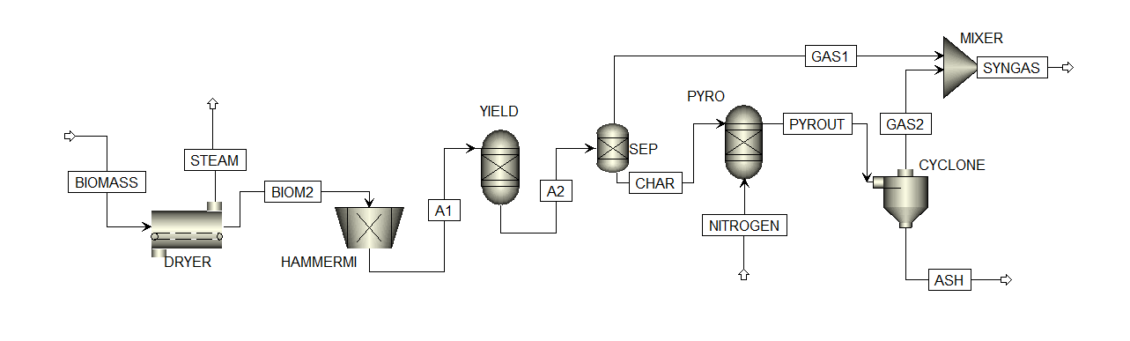
Project profile and schedule used in the project simulation
PROJECT NAME: | Combine thermal plant
Plant process capacity: | 1500 kg/hr
Plant location: | Nigeria -Africa
Brief description: | Pyrolysis project
SCHEDULE:
Start Date for Engineering | 09-Sep-19
Duration of EPC Phase | 16 months
Completion Date for Construction | Tuesday, December 31, 2021
ECONOMIC PARAMETERS
Country | Nigeria-Africa
Units of Measure | METRIC
Currency (Cost) Symbol | U.S. DOLLAR
System Cost Base Date | 1Q 16
Project Type | Grass roots/Clear field
Design code | ASME

Project summary for proposed biomass thermal process plant
CAPITAL COST EVALUATION BASIS
IF (ROR Interest Factor) |  | 1.2
ECONLIFE (Economic Life of Project) | Period | 10
DEPMETH (Depreciation Method) |  | Straight Line
DEPMETHN (Depreciation Method Id) |  | 1
ESCAP (Project Capital Escalation) | Percent/period | 5
ESPROD (Products Escalation) | Percent/period | 5
ESRAW (Raw Material Escalation) | Percent/period | 3.5
ESLAB (Operating and Maintenance Labor Escalation) | Percent/period | 3
ESUT (Utilities Escalation) | Percent/period | 3
START (Start Period for Plant Startup) | Period | 1
PODE (Desired Payout Period (excluding EPC and Startup Phases)) | Period | 10
POD (Desired Payout Period) | Period | 8
DESRET (Desired Return on Project for Sales Forecasting) | Percent/Period | 10.5
END (End Period for Economic Life of Project) | Period | 10
GA (G and A Expenses) | Percent/Period | 8
DTEP (Duration of EP Phase before Start of Construction) | Period | 0.27
INPUT PARAMETERS |  | Value (Million $)
Capital investment cost (CIC) |  | 280.4
Annual labour cost |  | 18.5
Annual repair and maintenance |  | 5.5
Total cost of biomass per year |  | 4.8
Depreciation | (20% of CIC) | 52
Interest rate | (10% CIC) | 2.8
Discount rate | (10% CIC) | 2.8
Salvage value | (10% CIC) | 2.8
Insurance and taxes | (10% CIC) | 2.8

Economic analysis of thermal processes and investment summary
 | Scenario 1 | Scenario 2 | Scenario 3 | Scenario 4
Annual production sale of bio-products (Million $) | 125 | 128 | 110 | 130
Net present value of profit (Million $) | 1,062 | 1,091 | 937 | 1,105
Net present value of operation and maintenance cost (Million $) | 297 | 297 | 297 | 297
Accumulated Net present value of all cost (Million $) | 669 | 669 | 669 | 669
Net present value of the project (Million $) | 1,010 | 1,04 | 885 | 1,053
Benefit cost ratio | 1.3 | 1.4 | 1.3 | 1.4
Payback period (years) | 8.5 | 8.2 | 9.8 | 8
Internal rate of return (%) | 16 | 17 | 14 | 17.2

CAPITAL COST | % | OPERATING COST | %
Equipment | 30 | Operating labour | 32
Engineering cost | 7 | Maintenance and repair | 3
Working capital cost | 12 | Supervision/admin | 15
Construction overhead | 3 | Overhead | 25
Materials for construction | 6 | Feedstock | 10
Transport and pre-processing | 20 | Laboratory research and devt | 5
Contingency and fees | 10 | Insurance and taxes | 2
Insurance and tax | 2 | Utilities | 4
Other expenditures | 10 | Others | 4

