Suppression of molten salt corrosion by plasma sprayed Ni3Al coatings

Sarah Yasir, ª Jose Luis Endrino, ^{a, b} Elena Guillén, ^{c} and Adrianus Indrat Aria ^{a, *}
ª Surface Engineering and Precision Centre, Cranfield University, College road, Cranfield, MK43 0AL, United Kingdom
^{b} Nano4Energy, Calle de José Gutiérrez Abascal, 2, 28006 Madrid, Spain
^{c} Profactor GmbH, Im Stadtgut A2, 4407 Steyr-Gleink, Austria
Corresponding author:
* Email: A.I.Aria@cranfield.ac.uk – ORCID: 0000-0002-6305-3906

Figure 1: (a) Schematics of air plasma spray deposition of Ni3Al coatings and molten nitrate salt tests at 565°C. Ni3Al powder is melted in a stream of plasma at atmospheric pressure and propelled towards the substrate. Each SS347 and Ni₃Al/SS347 coupon is then immersed in NaNO₃:KNO₃ salts contained in individual alumina crucibles at a constant temperature of 565°C for up to 3000 hr. (b) Time dependent area-normalised weight change (ΔM/A) of Ni₃Al/SS347 and SS347 in molten nitrate salts and air at 565°C. Here, the weight change is normalised with the surface area of the coupons. Solid and dashed lines indicate piecewise linear regressions for weight change in molten nitrate salts and air, respectively.
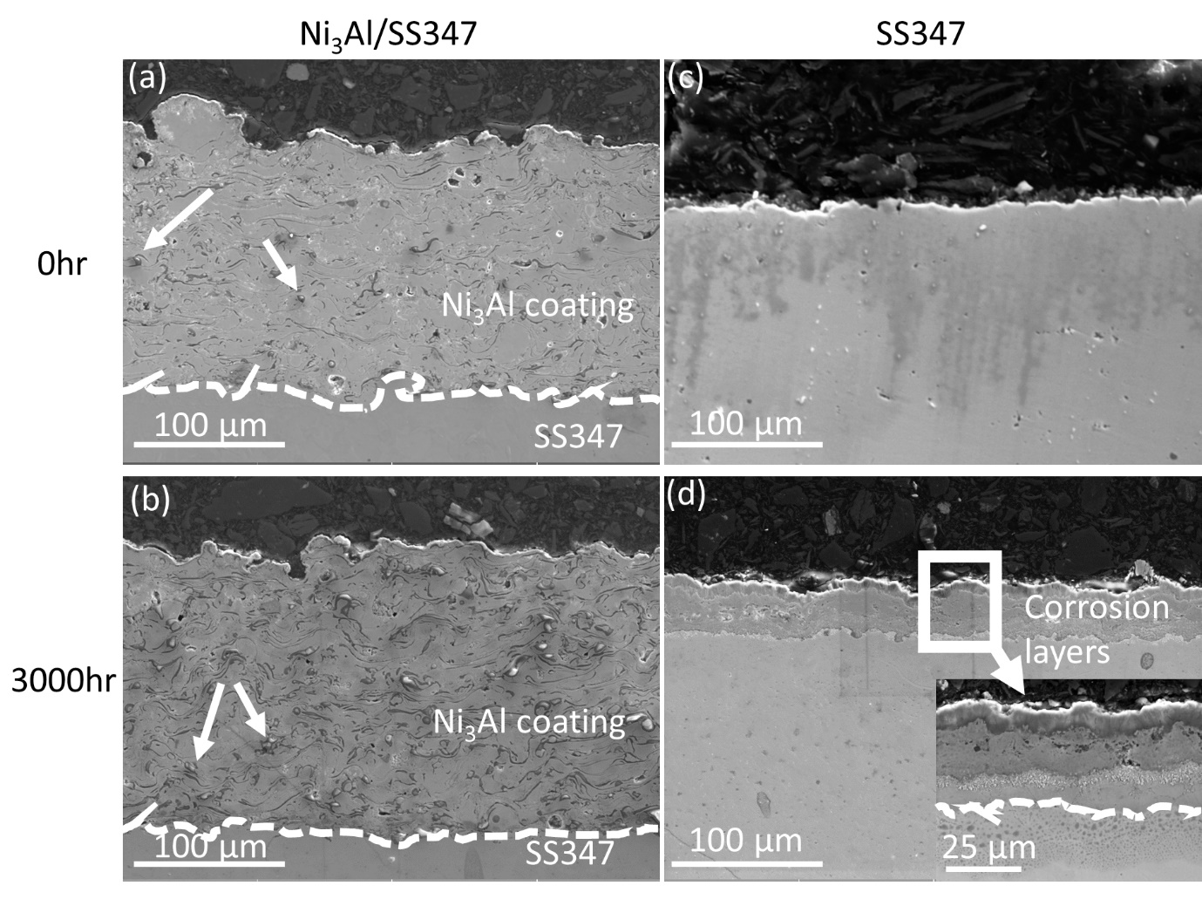
Figure 2: Cross-sectional SEM images of Ni₃Al/SS347 (a, b) and SS347 (c, d) at 0 hr (a, c) and 3000 hr (b, d) of immersion in molten nitrate salt at 565ºC. Dashed lines indicate the interface between Ni₃Al coating and SS347 substrate, while arrows indicate alumina particles embedded within the Ni₃Al coatings (a, b). No significant change in the coating morphology and no formation of corrosion layers can be observed on Ni₃Al/SS347 after 3000 hr. In contrast, formation of corrosion layers can be observed on the surface SS347 after 3000 hr. A higher magnification SEM image (inset in d) shows the distinguishable morphologies of these corrosion layers. The dashed line in the inset indicates the interface between the corrosion layers and the original SS347 layer.

Figure 3: (a) Elemental maps and corresponding SEM image of cross-sectioned Ni₃Al/SS347 at 3000 hr in molten nitrate salt at 565ºC. These maps show spatial distribution of Fe, Ni, Al, O, and Na at the interface between Ni₃Al coating and SS347 substrate. All scale bars represent 50 μm. (b) Elemental composition in atomic percentage (at. %) of Fe, Ni, Al, O, and Na of Ni3Al/SS347 taken at the area indicated by white line in the corresponding SEM image. The composition is obtained at 3000 hr and presented as a function of the distance from the interface between Ni₃Al coating and SS347 substrate. Positive distance corresponds to coatings (Coat) and outer mounting resin (Out), while negative distance corresponds to substrate (Sub). Solid lines are ~5 μm simple moving average to guide the eye.

Figure 4: (a) Elemental maps and corresponding SEM image of cross-sectioned SS347 at 3000 hr in molten nitrate salt at 565ºC. These maps show spatial distribution of Fe, Ni, Cr, O, and Na at the surface of SS347 substrate. All scale bars represent 50 μm. (b) Elemental composition in atomic percentage (at. %) of Fe, Ni, Cr, O, and Na of SS347 taken at the area indicated by white line in the corresponding SEM image. The composition is obtained at 3000 hr and presented as a function of the distance from the interface between corrosion layers and SS347 substrate. Positive distance corresponds to corrosion layers (Cor) and outer mounting resin (Out), while negative distance corresponds to substrate (Sub). Solid lines are ~5 μm simple moving average to guide the eye.

Figure 5: (a) XRD patterns of Ni3Al/SS347 and SS347 at different molten salt exposure times: 0, 1000, 2000, 3000 hr. SS347 exhibits peaks that correspond to austenitic stainless steel (●) and various oxides of Fe, including Fe₃O₄ and (Cr, Fe)₂O₃ (▲), Fe₂NiO₄ (★), and NaFe₂O₃ (). Ni₃Al/SS347 exhibits peaks that corresponds to Ni₃Al () and NiO (▼). Peaks are identified according to the International Centre for Diffraction Data (ICDD) database [56–63] (b) Schematic of corrosion suppression of Ni₃Al coatings to the SS347 substrate in molten salts. Ni₃Al coatings are rapidly oxidised and stabilised in the first 500 hr. The formation of oxides within the Ni₃Al coatings supresses the diffusion of Na from the molten salt or the release of Fe, Ni, and Cr from the substrate for at least 3000 hr. In contrast, continuous uptake of O and Na along with release of Fe, Ni, and Cr resulting in the formation of corrosion layers comprised of various oxides of iron on the surface of SS347.

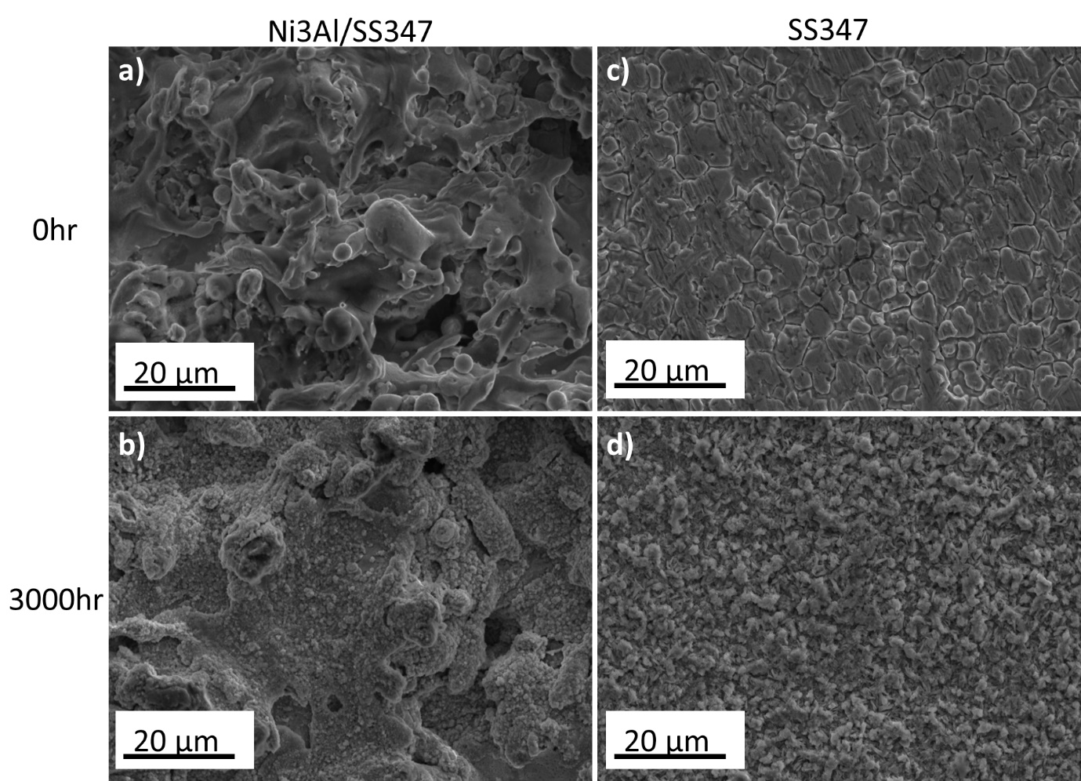
Figure S1: SEM images of surface of Ni3Al coated SS347 taken at 0 hr (a, b) and 3000 hrs (c, d) of immersion in molten salt. All tests were done using 60 wt. % NaNO3 + 40 wt. % KNO3 salts at 565oC and images were taken using secondary electron imaging mode.

Figure S2: Spatial elemental maps of cross-section SS347 along with corresponding SEM images at 0 hr, 500 hrs, 1000 hrs, 2000 hrs and 3000 hrs of immersion molten nitrate salt at 565ºC.

Figure S3: Total thickness of all grown oxide layer (µm) is plotted as a function of solar salt immersion time (hour) for bare SS347. The thickness grows with immersion time. The oxide growth rate is 0.03 µm/hr for 0 – 500 hrs and 0.01 µm/hr for 500-3000 hrs.

