Cambridgeshire Police Female Officer survey 1

Start of Block: Default Question Block

Q1 Please enter your unique identifer
________________________________________________________________

Q2 What type of bra do you normally wear under your body armour?
________________________________________________________________

Q3 Prior to being measured for this study, what size is the bra do you normally wear under your body armour?
________________________________________________________________

Q11 Before starting this trial, when was the last time you were fitted for a bra
- Within last year (1)
- Within the last 2 years (2)
- Within the last 3 years (3)
- Within the last 5 years (4)
- Can't remeber (5)
- Never been measured before (6)

Q9 What is your main duty (i.e. routine patrol, firearms etc)
________________________________________________________________

Q4 What type of armour are you issued with?
- Routine patrol (1)
- Firearms, no plates (2)
- Firearms with plates (3)

Q6 When standing wearing your body armour, how comfortable is it?
- Very Comfortable (1)
- Comfortable (2)
- Uncomfortable (3)
- Very Uncomfortable (4)

Q8 On the images below, please indicate any areas that are uncomfortable or rub when wearing your body armour. (click on image with mouse, maximum of 10 points)
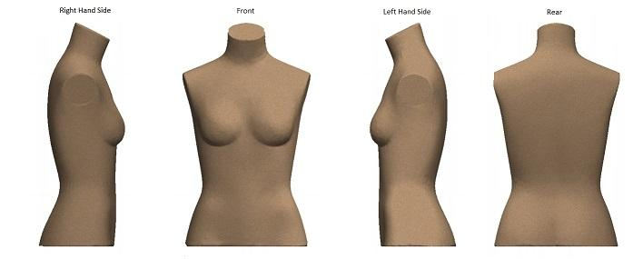

Q10 Whilst wearing your body armour, please rate the following actions (if applicable)
 | Very Easy (1) | Easy (2) | Difficult (3) | Very Difficult (4) | Not applicable (5)
Sitting in a car (passenger) (1)
Driving a car (2)
Walking (3)
Running (4)
Self defence techniques (5)
Using a pistol/TASER (6)
Using a carbine (7)

End of Block: Default Question Block

