Cambridgeshire Police Female Officer survey post wearing

Start of Block: Default Question Block

Q1 Please enter your unique identifer
________________________________________________________________

Q2 What bra type have you been wearing?
________________________________________________________________

Q3 What size is it?
________________________________________________________________

Q10 How many times have you washed the bra?
________________________________________________________________

Q9 How many of each shift have you done whilst wearing this bra?
- Early (1) ________________________________________________
- Late (2) ________________________________________________
- Night (3) ________________________________________________
- Other (4) ________________________________________________

Q6 When standing wearing your body armour and this bra, how comfortable is it?
- Very Comfortable (1)
- Comfortable (2)
- Uncomfortable (3)
- Very Uncomfortable (4)

Q8 On the images below, please indicate any areas that are uncomfortable or rub when wearing your body armour and this bra. (click on image with mouse, maximum of 10 points)
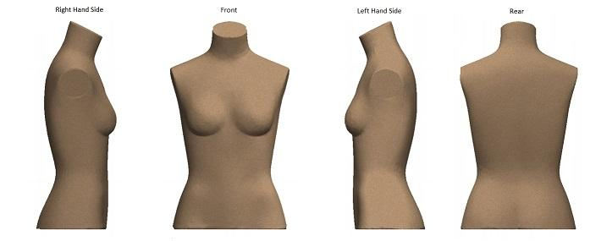

Q10 Whilst wearing your body armour and this bra, please rate the following actions (if applicable)
 | Very Easy (1) | Easy (2) | Difficult (3) | Very Difficult (4) | Not applicable (5)
Sitting in a car (passenger) (1)
Driving a car (2)
Walking (3)
Running (4)
Self defence techniques (5)
Using a pistol/TASER (6)
Using a carbine (7)

Q11 If you have any comments regarding the bra you have been wearing please comment below.
________________________________________________________________
________________________________________________________________
________________________________________________________________
________________________________________________________________
________________________________________________________________

Q12 When you have worn both bras for 10 shifts please answer the next two questions
Which bra did you find most comfortable?
________________________________________________________________

Q13 What type of bra will you use from now?
________________________________________________________________

End of Block: Default Question Block

