Nature inspired materials: Emerging trends and prospects
Nirmal Kumar Katiyarª, Gaurav Goel^{a,b}, Sara Hawi^{b} and Saurav Goel^{a,b,c,d}*
ª School of Engineering, London South Bank University, London, SE10 AA, UK
^{b} School of Aerospace, Transport and Manufacturing, Cranfield University, Bedford, MK43 0AL, UK
^{c} EPSRC Centre for Doctoral Training (CDT) in Ultra-Precision Engineering, University of Cambridge and Cranfield University, UK
^{d} Shiv Nadar University, Gautam Budh Nagar, 201314, India

*Corresponding author Email: GoeLs@Lsbu.ac.uk

Abstract
The term ‘Nature-inspired’ is associated with a sequence of efforts to understand, synthesise and imitate any natural object or phenomenon either in the tangible or intangible form which allows us to obtain improved insights into nature. Such inspirations can come through materials, processes, or designs that we see around. Materials as opposed to processes and designs found in nature due to being tangible can readily be used without engineering efforts. One such example is that of an aquaporin which is used to filter water. The scope of this work in Nature-inspired materials is to define, clarify and consolidate the current understanding by probing new insights in the recent developments by reviewing examples from the laboratory to industrial scale while highlighting newer opportunities in this area. A careful analysis of the “nature-inspired materials” shows that they possess specific functionality that relies on our ability to harness peculiar electrical, mechanical, biological, chemical, sustainability or combined gains.
Keywords: Nature inspired; Biomimicry; Design of materials; Hierarchical structure; Biomimetic; Design spiral; Bioinspired material.

Introduction
Nature has served mankind as a great source of inspiration by the virtue of millions of well-coordinated, engineered and crafted processes, algorithms, materials and designs. These days. a wide range of nature inspired products are available in the niche market, shown in Figure 1.
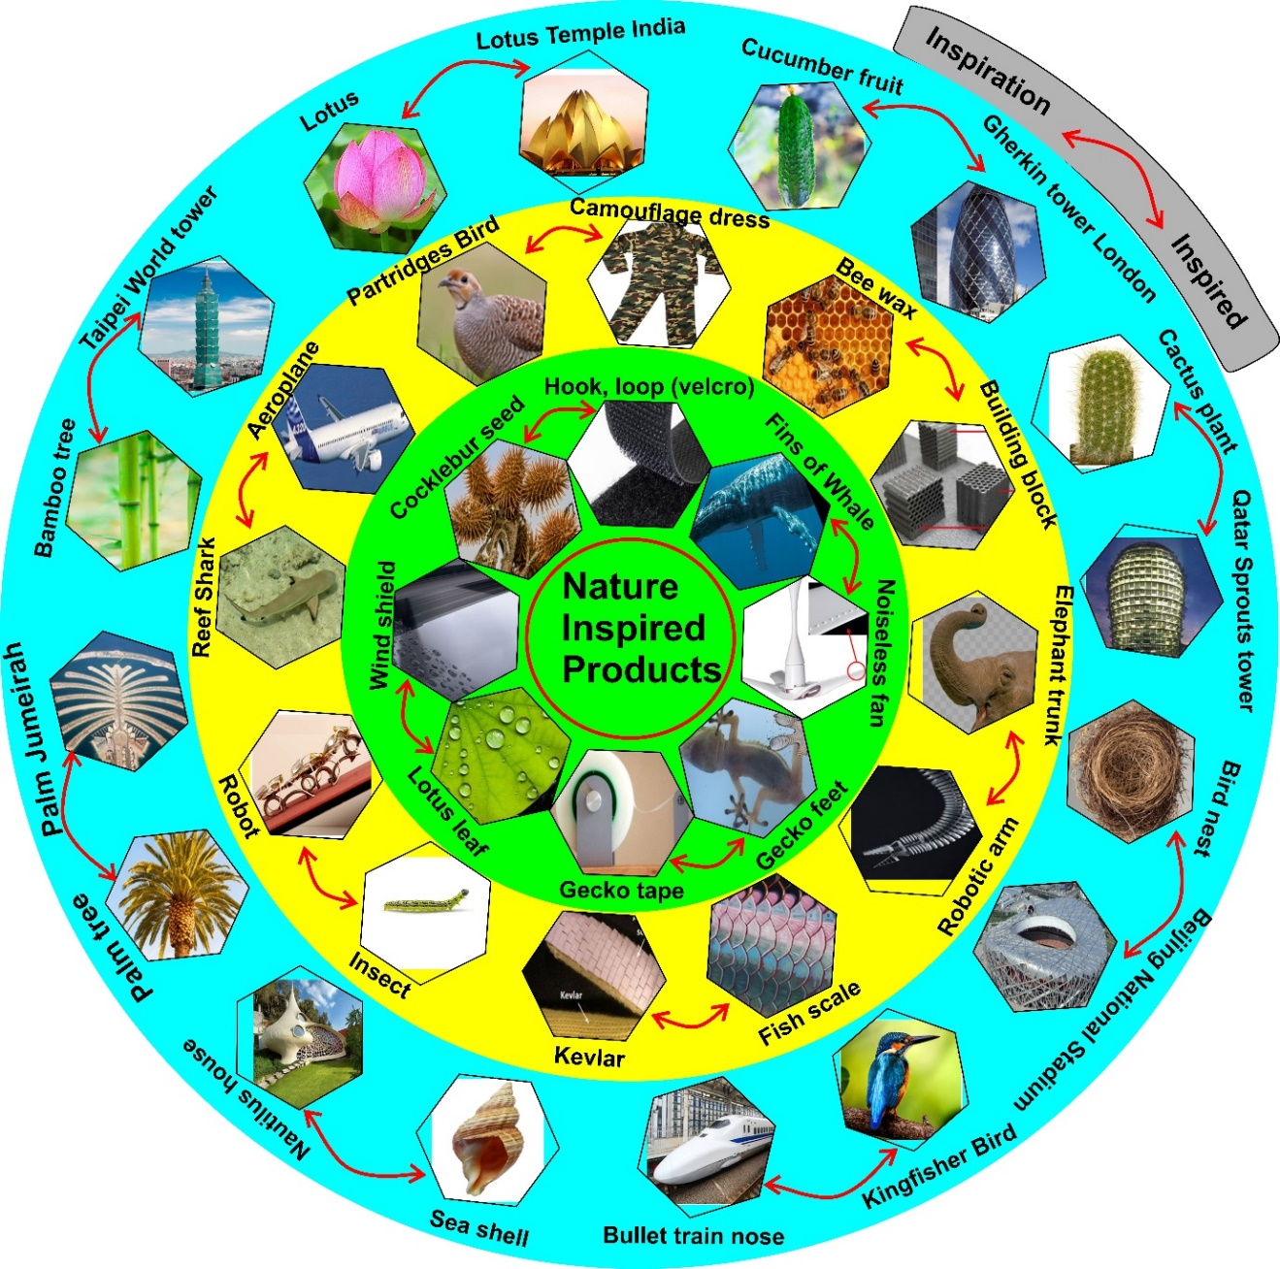
Figure 1: Commercially available nature-inspired products. Green coloured circle represents functional mimetic, yellow coloured circle represents feature mimetic, and cyan colour represents world-remarkable architecture inspired from nature.
Currently, terms such as bio-inspiration, biomimicry, biomimetics, nature-inspiration and nature-mimicry are often used synonymously in the literature. In this context, the word with prefix “nature” captures the broad ecosystem of living and non-living natural systems and the word with prefix “bio” is associated only with the living natural organisms (biology) and is engulfed within the broad spectrum of nature as shown in Figure 2. Therefore, whether it is biomimicry or bioinspiration, it falls within the terms “Nature mimicry” and “Nature inspiration” respectively, however, vice-versa is not true.
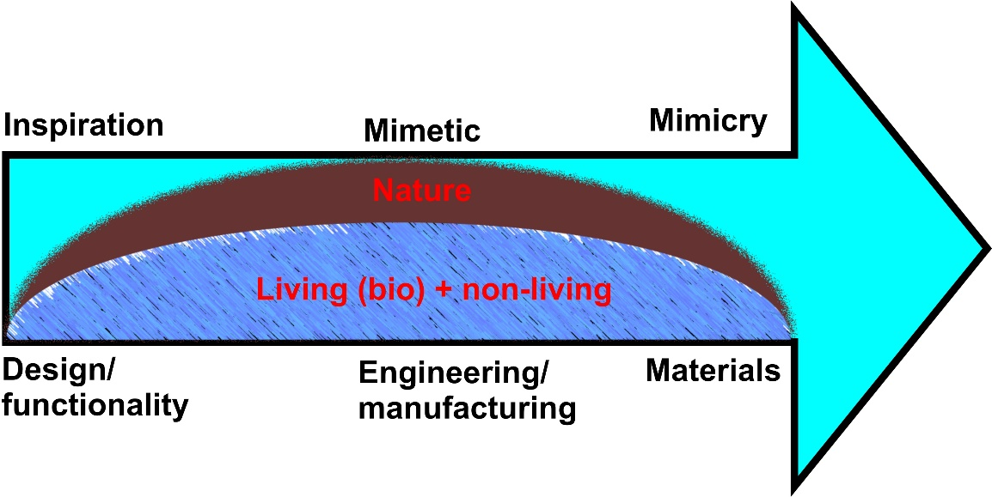
Figure 2: Schematic of nature inspiration, mimetic and mimicry.
ISO 18458:2015(E), an established International standard on this topic, describes subtle differences in the words bioinspiration, biomimetics and biomimicry. Taking the learnings from this ISO standard and various other sources, we suggest that the term “inspiration” refers to the primitive stage of observation of a certain design or functionality which stimulates creativity and seeds an idea of developing something similar. “Mimetic” is a step further which involves application of technology to engineer/manufacture materials inspired from nature to exploit certain functionality observed in nature. “Mimicry” is the most advanced form of inspiration which involves applying engineering and technology tools to develop materials akin to nature with the prime objective of achieving sustainability. Overall, it appears that while inspiration is a primitive step to mimic nature, mimicry is the most advanced form which needs engineering perfection to achieve sustainability, while biomimetic is the intermittent state between the two.
Currently, interest is growing towards multi-functional step up mimetics (bottom-up approach) such as a self-cleaning building, where a building block making up the building can be inspired from crystal structures (FCC, BCC, HCP, etc.) to achieve higher strength¹ as well as having building architecture resembling the shape of natural objects such as a termite etc. This can further be coupled with an additional consideration of having the outer wall surface of the same building inspired from the self-cleaning lotus effect² or photosynthesis inspired from the tree³, colour change inspired from bird wings or peacock feathers, etc. Such a complex multifunctional and multiscale mimetic (enabling multiple sustainable functionalities) requires a holistic approach and work in this direction is still in infancy. The scope of this review is strictly to discuss the latest advances in the field of “Nature inspired Materials” in light of the design, manufacturing and inspirational sources to highlight the current trends.

Broad classification of Nature inspiration

Nature-inspired processes
Nature-inspired processes are artificial processes which enable emulation of a certain natural process such as photosynthesis. An artificial photosynthesis can therefore aid in harvesting solar energy or solar-to-fuel conversion. A nature-inspired process in this case is triggered by the observation of photosynthesis of plant/tree leaves (storing energy in the form of chemical bonds). Recently, many systems have been developed to harvest solar energy, such as a system having flower-like nanostructure generated from copper phosphate nanocomposites, in which TiO₂ nanoparticles were incorporated over the petals of the flower (or copper phosphate nanosheet). The copper phosphate flower provides a large surface area to bind TiO₂ nanoparticles whereby the TiO₂ nanoparticles act as photocatalysts. Therefore, a copper phosphate flower functionalised with TiO₂ nanoparticles works as a solar light harvesting device^{3, 4}. This system works as an antenna for solar light absorption and splits the water molecules into O₂ and H₂ (clean energy as a hydrogen fuel cell) gas. This process is akin to photosynthesis in plants. A comparison of natural photosynthesis and nature inspired artificial photosynthesis is shown in Figure 3(a-b).
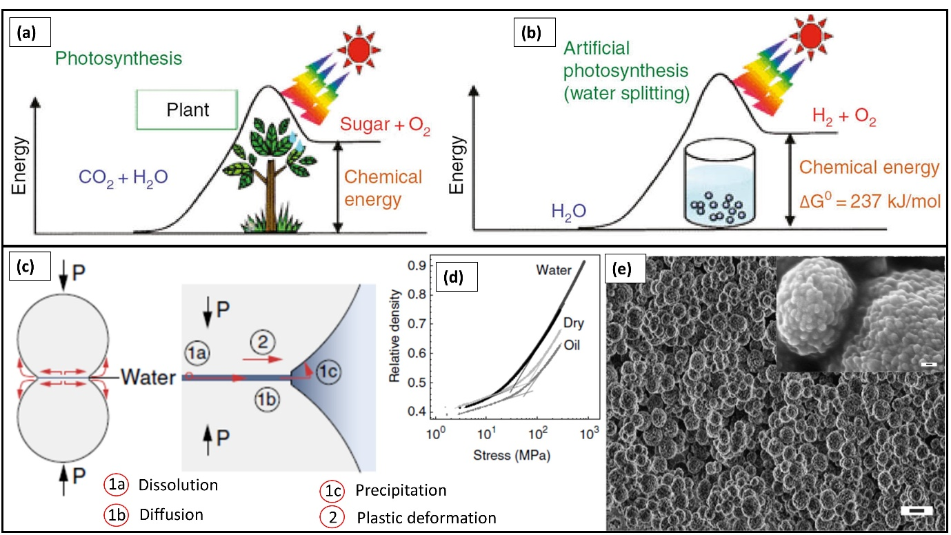
Figure 3: (a)The natural photosynthesis vs (b) artificial photosynthesis or nature-inspired photosynthesis⁵ (c) artificial biomineralization four-stage process, (d) achieved density in different media (e) SEM image, the morphology of artificial biomineralized ceramic⁶. (Figure a, and b adapted from Ref.⁵ (© RSC 2009) and c, d and e adapted from Ref.⁶(© NPG 2017).

A similar strategy has been applied to the self-cleaning surfaces (solar panel, walls, etc.), wherein TiO₂ as photocatalyst was coated over the surface, which degrades or splits the organic dirt photo-catalytically into their constituents in the presence of UV-light, and helps water to spread over the surface (rinsing the surface) due to hydrophilicity; which allows the surface to become self-cleaned⁷.
Ceramics found in nature utilise less energy and form at mild temperatures. This happens due to a natural process called biomineralization. In contrast, manmade ceramics require high temperatures above 1400 ºC for densification. The higher temperatures densification of the materials is an obstacle as it reduces material properties due to the coarsening of grain size. Therefore, adapting the geologically inspired⁸ biomineralization process can produce denser ceramic materials such as calcium carbonate (nanovaterite) which forms during low-temperature compaction of nanopowder, the four-stage strategy (dissolution, diffusion, precipitation, and plastic deformation) is shown in Figure 3(c). Biomineralization is best suited to aqueous media and reaches the required density and morphology as shown in Figure 3(d-e), but this is presently limited to thin films⁶.

Water purification or removal of the targeted chemicals from water is an inspiration from plant roots that allows selective water uptake and removal of selected nutrients from surrounding soil⁹.
There are many more processes which continually inspire us to develop artificial systems such as energy storage inspired by biochemical energy storage¹⁰, protein production inspired by spider silk production¹¹ and self-degrading plastic inspired by natural decomposition¹².

Nature-inspired designs
Nature has been splendidly designed which makes life on earth habitable. Nature-inspired design has therefore attracted a great interest in recent times. Some of the examples in this series are shown in Figure 4. Nature-inspired design can be adopted in two forms: surface design or structural design.
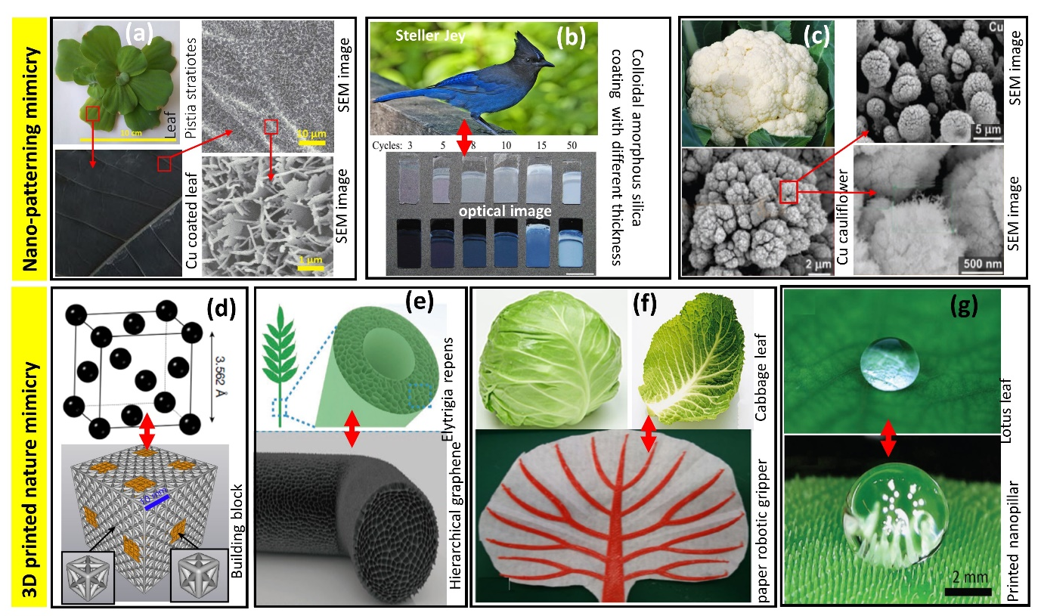
Figure 4: Examples of nature inspired bulk and surfaces (a) Cu nanostructure for wide wavelength absorption generated through phanera pupurea/ Pistia stratiotes leaf as template¹³ (b) colour alteration with different angles inspired from Steller Jey feather¹⁴ (c) Cu nanostructure generated using laser, structure from cauliflower¹⁵ (d) building block inspired from crystal structure¹ (e) hierarchical graphene ultralight inspired from elytrigia repens¹⁶ (f) soft robotic thermally driven paper gripper inspired from curling of cabbage leaf¹⁷ (g) 3D printed nanopillar for superhydrophobic action inspired by a lotus leaf¹⁸. Figure a, adapted from Ref.¹³ (© 2020 NPG); b from Ref.¹⁴ (© 2017 Wiley-VCH); c from Ref.¹⁵ (© 2020 Wiley-VCH); d from Ref.¹(© 2019 NPG); e from Ref.¹⁶ (© 2019 Wiley VCH); f from Ref.¹⁷ (© 2019 Springer) and g from Ref.¹⁸ (© 2019 Wiley VCH).

Surface design involves modification of a surface for instance to tailor wetting behaviour. For example, hydrophobic plant leaves such as purple bauhinia (Phanera pupurea), water cabbage (Pistia stratiotes) and hydrophilic nature rosy periwinkle (Cathranthus roseus)¹³, the leaves, upon being coated with a thin copper film, showed changed wettability. Hydrophobic leaves become highly absorbent and the hydrophilic leaves showed low absorbance or high reflectance (due to the absence of nano-structuring over the leaf surface). The presence of nanostructures over leaf surface significantly reduces its reflectance, resulting in increased absorbance; this phenomenon inspired the use of nanostructured surfaces for wide wavelength (broadband) absorbance in solar absorber coatings¹³. Another surface patterning is inspired by the Jay's feather, which shows different colours on different incident angles.
Like Nature inspired surface design, nature-inspired structural design can also offer new and enhanced properties (see Figure 5). The toughness and strength are known for dichotomy trends, such as metal possessing improved toughness possessing reduced strength. Similarly, in ceramics, the higher the compressive strength, the lower is the toughness¹⁹. Imitating the crystal structure’s architecture by 3D printing in meso-microscale building blocks showed highly damage tolerant properties¹.
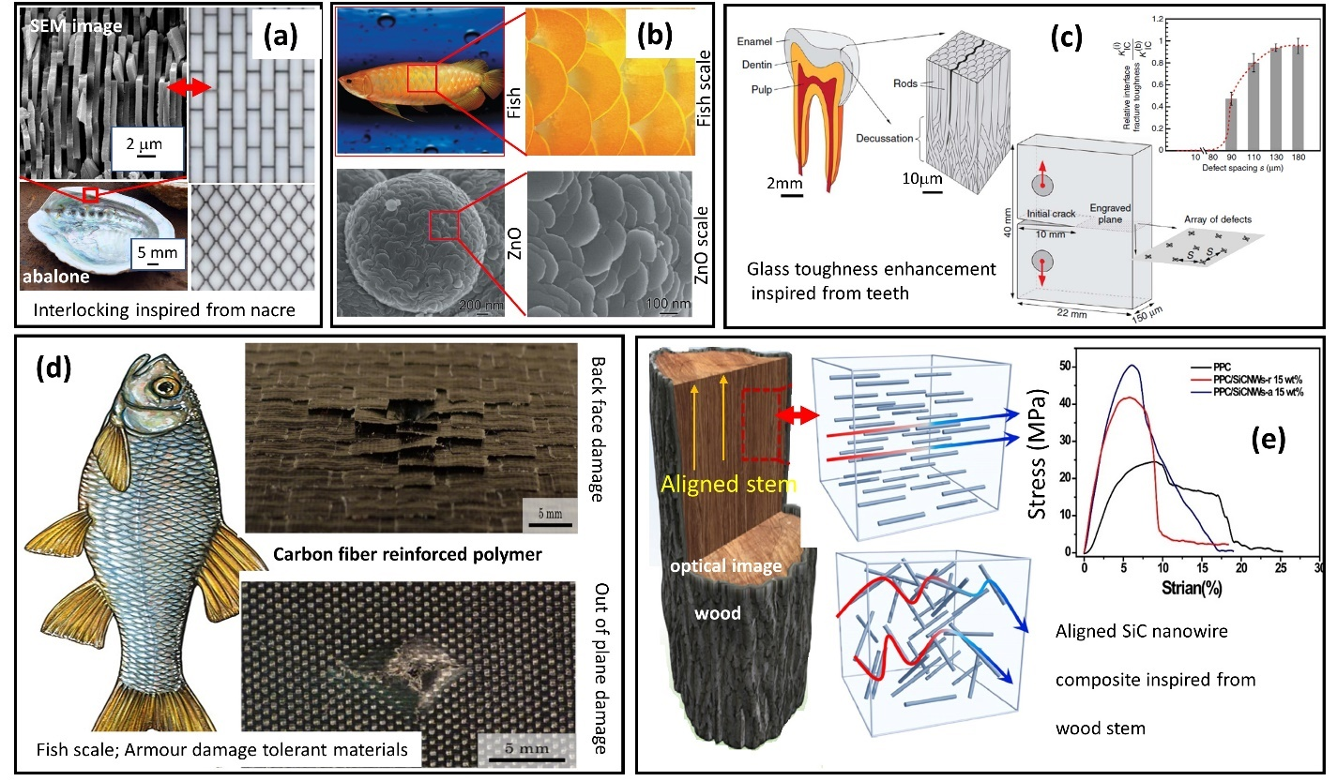
Figure 5: Different nature-inspired examples (a) enhanced wall strength construction mimicry of interlocking aragonite plates in nacre²⁰, (b) fish scale generated using ZnO²¹ (c) enhanced glass toughness inspired from tooth enamel²², (d) fibre reinforced armour strength polymer inspired from fish scale²³ (e) the alignment of carbon nanotubes in nanocomposites inspired from the wood stem²⁴. Figure a adapted from Ref.²⁰ (©)2016 NPG); b from Ref.²¹ (© 2015 NPG); c from Ref.²² (© 2014 NPG); d from Ref.²³ (© 2020 Elsevier); e from Ref.²⁴ (© 2020 Elsevier).

Nature-inspired materials
This section is at the core of this article and discusses the ideas for developing materials meeting our needs and thus helping to achieve sustainability in our lifestyle. Nature-inspired materials are developed with the intention of harnessing a certain type of functionality, which allows us to tap into a particular type of gain. A categorisation of nature-inspired materials by the virtue of the gain they provide has been shown in Figure 6 which shows that the type of gain may be (i) electrical, (ii) biological, (iii) chemical (iv) mechanical, (v) sustainability, (vi) or a multiplicity of gains. The list of gains classified in Figure 6 (and Table 1) is by no means exhaustive, but it enables suitably positioning a new development on this front. The individual categories shown in Figure 6 are discussed further.
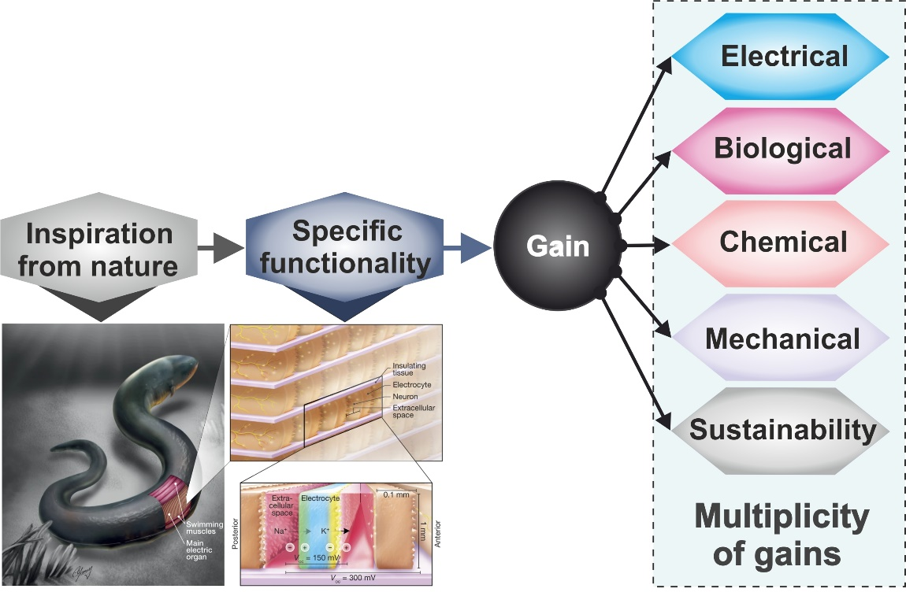
Figure 6: Nature-inspired materials demonstrating different gains
Table 1: List of different nature inspired materials classified according to the scheme shown in Figure 6.
Functionality | Application
Nature inspired Materials triggered by achieving 'Electrical GAIN'
Electric-eel-inspired Chemical to Electrical Energy conversion²⁵ | Artificial electrical organs
Biological micromotors based on bacterium²⁶ | Nature inspired nanomotor
Photosynthetic proteins²⁷ | Self-charging biophotonic device
Nature inspired Materials triggered by achieving 'Biological GAIN'
Biological cooperativity of proteins²⁸ | Protein fibrils
Coral-algal symbiosis²⁹ | To grow microalgae with high spatial cell densities
Tunable self-healing³⁰ | Tissue Repair
Morphogenesis of biological structures³¹ | Biomorphs - Pneumatic shape-morphing structures
Response of Protein³² | Cancer biomarker detection
Plant seed dispersal units that self-fold on differential swelling³³ | Self-shaping ceramic
Nature inspired Materials triggered by achieving 'Chemical GAIN'
Hierarchical micro- and nanoscale features of diatom³⁴ | Diatomite membrane can selectively filter water in various oils
Biomineralization³⁵ | Dental hard tissue
Biomineralization³⁶ | Perovskite cells
Biomimicked dual crosslinking³⁷ | Sequestration of carbon dioxide (CO₂)
Hydrophobic paint (Lotusan) | Stocolor® Lotusan paint
Self-healing | Airplane
Nature inspired Materials triggered by achieving 'Mechanical GAIN'
Fast osteointegration³⁸ | Porous struts applied to (anterior cervical reconstruction of goat)
Functional properties of biological tissues³⁹ | Tissues inspired bioelectronics
Spider silk mimicked wettability⁴⁰ | Biomimicked spindle-knot microfibers with cavity knots (named cavity-microfiber)
Subcellular structural features and mechanical properties of neurons⁴¹ | Neural probes or Neuron-like electronics (NeuE)
Nacre ⁴² | Optical transparency and mechanically tough composites
Ultrafast water transport on the surface of a Sarracenia trichome⁴³ | Microfluidic
Tooth enamel-mimicked columnar nanocomposites⁴⁴ | Abiotic tooth enamel
Mechanically response to external stimuli⁴⁵ | Actuator, artificial muscles
Spider dragline silk based on molecular assembly of silk proteins⁴⁶ | Synthetic spider silks
Fish scales and Osteoderms⁴⁷ | Bullet‐proof protecto‐flexible material
Nature inspired Materials triggered by achieving 'Sustainability GAIN'
Recyclability ⁴⁸ | Recyclable lightweight structures with hierarchical architectures, complex geometries and unprecedented stiffness and toughness
Biodegradability (Shrilk) | Implantable foams, films and scaffolds for surgical closures as well as regenerative medicine applications
Nature inspired Materials triggered by achieving 'Multiplicity of Gains'
Spider silk mimicked⁴⁹ | Humanoid robotics
Macroscopically ordered rod-like nanoapatites⁵⁰ | Aqueous liquid crystal, aqueous Mg (OH)₂ and Mg₃(PO₄)₂ LCs
Plant catechol chemistry⁵¹ | Tough and adhesive hydrogels
Adhesive nature of catechol chemistry⁵² | Switchable adhesive properties in a wet environment
Nature's Murray networks (Murray's law)⁵³ | Murray material
Biomimicked antireflective properties (insect compound eyes)⁵⁴ | Solar energy harvesting
Artificial urushi (wetting)⁵⁵ | Coatings
Autonomous photomechanical actuation ⁵⁶ | Flytrap

Electrical gain
A very interesting example in this category is that of an electric-eel mimicked miniature polyacrylamide hydrogel compartment which converts chemical energy to electrical energy²⁵. This research can lead to development of self-powered body implants. Another example is that of a nanomotor made of hyperbranched polyamide/L-arginine (HLA)²⁶ which was mimicked from endogenous biochemical reactions in the human body. This development showed a pathway on how a nanomotor with no waste discharge can be created to facilitate many potential biological applications. Ravi et al.²⁷ reported storage of electrical charge in multilayers of photoproteins isolated from Rhodobacter sphaeroides. The use of these proteins as charge storage medium along with light harvesting may facilitate the development of a ‘Self-charging bio-photonic device’. Teng et al.⁵⁷ demonstrated the potentiality of bio-inspired nervous signal transmission to simulate the neural ion-carried information system as shown in Figure 7.
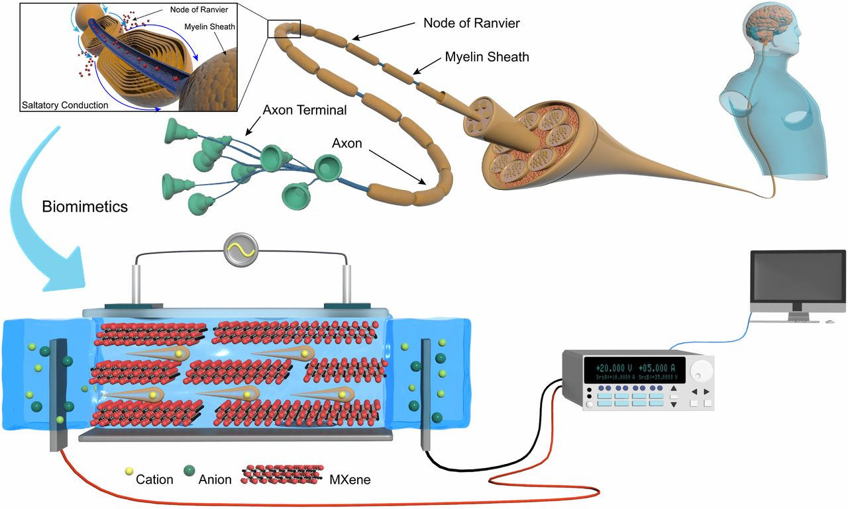
Figure 7: The bio-mimicked nervous signal transmission system (PDMS sealed 2D MXene nanofluidic device with additional signal input and acquisition modules)⁵⁷. Adapted from Ref.⁵⁷ (© 2020 PNAS).

Biological gain
This section describes examples of nature inspired materials developed with an ambition to achieve biological gain. Recent research reported in this category presents examples of bionic 3-D printed corals which promote space-efficient microalgal growth and possess outstanding photosynthetic quantum efficiencies²⁹. This work is helpful in coral reef research and photobioreactor design. Another development inspired from observing the mechanism of plant seed dispersal units that can self-fold on differential swelling, led to the fabrication of alumina compacts with bilayer architectures with control over shape change during the sintering step³³. Biodegradable self-healing hydrogels for tissue repair were also reported ³⁰. In this work, the authors developed novel chitosan–cellulose nanofiber (CS–CNF) composite self-healing hydrogels with tuneable self-healing properties. This research may lead to the development of a design rationale for hydrogels with better injectability and tissue regeneration potential. Gan et al.⁵¹ demonstrated a strategy to design tough and adhesive hydrogels based on dynamic plant catechol chemistry, as shown below in Figure 8.
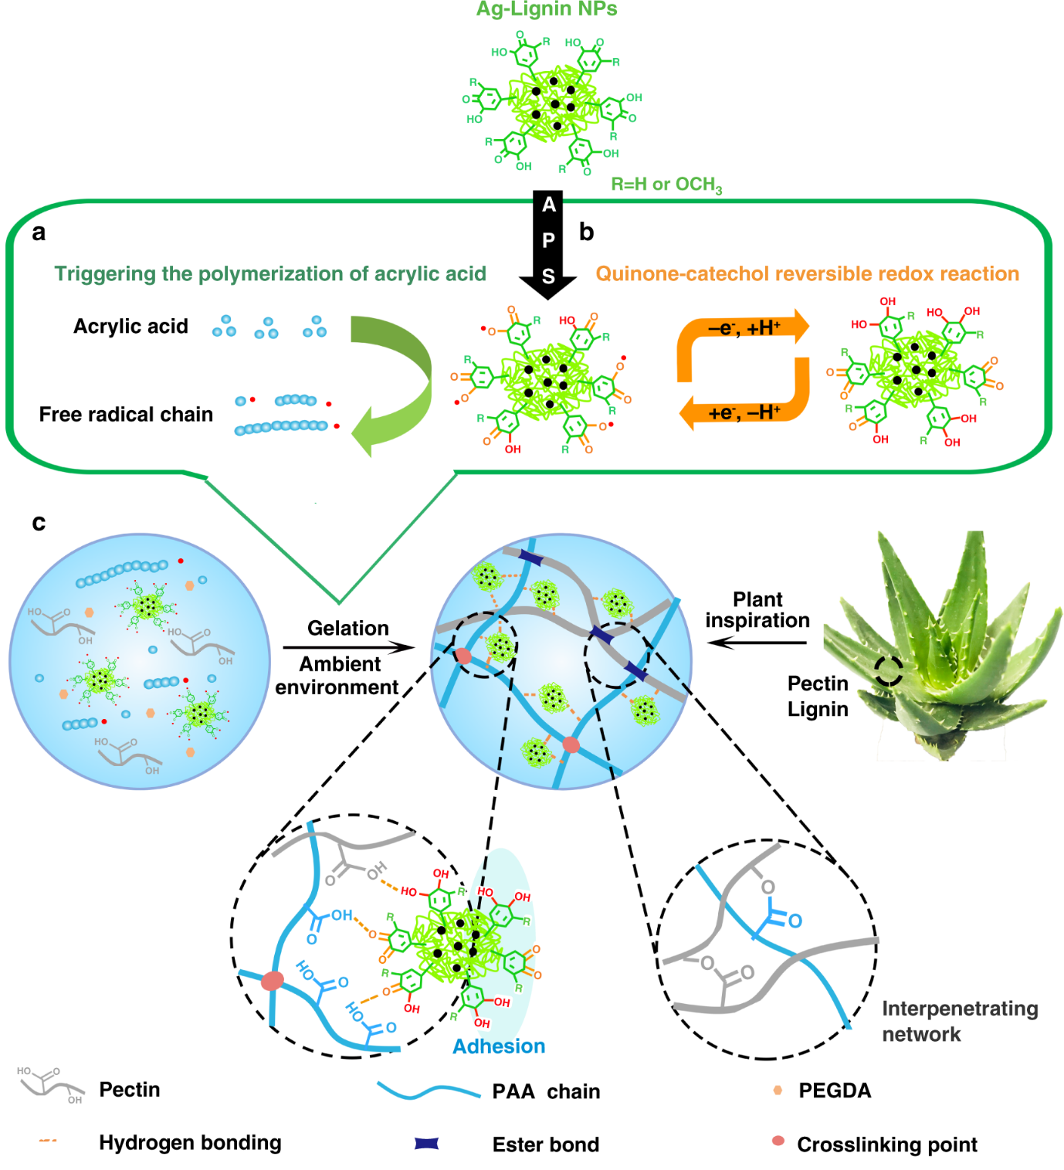
Figure 8: The bioinspired strategy for the plant-inspired catechol-chemistry-based self-adhesive, tough, and antibacterial NPs-P-PAA hydrogel⁵¹. Adapted from Ref.⁵¹ (©2019 NPG)

Chemical gain
Research inspired from the hierarchical micro- and nanoscale features of diatom, has led to the fabrication of a hierarchical diatomite membrane consisting of aligned micro-sized channels³⁴. This diatomite membrane possesses both underwater super-oleophobicity and super-hydrophobicity and facilitates highly efficient oil/water separation. Another research³⁵ reports the development of amorphous calcium phosphate (ACP) doped with fluoride ions (FACP) to obtain materials with enhanced anti-caries and demineralizing properties. This work made use of a biomineralization process and showed a pathway of preventative dentistry with remineralisation of dental hard tissues. The biomineralization strategy also helped to convert metal carbonate structures into lead halide perovskite semiconductors with tuneable bandgaps, along with preservation of the 3D shape ³⁶. This approach is promising as calcium carbonate biominerals are converted into semiconductors, furnishing biological and programmable synthetic shapes. Development of carbonic anhydrase (CA)-based materials for the environmentally-friendly sequestration of carbon dioxide (CO₂) under mild conditions can be helpful in arresting global warming³⁷. This research reported development of CA-encapsulating silk protein hydrogel employing photoinduced dityrosine crosslinking followed by dehydration-mediated physical crosslinking. Recent ambition in this research has been to develop various progressive facade coatings employing biomimetic and bioinspired strategies^{58, 59}.

Mechanical gain
Nature based materials can have the motive of enhancing mechanical properties of materials such as strength, toughness, hardness, durability etc. Recently published research³⁸ shows development of a novel porous strut made of hollow cylindrical nanohydroxyapatite/polyamide, leading to faster osteointegration thus helping in cervical reconstruction. These struts possess the advantage of accelerated attachment/adhesion. Another example is regarding the design of new adhesive devices inspired from insect footpads⁶⁰. These footpads contain multiple hairs which secrete liquid generating capillary force and thus helping the footpad to stick to any surface. Taking the example of Drosophila, which is a type of fruit fly, the authors fabricated a new artificial adhesive device⁠-a spatula-like fibre-framed adhesive device supported by nylon fibres with a gel material at the tip.
Libonati et al.⁶¹ reported bone-inspired structure on fibre-reinforced composites. The geometry mimicked the osteonal secondary structure of the mammalian bone. Bundles of unidirectional glass fibres (UDGF) were embedded into ±45° carbon fibres (CF) sleeves. The orientation of the UDGF was orthogonal to the main osteon direction, providing a balance in the fibre orientation ensuring good performance of the whole material in the transversal direction. The outer circumferential system was mimicked by a bidirectional woven GF fabric. The whole system was impregnated by epoxy resin. The design significantly boosted the fracture toughness when compared to a classic laminated composite. Chen et al.³⁹ utilised PSeD-U elastomers with a unique physical and covalent hybrid crosslinking structure for developing mechanically and biologically skin like materials. Other researchers^{40, 46} reported spider silk properties and architecture inspired development of materials helping fog water harvesting and materials with enhanced mechanical properties. Chen et al.⁴³ reported Sarracenia trichome mimicked hierarchical microchannel organized material with superior fog water harvesting. Wang et al.⁶² designed and fabricated a two-dimensional (2D) spider-web-like fog collector and a three-dimensional (3D) cactus-like fog collector using direct laser structuring and origami techniques as shown in Figure 9.
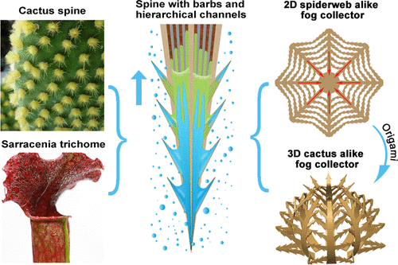
Figure 9: The Bio-mimicked spine with backward microbarbs and hierarchical microchannels for ultrafast water transport and efficient fog harvesting⁶². Adapted from Ref.⁶² (©2020 ACS)

Yang et al.⁴¹ developed Neural probes or Neuron-like electronics (NeuE) directed towards brain-machine interfaces. Magrini et al.⁴² developed materials inspired from nacre-like architecture by combining antagonistic functional properties such as optical transparency and mechanical toughness. Yeom et al.⁴⁴ reported enamel-inspired columnar nanocomposites by sequential growth of zinc oxide nanowire carpets followed by layer-by-layer deposition of a polymeric matrix with comparable mechanical properties. Deng et al.⁴⁵ prepared hierarchically arranged helical fiber (HHF) actuators which are able to sense solvents and vapours and respond.

Multiplicity of gains or collective gains
The developments of materials described in this section are those which show multiple gains or a combination of several gains necessary to design a full system. An example of this is that of a human nerve or an optical eye for Scotopic vision, as shown in Figure 10.
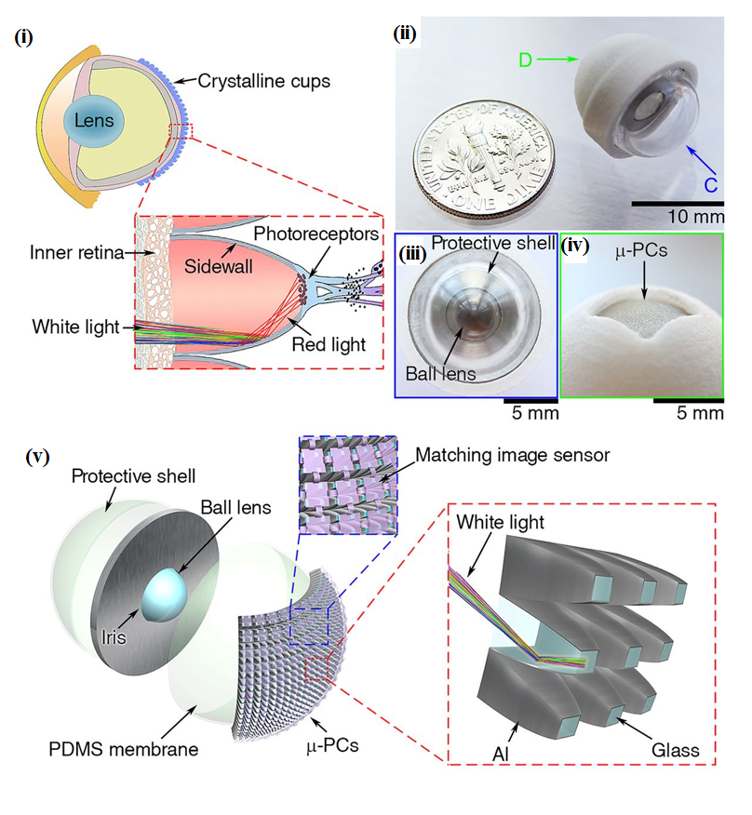
(a)
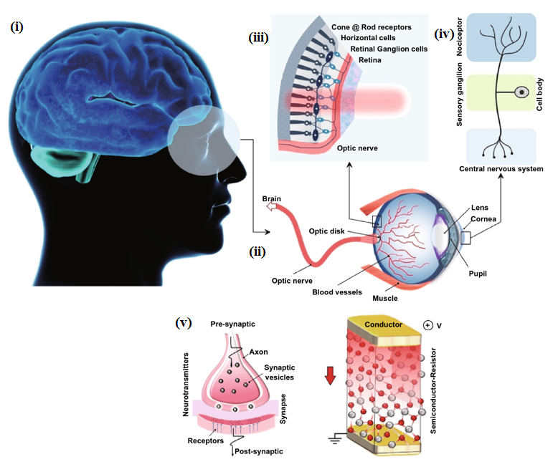
(b)
Figure 10: Devices inspired from body parts (a) Schematic illustrations and images of a natural eye of elephantnose fish and an artificial eye for Scotopic vision⁶³ (b) The scheme of human eye receptor and nociceptor system and its artificial counterparts in conductor/semiconductor /conductor-sandwiched configuration⁶⁴. Figure (1) Adapted from Ref.⁶³ (©2016 PNAS); (2) Adapted from Ref. ⁶⁴(©2020 Springer).
Nerves are central systems that allow sensing in a human body such as touch, perception, recognition, communication and transmission. Developing bionic artificial nerves is vitally important for humanoids and intelligent robots⁶⁵. A recently developed artificial nerve is very efficient in transmitting mechanosensitive signals. It works based on an electrical double layer structure thus minimising noise. It is envisaged that with further developments, these artificial nerves will be able to sense temperature, humidity, light and will contribute to sophisticated neuroprosthetics. The electro-tendon mechanically toughened by single-wall carbon nanotubes (SWCNTs) and electrically enhanced by PEDOT: PSS (poly(3,4-ethylenedioxythiophene) polystyrene sulfonate) can withstand more than 40,000 bending-stretching cycles without changes in conductivity. Various hierarchical designs in nature are guided by Murray’s law and utilising this law, researchers developed materials whose pore sizes decrease across multiple scales and finally terminate in size-invariant units like plant stems, leaf veins, and vascular and respiratory systems⁵³. This approach ensures hierarchical branching and precise diameter ratios for connecting multi-scale pores from macro to micro levels. It is envisaged that these Murray materials can enhance performance in photocatalysis, gas sensing, and Li-ion battery electrodes.

Towards a holistic nature-inspired approach

Conventional nature inspiration was based on direct copying/imitation of naturally occurring materials’ structure with the expectation that these will meet the desired functionalities. However, with newer learnings over the years, this concept is now achieving newer heights and horizons that can be referred to as fundamental design where mimetics is now achieved only after the process is well understood in terms of its three main pillars: design, materials and manufacturing. These are also the common pillars of an engineering design approach and this brings us to discuss a few fundamental differences between nature-triggered protocols and engineering-triggered protocols which are shown in Table 2 ⁶⁶.
Table 2: Nature-triggered vs engineering-triggered protocols
Attributes/protocol | Nature-triggered protocols | Engineering-triggered protocols
Design | - Driven by quasi-static processes  - Hierarchical at all scales  - Self healing (biological) | - Driven by design intent to achieve specific function and choice of materials  - Safety factor – overdesign risk
Materials | Limited to limited elements: C, N, O, H, Ca, P, S, Si, etc | Large variety of elements: Fe, Cr, Ni, Al, Si, C, N, O, etc
Manufacturing | - Self-assembly  - Functional adaptation affected by external environment  - Low energy required (low temperatures and ambient conditions)  - Sustainable | - Fabrication according to an exact design with limited manufacturing methods  - Energy intensive production systems  - Waste of energy and materials  - Human presence

In a nature-triggered protocol, the design is driven by a quasi-static thermodynamic process as it is a slow-paced process, allowing the material system to maintain its internal equilibrium. These processes are self-run and do not need human presence. Natural/biological materials possess different structural design elements (i.e. fibrous, helical, cellular, tubular elements etc.) organised hierarchically due to the nature of the process driver. While comparing natural and synthetic materials in terms of their properties such as strength and toughness, one might consider that synthetic materials have superior performance. However, nature assembles these relatively weak constituents into hierarchical composite structures that exhibit impressive combinations of strength and toughness. Thus, natural materials owe their superiority to the design of their structural hierarchical synergistic material systems, whereas engineering or synthetic materials rely on their inherent properties to guide the design.
Also, the method of production of natural materials is a slow bottom-up approach in which materials grow, self-assemble and adapt to the ambient environment rather than being specifically designed and restricted as engineered materials. This bottom-up approach allows natural materials to be hierarchical at all scales. For example, the peacock feather rachis design has been unveiled using a Scanning electron microscope (SEM) in Figure 11. The intricate way by which mother nature enweaves the features from the nano to the macro level to make its creations robust and lightweight is an artform. So is the capability of nature to design biomaterials with multifunctionality such as self-healing properties (biological materials) stemming from environment adaptation etc.
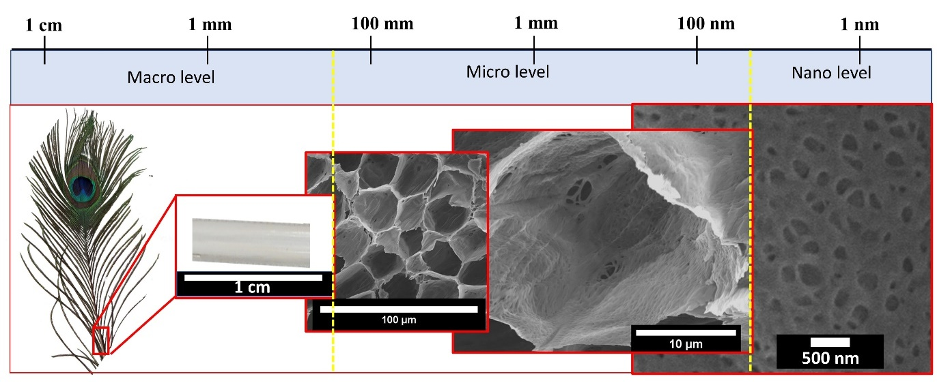
Figure 11: Different size scale level of intricate pattern enabled in nature or biological made materials (Peacock feather and their rachis’s SEM image).
As natural materials grow usually under ambient conditions, they do not require high energy for fabrication like engineering materials. In addition, sustainability of nature-triggered protocols is far superior when compared to engineering-triggered protocols. Due to these differences between nature-triggered protocols and engineering-triggered protocols, a better approach to Nature-inspiration would be adaptation and not blind imitation.
The drivers behind the pursuits of Nature-inspiration (encompassing bioinspiration) influence, to some extent, the strategy applied. As such we can identify functional problem solving through either problem-driven nature-inspiration or solution-driven nature-inspiration. These two approaches differ in the initial steps as these are the steps where inspiration and ideas play a big role in design but converge to the same outcome. After the identification of biological models, the process becomes systematic.
The biomimicry design spiral⁶⁷ was the stepping stone on which other design approaches such as the DTU biocard⁶⁸, the Biomimicry 3.8 DesignLens⁶⁹, the ISO18458:2015 standard, the unified problem-driven process of biomimetics⁷⁰, and the solution-driven process⁷¹ were developed. A design spiral inspired from the biomimicry design spiral is shown in Figure 12.
Figure 12: Design spiral (concept adapted from Biomimicry Research Institute).
The individual steps or language may differ between the problem-driven processes, yet they all follow a common trend that was congregated in the unified problem-driven process of biomimetics introduced by Fayemi et. al (2017)⁷⁰. While this approach was developed for biomimetic design, its strategies likewise apply to nature-inspired design with a change in terminology to encompass living and non-living entities: biology to Nature. The nature expanded unified problem-driven approach can then be expressed in 8 main steps as:
- Problem analysis: Assess the situation in the case where no problem has been pinpointed yet or describe the problem previously identified.
- Abstract technical problem: Identify context and constraints to define the function required.
- Transpose to nature: Formulate the function required into a question towards nature and investigate how nature can achieve that. Careful question formulation is required as the results are highly sensitive to the formulation.
- Identify potential natural models: Through literature search, natural models (including biological models) can be identified.
The accumulated knowledge obtained at this step on both the technological and natural levels might necessitate revisiting the first 3 steps thus forming an iterative loop.
- Selecting a natural model of interest: Select a natural model from the identified models.
- Abstract natural strategy: Understand the workings of the selected natural models and detach them from the natural entity. As a direct transition from nature to technology is impractical in most cases, the combination of several natural strategies is vital to solve the initial problem through a transferrable functional model.
- Transpose to technology: To be able to express the natural solution in technical terms, technological knowledge is crucial to allow implementation in the technical world.
- Implementation and testing: Effective conversion of the natural strategies to technology and subsequent implementation and testing will result in the successful conclusion of the cycle and the introduction of a nature-inspired design. In the case of unsatisfactory results, the process is repeated within either phase 1 (steps 1 to 3) or 2 (steps 4 to 8).
An illustration of the workings of the unified problem-based approach applied on the development of a dynamic thermoregulatory material inspired by squid skin⁷² is shown in Figure 13.
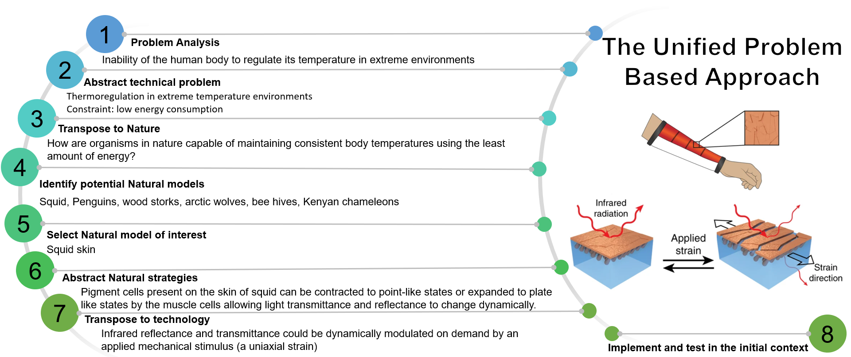
Figure 13: Unified problem-based approach applied in the case of squid skin mimetics^{70, 72}.
As for the solution-driven process, it has been explained⁷¹ that this approach stands out from the problem driven approach in natural solution identification as being the step that initiates the design process. This is done through observation as this is the stage where inspiration and curiosity come in. Numerous examples can be expressed, some that are obvious and that everyone has encountered like observing droplets forming on numerous plant leaves and bird feathers such as pigeons and the ability of a chameleon to change colour to regulate its temperature and communicate and many others.
Since nature-inspired design is a multidisciplinary process, the challenge lies in the identification of the natural function to identify specific applications as it is difficult to transcript natural concepts and terminologies into an engineering perspective in the exact same way. This has led to slow progress in the field. Therefore, several attempts have been made to facilitate the translation of concepts and terminologies between nature and engineering and aid engineers in finding the functions and solutions that are suitable for their application. Intuitively, efforts have been made towards the creation of databases to gather hundreds of observed natural phenomena and classify them according to their function such as ask Nature and the bionics system database. Using such platforms and established knowledge superior nature-inspired materials can be designed.
However, as it was discussed previously, there is a difference between natural fabrication modes and engineering manufacturing which limits the flexibility of design. However, nature-inspiration does not only apply to the structure and function, but it is also used in process development. For instance, biomineralization is one of the processes inspired from nature. Nevertheless, due to the limitations still existing in fabrication modes, most biomineralization attempts have been underachieving compared to their natural counterparts as they are slow and can only be used to produce small prototypes exhibiting inferior mechanical properties⁷³. With new advances in fabrication methods, designs can now be made more flexible and manufacturing can be agile and smarter with low waste thus contributing to sustainability; one of the resolves of nature-mimicry.

Author’s views and further prospects

Nature manifests its construction using the tiniest form of matter by taking a minimum energy approach. During the last two decades, nanoscience/nanotechnology has helped to improve the current understanding of the nanoscale world which is the length scale at which nature begins its construction, although the time scale is too large. Nature can easily create multi-gain components e.g. a human finger which can perceive pressure, hotness/coolness, can feel the wind flowing, inform about any damage (pain), can move on the instruction of the brain, enabled with self-healing ability on any cut, can grip things, and also leave behind their footprint (fingerprints). The engineering world has not yet matured enough to create such multi-gain component so swiftly and readily – more advances are needed in materials, design, manufacturing and sensing to unlock nature’s puzzle.
A biosystem is associated with three aspects, (i) miniaturization (many functions introduced in a small volume), (ii) organic-inorganic hybridization (introducing strength, durability, flexibility, etc.), and (iii) hierarchy (network construction from nano to millimetre work function).
Currently, nature-inspired materials, processes, and designs still lack the hierarchical network which requires a better control system to be developed. An even bigger challenge is the practical realisation of nature-inspired materials at a commercial scale, which comes down to their scalable and affordable production. Therefore, material developments must resonate with the manufacturing developments. Manufacturing techniques can be classified in three main categories (i) those based on removal of material herein referred to as subtractive methods (ii) those techniques which involve deposition herein referred to as additive methods and (iii) techniques involving no addition or removal of material. Based on this categorisation, some prime candidate technologies together with the newly emerging techniques being used for fabrication of nature-inspired materials are shown in Figure 14.

LbL: Layer by layer; CVD: Chemical vapour deposition; PVD: Physical vapour deposition; MM3D: Multimaterial multinozzle 3-dimensional printing; PCMM: Photochemical micromachining; LIGA: German acronym for Lithographie, Galvanoformung, Abformung
Figure 14: Conventional and emerging manufacturing techniques for nature-mimetics
Among other techniques, 3D printing is gaining much attention due to the flexibility of shape it offers. Future potentials of 3D printing have prospects of copying natural architecture such as biomimetic scaffold inspired from spinal cord⁷⁴, an ultralight biomimetic hierarchical structure inspired from cellular structure¹⁶, damage tolerant building block inspired from crystal structure¹, etc. 3D printing technology offers potentials to match properties such as similarity precise shape, hierarchical network, functional integration and scalability. With the recent emergence of multi-material multi-nozzle 3D printing (MM3D), one can extend the bandwidth or the range of materials which can be fabricated in a scalable way at once with significantly high precision.
There are challenges associated with the design of nature-inspired materials, for example, the smallest feature size for most production scale machines is in the range of hundreds of microns. Nonetheless, in powder bed processes, the trapped powder needs to be removed so the smallest size of voids is limited. After taking process constraints into account, initial designs are established, and parametric modelling is conducted. Consequently, simulations can be performed in order to optimise the design according to the function. However, the timescale over which any simulation is performed cannot match the experimental scale range of a few femtoseconds to a few weeks or years. In some cases, where the structure-function relationship is not understood fully, hands on sampling and testing with a systematic Design of Experiments (DOE) approach can be employed. Intuitively, after optimisation either through simulations or through sampling, prototyping and testing would be required which need multidisciplinary efforts.
These are the most pressing challenges in imitating intricate hierarchical patterns and producing nature-inspired materials. As such natural materials have the capability of decomposing into the original constituents and do not create an adverse ecological impact. However, artificial materials do not have the same recyclability and the pollution caused by plastics is a prime example of human intervention in Nature’s ecosystem. Work on considering sustainability of the functional nature-inspired materials is a grand engineering challenge.
In view of these challenges, the following future directions are noteworthy:
- Achieving precision form accuracy of a few nanometres in producing nature-inspired materials
- Achieving lifetime and recyclability of the nature-inspired materials akin to nature
- Making Nature inspired materials/design a fully digitalised process to be guided by predictive modelling and simulations
- Identifying new sectors where these developmental materials can be deployed to reduce our carbon footprint while achieve sustainability development goals (SDG’s).
Acknowledgements
All authors greatly acknowledge the financial support provided by the UKRI via Grants No. EP/L016567/1, EP/S013652/1, EP/S036180/1, EP/T001100/1 and EP/T024607/1, Royal Academy of Engineering via Grants No. IAPP18-19\295, TSP1332 and EXPP2021\1\277, EURAMET EMPIR A185 (2018), EU Cost Action (CA15102, CA18125, CA18224 and CA16235), VC Fellowship from Cranfield University and Newton Fellowship award from the Royal Society (NIF\R1\191571). We also acknowledge financial support from the European Regional Development Funds (ERDF) sponsored A2i project at LSBU that have catalysed several industrial partnerships. Wherever applicable, the work made use of Isambard Bristol, UK supercomputing service accessed by Resource Allocation Panel (RAP) grant as well as ARCHER resources (Project e648).

Conflict of interest
The authors declare that they have no conflict of interest.
Data Statement:
All data in the manuscript will be available through Cranfield University open repository (10.17862/cranfield.rd.12775685)

References

1. Pham M-S, Liu C, Todd I, Lertthanasarn J. Damage-tolerant architected materials inspired by crystal microstructure. Nature 565, 305-311 (2019).

2. Darmanin T, Guittard F. Superhydrophobic and superoleophobic properties in nature. Mater Today 18, 273-285 (2015).

3. Gust D, Moore TA, Moore AL. Solar Fuels via Artificial Photosynthesis. Acc Chem Res 42, 1890-1898 (2009).

4. Wang J, Zhu T, Ho GW. Nature-Inspired Design of Artificial Solar-to-Fuel Conversion Systems based on Copper Phosphate Microflowers. ChemSusChem 9, 1575-1578 (2016).

5. Kudo A, Miseki Y. Heterogeneous photocatalyst materials for water splitting. Chem Soc Rev 38, 253-278 (2009).

6. Bouville F, Studart AR. Geologically-inspired strong bulk ceramics made with water at room temperature. Nat Commun 8, 14655 (2017).

7. Xi B, et al. TiO2 Thin Films Prepared via Adsorptive Self-Assembly for Self-Cleaning Applications. ACS Appl Mater Interfaces 4, 1093-1102 (2012).

8. Yao S, et al. Biomineralization: From Material Tactics to Biological Strategy. Adv Mater 29, (2017).

9. Freeman EC, Soncini RM, Weiland LM. Biologically inspired water purification through selective transport. Smart Materials and Structures 22, 014013 (2012).

10. Wang H, Yang Y, Guo L. Nature-Inspired Electrochemical Energy-Storage Materials and Devices. Adv Energy Mater 7, 1601709 (2017).

11. Kronqvist N, et al. Efficient protein production inspired by how spiders make silk. Nat Commun 8, 15504 (2017).

12. Guan Q-F, Yang H-B, Han Z-M, Ling Z-C, Yu S-H. An all-natural bioinspired structural material for plastic replacement. Nat Commun 11, 5401 (2020).

13. Dao TD, Pham DD, Nguyen TAH, Tran TVH, Vu Hoang C, Pham TT. Bio-inspired broadband absorbers induced by copper nanostructures on natural leaves. Sci Rep 10, 3243 (2020).

14. Iwata M, Teshima M, Seki T, Yoshioka S, Takeoka Y. Bio-Inspired Bright Structurally Colored Colloidal Amorphous Array Enhanced by Controlling Thickness and Black Background. Adv Mater 29, (2017).

15. Reinhardt H, Kroll M, Karstens SL, Schlabach S, Hampp NA, Tallarek U. Nanoscaled Fractal Superstructures via Laser Patterning—A Versatile Route to Metallic Hierarchical Porous Materials. Advanced Materials Interfaces 2000253, 7 (2020).

16. Peng M, et al. 3D Printing of Ultralight Biomimetic Hierarchical Graphene Materials with Exceptional Stiffness and Resilience. Adv Mater 31, (2019).

17. Hu F, Lyu L, He Y. A 3D Printed Paper-Based Thermally Driven Soft Robotic Gripper Inspired by Cabbage. International Journal of Precision Engineering and Manufacturing 20, 1915-1928 (2019).

18. Li Y, et al. Bioinspired Functional Surfaces Enabled by Multiscale Stereolithography. Advanced Materials Technologies 4, 1800638 (2019).

19. Launey ME, Ritchie RO. On the Fracture Toughness of Advanced Materials. Adv Mater 21, 2103-2110 (2009).

20. Djumas L, Molotnikov A, Simon GP, Estrin Y. Enhanced Mechanical Performance of Bio-Inspired Hybrid Structures Utilising Topological Interlocking Geometry. Sci Rep 6, 26706 (2016).

21. Sun Z, et al. Fish-scale bio-inspired multifunctional ZnO nanostructures. NPG Asia Materials 7, e232-e232 (2015).

22. Mirkhalaf M, Dastjerdi AK, Barthelat F. Overcoming the brittleness of glass through bio-inspiration and micro-architecture. Nat Commun 5, 3166 (2014).

23. Häsä R, Pinho ST. Bio-inspired armour: CFRP with scales for perforation resistance. Materials Letters 273, 127966 (2020).

24. Qu H, et al. Bio-inspired stem-like composites based on highly aligned SiC nanowires. Chem Engg J 389, 123466 (2020).

25. Schroeder TBH, et al. An electric-eel-inspired soft power source from stacked hydrogels. Nature 552, 214-218 (2017).

26. Wan M, et al. Bio-inspired nitric-oxide-driven nanomotor. Nat Commun 10, 966 (2019).

27. Ravi SK, et al. Photosynthetic apparatus of Rhodobacter sphaeroides exhibits prolonged charge storage. Nat Commun 10, 902 (2019).

28. Bharmoria P, et al. Instantaneous fibrillation of egg white proteome with ionic liquid and macromolecular crowding. Communications Materials 1, 34 (2020).

29. Wangpraseurt D, et al. Bionic 3D printed corals. Nat Commun 11, 1748 (2020).

30. Cheng K-C, Huang C-F, Wei Y, Hsu S-h. Novel chitosan–cellulose nanofiber self-healing hydrogels to correlate self-healing properties of hydrogels with neural regeneration effects. NPG Asia Materials 11, 25 (2019).

31. Siéfert E, Reyssat E, Bico J, Roman B. Bio-inspired pneumatic shape-morphing elastomers. Nat Mater 18, 24-28 (2019).

32. Moreira FTC, Truta LAANA, Sales MGF. Biomimetic materials assembled on a photovoltaic cell as a novel biosensing approach to cancer biomarker detection. Sci Rep 8, 10205 (2018).

33. Bargardi FL, Le Ferrand H, Libanori R, Studart AR. Bio-inspired self-shaping ceramics. Nat Commun 7, 13912 (2016).

34. Lo Y-H, Yang C-Y, Chang H-K, Hung W-C, Chen P-Y. Bioinspired Diatomite Membrane with Selective Superwettability for Oil/Water Separation. Sci Rep 7, 1426 (2017).

35. Iafisco M, et al. Fluoride-doped amorphous calcium phosphate nanoparticles as a promising biomimetic material for dental remineralization. Sci Rep 8, 17016 (2018).

36. Holtus T, et al. Shape-preserving transformation of carbonate minerals into lead halide perovskite semiconductors based on ion exchange/insertion reactions. Nature Chemistry 10, 740-745 (2018).

37. Kim CS, Yang YJ, Bahn SY, Cha HJ. A bioinspired dual-crosslinked tough silk protein hydrogel as a protective biocatalytic matrix for carbon sequestration. NPG Asia Materials 9, e391-e391 (2017).

38. Liang X, et al. In vivo evaluation of porous nanohydroxyapatite/polyamide 66 struts in a goat cervical fusion model. Sci Rep 10, 10495 (2020).

39. Chen S, et al. Mechanically and biologically skin-like elastomers for bio-integrated electronics. Nat Commun 11, 1107 (2020).

40. Tian Y, et al. Large-scale water collection of bioinspired cavity-microfibers. Nat Commun 8, 1080 (2017).

41. Yang X, et al. Bioinspired neuron-like electronics. Nat Mater 18, 510-517 (2019).

42. Magrini T, Bouville F, Lauria A, Le Ferrand H, Niebel TP, Studart AR. Transparent and tough bulk composites inspired by nacre. Nat Commun 10, 2794 (2019).

43. Chen H, et al. Ultrafast water harvesting and transport in hierarchical microchannels. Nat Mater 17, 935-942 (2018).

44. Yeom B, et al. Abiotic tooth enamel. Nature 543, 95-98 (2017).

45. Deng J, et al. Preparation of biomimetic hierarchically helical fiber actuators from carbon nanotubes. Nature Protocols 12, 1349-1358 (2017).

46. Peng Q, et al. Recombinant spider silk from aqueous solutions via a bio-inspired microfluidic chip. Sci Rep 6, 36473 (2016).

47. Estrada S, Ossa A. Nature-Inspired Protecto-Flexible Impact-Tolerant Materials. Adv Eng Mater n/a, 2000006.

48. Gantenbein S, Masania K, Woigk W, Sesseg JPW, Tervoort TA, Studart AR. Three-dimensional printing of hierarchical liquid-crystal-polymer structures. Nature 561, 226-230 (2018).

49. Pan L, et al. A supertough electro-tendon based on spider silk composites. Nat Commun 11, 1332 (2020).

50. Tan J, Jin X, Chen M. Bio-inspired synthesis of aqueous nanoapatite liquid crystals. Sci Rep 9, 466 (2019).

51. Gan D, et al. Plant-inspired adhesive and tough hydrogel based on Ag-Lignin nanoparticles-triggered dynamic redox catechol chemistry. Nat Commun 10, 1487 (2019).

52. Zhao Y, et al. Bio-inspired reversible underwater adhesive. Nat Commun 8, 2218 (2017).

53. Zheng X, et al. Bio-inspired Murray materials for mass transfer and activity. Nat Commun 8, 14921 (2017).

54. Yang S, Sun N, Stogin BB, Wang J, Huang Y, Wong T-S. Ultra-antireflective synthetic brochosomes. Nat Commun 8, 1285 (2017).

55. Otsuka T, Fujikawa S-i, Yamane H, Kobayashi S. Green polymer chemistry: the biomimetic oxidative polymerization of cardanol for a synthetic approach to ‘artificial urushi’. Polymer Journal 49, 335-343 (2017).

56. Wani OM, Zeng H, Priimagi A. A light-driven artificial flytrap. Nat Commun 8, 15546 (2017).

57. Teng Y, Liu P, Fu L, Kong X-Y, Jiang L, Wen L. Bioinspired nervous signal transmission system based on two-dimensional laminar nanofluidics: From electronics to ionics. Proceedings of the National Academy of Sciences 117, 16743 (2020).

58. https://www.sto.com/en/portfolio/facades/intelligent-technologies/standard.html.

59. Wu ZL, Gong JP. Hydrogels with self-assembling ordered structures and their functions. NPG Asia Materials 3, 57-64 (2011).

60. Kimura K-i, Minami R, Yamahama Y, Hariyama T, Hosoda N. Framework with cytoskeletal actin filaments forming insect footpad hairs inspires biomimetic adhesive device design. Communications Biology 3, 272 (2020).

61. Libonati F, Vellwock AE, Ielmini F, Abliz D, Ziegmann G, Vergani L. Bone-inspired enhanced fracture toughness of de novo fiber reinforced composites. Sci Rep 9, 3142 (2019).

62. Wang J, Yi S, Yang Z, Chen Y, Jiang L, Wong C-P. Laser Direct Structuring of Bioinspired Spine with Backward Microbarbs and Hierarchical Microchannels for Ultrafast Water Transport and Efficient Fog Harvesting. ACS Appl Mater Interfaces 12, 21080-21087 (2020).

63. Liu H, Huang Y, Jiang H. Artificial eye for scotopic vision with bioinspired all-optical photosensitivity enhancer. Proceedings of the National Academy of Sciences, 201517953 (2016).

64. Karbalaei Akbari M, Hu J, Verpoort F, Lu H, Zhuiykov S. Nanoscale All-Oxide-Heterostructured Bio-inspired Optoresponsive Nociceptor. Nano-Micro Letters 12, 83 (2020).

65. Liao X, et al. A bioinspired analogous nerve towards artificial intelligence. Nat Commun 11, 268 (2020).

66. Hunter P. From imitation to inspiration: Biomimicry experiences a revival driven by a more systematic approach to explore nature's inventions for human use. EMBO Rep 18, 363-366 (2017).

67. https://asknature.org/resource/biomimicry-design-spiral/. (ed^(eds).

68. Anker LT. Do biomimetic students think outside the box? In: Proceedings of the International Conference on Engineering Design, ICED (ed^(eds). DS87-4 edn (2017).

69. Alessandro B, Caterina C, Marinella L, Francesco R, Alessandro Z. Biomimicry thinking: methodological improvements and practical implementation. Bioinspired, Biomimetic and Nanobiomaterials 6, 87-101 (2017).

70. Fayemi PE, Wanieck K, Zollfrank C, Maranzana N, Aoussat A. Biomimetics: process, tools and practice. Bioinspiration & Biomimetics 12, 011002 (2017).

71. Helms M, Vattam SS, Goel AK. Biologically inspired design: process and products. Design Studies 30, 606-622 (2009).

72. Leung EM, et al. A dynamic thermoregulatory material inspired by squid skin. Nat Commun 10, 1947 (2019).

73. Wegst UGK, Bai H, Saiz E, Tomsia AP, Ritchie RO. Bioinspired structural materials. Nat Mater 14, 23-36 (2015).

74. Koffler J, et al. Biomimetic 3D-printed scaffolds for spinal cord injury repair. Nature Medicine 25, 263-269 (2019).

