Development of a Smart Sniffer Device for the Detection of Illicit Drugs, Homemade Explosives, and their Precursor Chemicals.
Iona Hardy, Cranfield University

In memory of Dr Mike Gibson
The controlled drug market in the UK alone is worth £9.4 billion a year (£19 billion a year cost to society) and is used to finance other crimes, including terrorism with enormous social-economical costs. The threat continues to change and exploitation of the latest scientific and technical advances to enhance operation capabilities for an early detection of terrorist and criminal activities, is at the core of Law Enforcement Agencies (LEAs) operational requirements. Among the detection technologies currently used/explored by UK and International market, a portable sniffer device that can detect multiple illicit substances, in a non-destructive, rapid, and accurate manner, would offer a valid alternative to LEAs.
The CRIM-TRACK sniffer device was developed by Cranfield and Danish Technical University (EU FP7 project) and is currently at TRL 4. Capable of being used by an untrained operator, it uses a colorimetric sensor system consisting of chromic substances to detect vapour traces of explosives, controlled drugs, and their precursor chemicals. The sniffer device includes an air sampling system, colorimetric sensor system, monitoring station and wireless communication between sniffer and monitoring station (Figure 1).
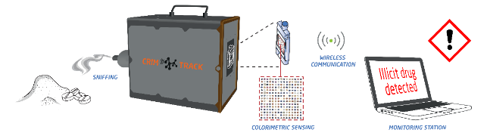
Figure 1. Schematic representation of Crim-Track sniffer device.
The aim of this PhD project is to further develop and optimise the CRIM-TRACK sniffer device to detect vapour traces of a wide range of threat substances with parts per trillion (ppt) sensitivity, in very short times (less than 5 minutes) and in a variety of scenarios. It focuses on its colorimetric sensor system which contains selected dyes that interact with the analytes in their vapour state. This consists of a disposable chip printed with multiple spots of 27 different dyes in a randomised 15-by-15 spot pattern. On analyte exposure these dyes may change colour which is recorded using a high-resolution RGB camera and analysed using artificial intelligence.
During the first nine months of this PhD, the work focuses on the examination of the chemical interactions between the dyes and the illicit substances by using analytical techniques such as NMR spectroscopy in solution with the aim to establish a hierarchy of good to bad dyes for specific controlled drugs and explosives and their precursor chemicals. This would permit the targeted selection of the dyes for new microchips and would enhance the detection ability of the sniffer in variable scenarios. A large set of proton NMR experiments were performed, and the spectra were analysed. Any variation of the chemical shifts of mixtures of dye/illicit substance compared to those of the single components, was associated to physical interaction or chemical reaction between the components of the mixture. When molecules of benzyl methyl ketone (BMK), chemical precursor of methamphetamines, approach the aromatic rings of dye named DAB4, affect their electron density causing significant chemical shifts of the aromatic protons. This result confirms the detection results from the CRIM-TRACK sniffer where dye DAB4 changes colour when in contact with ppt of BMK vapours. The NMR results currently direct the selection of new formulations for the CRIM-TRACK microchip. Parallel to the above investigation, preliminary detection tests of BMK and methamphetamine are performed with the CRIM-TRACK sniffer in collaboration with Danish Technical University.

