Using the CORD repository

Library Service

CORD is a user-friendly system where researchers can securely deposit data (or other outputs) to comply with funder requirements and simplify managing their research outputs. CORD can be used by any Cranfield researcher (staff or student), where there is no appropriate external data store.
CORD uses the figshare platform, and acts as a catalogue of our research data and supporting outputs, as CERES does for publications. You can upload datasets, link them to your publications, and see stats on the usage of your items. Depositing data on CORD achieves compliance with EPSRC, BBSRC, and other funders who expect researchers to share their outputs as openly as possible when projects end.

1. Logging in
You will find links to CORD from the intranet (under 'Applications' in the staff view, or on the Research > Research Data Management pages in all views) and the external website. Follow a link or access CORD directly by going to https://cord.cranfield.ac.uk, then you can log in using the link at the top right:
If you're on campus, it should take you straight to the Cranfield University login page where you enter your usual network username and password. (Or it might automatically log you in, if you've signed in elsewhere recently in that browser.)
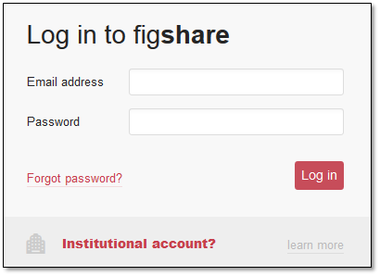
If you're not recognised as on-campus, you might see a pop-up login box asking for a username and password, as shown to the left; use the 'institutional account' link and then enter your email address to be identified as from Cranfield. You are then taken to the institutional login page, to continue as above.

2. Navigating CORD
Once logged in, the menu bar at the top will have additional options:
'Browse' and the search bar allow you to explore items uploaded to CORD. This is a subset of all content on figshare, but after searching, you can expand your results to worldwide content by ticking ‘incl content from figshare’ at the top of the results pane. Figshare is used by many institutions around the world as well as individual users with personal accounts, so this can be great for discovering potential data sets for reuse in upcoming research projects, or making connections with other researchers you may wish to collaborate with.
'Upload' starts the process of uploading a new dataset.
'My data' shows you a list of all your CORD records/uploaded files, for you to edit.
You may see a number by the bell icon, which is notifications of activity related to items, projects, or storage allocations; clicking this takes you to the 'activity' tab.
There is also a dropdown menu available by clicking your name, with the main option to use being ‘Profile' and we will look at this in the next section.

3. Setting up your profile
Once logged in, your name appears at the top right and clicking this gives you further menu options. Choose 'Edit profile' to set up or edit your profile. In your profile you should fill in as much information as you are comfortable sharing:
- ORCID: by adding your ORCID, you can then go to orcid.org and select CORD records that you would like to display in your ORCID 'CV'.
  - To finish the connection, you must log in to ORCID, scroll to the Works section, click +Add works, select Search & link, select DataCite. Here, you can choose to enable ‘auto-update’, i.e. everything you publish in CORD goes to your ORCID, or (our recommendation) use ‘Search and link’ to see a list of your CORD items and choose which ones appear in your ORCID.
- Name: your first and last names are brought through from our central system so should not need editing.
- Job title: this is not brought forward, but is important to add as it displays by your name when users search (e.g. to add you as a creator on a dataset). If there are multiple people with the same name, job title is an easy way to know which is the right one!
- Field of interest: this can be useful for others to know and there are quite a few options, although the list may be further expanded soon.
- Location: again, this displays by your name so is useful for identification, so you may like to enter "Cranfield University, UK".
- Social media: optionally, you can add links to your Facebook, Twitter, and/or LinkedIn accounts.
- Biographical information: you can write a summary of yourself/your work if desired. Note that your email address does not display publicly, so if you want to give readers a way to contact you, it can be useful to include your email here.
- Publications: you can enter a few key publications if you like, but this is not an essential field. Hopefully your recent publications may be pulled through automatically in future using your ORCID.

4. Adding an item

4.1 Create a new item
Once logged in, choose the 'My Data' or 'Upload' option in the menu bar. You then have two main ways to create a new item in CORD:
- Click the "+Create a new item" button. You will see a 'browse' link at the top of the screen, which you can use to navigate to the file(s) you want to add to the item.
- Drag and drop your data file onto this browser page. This opens the new item screen and also adds those files to the record. If you drag multiple files, you will get two options: group all files into a fileset (i.e. one descriptive record with multiple files attached) or create individual new items (i.e. each file gets its own descriptive record and DOI). You usually want the fileset option.
Whichever way you create the item, once you have the new item screen visible (see screenshot shown), you can add further files to the record by drag-and-drop or with the 'browse' link.
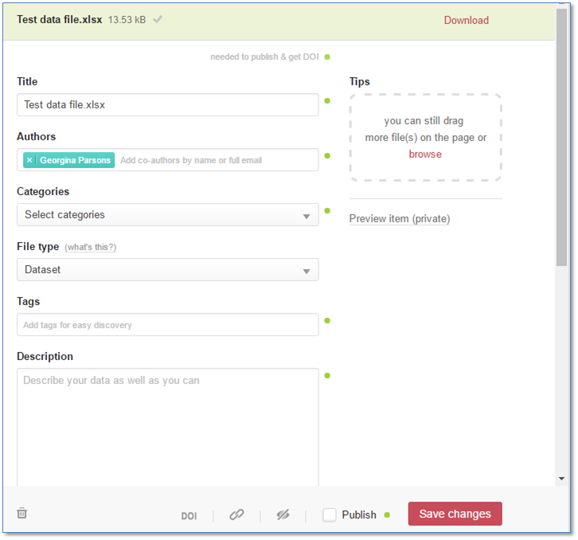
Each item can have multiple files attached but you can't upload a folder - if you need to share files within a folder structure, you'll need to zip it and upload the zip file. It is preferable, though, to provide the original unzipped files; this enables them to be previewed in the browser by users, and means we can better preserve them as we can set up automated reports, checks, or conversions of file types to manage the long-term accessibility of the files on CORD.
When a file has uploaded, a tick will display next to it. If you've uploaded the wrong file by mistake, you can hover over this tick so that it becomes a 'delete' link, and click it.

4.2 Fill in the form
As well as adding the data file(s) themselves, you need to fill in the metadata fields on screen, with a little information about the files. We've kept this form as short as possible, and when you click into any field, you'll see context-specific information in the 'tips' box on the right hand side advising how to complete that field.
- Title: make sure this describes the data. If you dragged and dropped your file, this field will contain the filename. You will probably want to remove the extension (e.g. ".xlsx") and maybe reformat or reword it.
- Authors: add any collaborators who should also get credit for this dataset; note that with data underpinning an article, these are not necessarily the same as the article authors. When you start typing a name, the system suggests figshare users with that name (not just from Cranfield, but anyone using figshare). If you want to add someone who is not on figshare, just type their name or email and hit return; they'll display in grey as they have no figshare profile page.
- Categories: browse or search for relevant categories and add one or more as required. If there are no appropriate ones, there is an "uncategorized" option. The list is currently using the Fields of Research taxonomy. Although we cannot add individual items to this list, we can add or replace this taxonomy, so if your area isn't covered but you know a taxonomy you'd like adding, let me know!
- File type: if you have uploaded multiple files, choose 'file set', otherwise choose the format that most closely fits your file. Note that although there is a 'publication' option, your publications (journal articles, conference papers, book chapters) should still go through CRIS; CORD is for any other supporting research output.
- Tags: these are keywords to help others discover your data and are free-text. When you type, the system will suggest keywords already in use, and you can click a suggestion; otherwise, hit return after each keyword to add it.
- Description: any data you upload should be understandable to others without needing to ask you questions. Sometimes this means adding extra context in the description field; in other cases the file may contain all necessary information. We also have a readme.txt template in case you want to add a text file to the record containing the context and other information (e.g. what the variable names mean, what acronyms mean, what equipment and calibration/precision settings were used, etc). Have a look at this blogpost to get a good idea of how to best name and describe your data.
- References: here you can add a URL and hit return to add more. You can link to anything you want: perhaps any related papers, project websites, or other supporting information. This is an optional field.
- Funding: please enter all bodies that have contributed to the funding of the research. As well as acknowledging their contribution, this is important so we know what compliance issues may exist, as different bodies have different expectations around data sharing. It's best if you enter the grant number; this is currently one free-text field but will be changing to improve integration with grant systems in the near future.
- Licensing: please use the default selection of CC-BY unless you or your funder require a different licence. CC-BY means anyone can use your data for any purpose but must give you credit, i.e. cite you. If you need a licence that isn't in the list, email researchdata@cranfield.ac.uk to request it.
- Authoriser: this is the email address of whoever has authorised/will authorise publication of the item. If you're a student, this should be one of your supervisors; in staff research, it is usually the PI of the project. I use this information to double check that the item can be made public; it's simply a safety net to help prevent any mistakes where there might be contractual requirements or commercialisation/publication plans that actually need data to be confidential for a time.
This is all the essential metadata, so you can now tick 'save changes' or 'publish'.

4.3 Publish your item
You've added the data file(s), you've filled in the metadata, so now you're ready to publish your item. At any point, you can click 'save changes' if you want to keep your item as a draft and come back to it later (it will appear in your 'My data' list).
When you’re ready to publish, you tick the 'publish' box, then you'll need to click the green 'publish item' button, and will then see the following message, confirming your item will be public and that you agree to the terms:
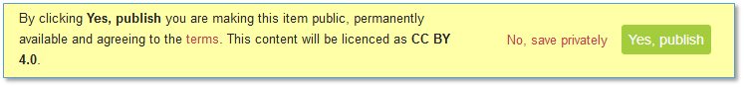
Please click through and read the terms; the main point to note is that you are confirming you have the right to share the file(s) you uploaded. If you are sharing any data that was created or collected from a source where you do not have the permission to re-share it, please do not post it to CORD. If you collected personal data, you must have anonymised the file and have consent to share it.
Once you click 'yes, publish', your item will be live… once it has been approved. Every item submitted to CORD is subject to a review, and it will only be public after the appropriate person has approved it. The review follows a straightforward checklist including: does the file open, is it as described, is it free from personal data, are there any typos, do links work, etc. The named 'authoriser' is also contacted to ensure they are happy with the item going public. You will get an email telling you when the item is published.

5. Embargoes and Restricted Access
Restricted publishing allows for the publication of files and metadata in various permutations to a variety of different audiences. Restricted publishing is an addition to CORD’s current embargo functionality, which previously allowed you to hide content, but did not give you the option to have it available for selected audiences.
The embargo area now merges the old embargo and confidential sections to introduce ‘permanent embargo’ as an option for making files not publicly available indefinitely.

All items that had confidentiality on files have been automatically migrated to permanent embargo.

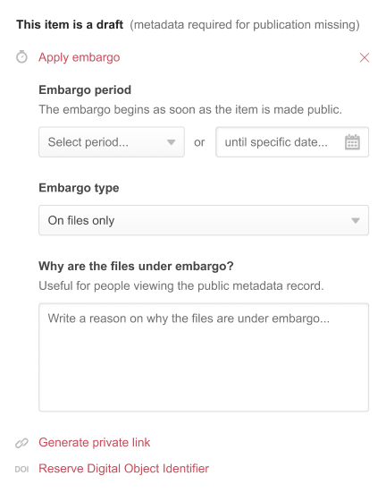

5.1 Apply embargo
When you click to apply an embargo, first you choose whether to do so on the file(s) only or on the whole record. Generally, the record should be published, and only the file(s) should be embargoed, because funders such as UKRI councils expect the record to be public online as soon as possible.
There are various situations where an embargo can be useful and you should explain why you're embargoing the data in the "reason" field. The main two are:
Embargoes for publication
E.g. entering the reason "Pending publication of results".
You have the right to fully exploit your data before sharing it and often this means delaying release of your data until papers are published. If you know your paper is being published on a particular date, you can embargo your data file(s) until that then (or make a reasonable estimate). Setting the embargo means you don't need to remember to come back and publish your data when your article is published, but if you don't know the publication date, you may prefer to use the 'reserve DOI' option.
If you are publishing multiple papers from one data file, you can embargo the data until the last paper is available; however, bear in mind funder expectations. UKRI councils expect the data directly underpinning an article to be published at the same time as the article - if you can split your data file into one item per article, this is 'more compliant'. If that's not easily possible, though, don't worry too much, as the embargo option is a sensible compromise.
Embargoes for commercialisation
E.g. entering the reason "Pending commercialisation of results".
You might also want to embargo if outputs are being commercialised, by you or an industry partner. It is possible to set an embargo period to allow for the commercialisation or patenting.

5.2 Options for restricted publishing configurations

Administrative publishing

This publishes an object so that the public item’s metadata and/or its files are available only to designated people from within the University who have a specific permission attached to their role. This allows you to restrict access to certain individuals within Cranfield only. The embargoed content, files and/or metadata, will be visible on public pages like the browse page or the portal only to the person that has the new permission, which has been assigned to a new role: Embargo Administrator.

Please note: the item owner themselves will not be able to see the public object. Objects go through the normal review processes.

Logged in users of my institution and/or logged in users of a group(s)

These two options can only be enabled together in the initial setup. They give you the option to publish the files, or files and metadata, so they are available to all logged in users or to users assigned to specific group(s). If you select a specific group, then this means that only users associated with that group will see the items on the portal where they are “published”. The group of the item does not need to be the same as the group of users selected to see the embargoed content.
This option is great for teaching materials, institutionally-purchased datasets, etc.

IP restrictions
To start, let’s look at three concepts to help understand this better:
- IP address - A single fixed address
- IP range - A band containing a variety of IP addresses. Should be provided ideally utilising CIDR notation
- IP Label - Figshare nomenclature to describe the presented option to the user when selecting IP range restrictions. An IP label can contain one or many IP ranges and/or IP addresses
When defining IP restrictions, the option available to you will be IP labels and the naming can be defined based on your request. You can have one or many IP labels.
Each label can define one range or a set of ranges. For example, over several campuses each has their own IP range. You can define them separately, to allow you the ability to restrict access only to one of the campuses, or you can group them together and each time you restrict to the “campus” label everyone from all the several campuses can see the data.
This will allow the files or the files and metadata to be hidden from audiences not specified by the selection. This use case is great for theses, external auditing, campus-specific data etc.
Combining options
You can select both logged in users and IP ranges for an item. With this configuration, users need to be either within the configured IP range(s) or logged in but do not have to be both.
With the current setup, you can combine the options under the CUSTOM option (IP range(s) and logged users) but you cannot combine the options you find under CUSTOM with the Administration option.

Options that restricted publishing will not allow
With restricted publishing, you can give access to a selected audience (based on the 3 options explained above) to the restricted content.
You cannot combine the options from Custom with the restriction to Administration. On top of that, you cannot define multiple restrictions on a single item. For example, you cannot say metadata is restricted to logged users and files can also be seen by the Embargo Administrators.

5.3 Generate private link
Once you click 'generate private link' you are given a link you can send to anyone you like, whether or not they have a CORD or figshare account. This can be used to share your record and file with an external partner so they can confirm they're happy with you publishing it.
Please be aware that the link can be forwarded and will work for anyone - if your file is confidential, you shouldn't use this method to share it with specific partners.
It is also useful to note that the view of the record is somewhat anonymised: the viewer using this link will see no Cranfield branding, no DOI, and no authors' names. This means it can be used when sharing data with publishers using double blind peer review.
You can stop the link from working at any point by editing the item (from your 'My data' screen) and selecting the cross next to the private link. This immediately deactivates the link. The link also expires, so remember it is just for private sharing while the record is still in its unpublished form, not for citing in a publication.

5.4 Reserve DOI
Clicking this link requests a DOI for your item, but remember - DOIs are for life! Once an item has a DOI, this cannot be changed, so you should not reserve a DOI for anything you don't intend to publish.
This option is most useful for data that underpins a publication. Funding bodies and publishers increasingly require that papers contain a data access statement, i.e. a sentence telling readers how they can access the underlying data. We have examples on our data statement guidance but the simplest template to use is "The underlying data can be accessed at https://doi.org/DOI" using the DOI of your dataset.
By reserving a DOI, you can insert this statement into your papers and then wait until they are published before returning to CORD to publish the data file(s). This ensures that no underlying evidence goes public before your article that presents the findings, and allows you to reserve the DOI early but finish up your CORD record at a more relaxed pace after your paper is accepted. Just don't forget to come back and hit publish before your article is released!

5.5 Metadata only
In some cases, data might be confidential and it is safer to store it off-network in a secure, approved location. However, a record on CORD, even without the data attached, can still be useful, and you can create such "metadata only" records.
One reason is that UKRI councils such as EPSRC expect a freely available online record about your data to be created within 12 months of the end of a project, so this metadata record ensures compliance with funder policy. Another reason is to ensure that Cranfield has a catalogue of the research we've done to inform any future research. If someone is checking whether proposed research is original and looks for other data created in this way, they will find what has already been carried out.
It also ensures best visibility of your outputs so others can still see your expertise. Those looking at your profile in CORD, or via Figshare in general will still see the description of this output. It might even attract future collaborators or further interest. You may also be able to share your data on request, just as with confidential data, but need to keep it in more secure storage in the meantime.
If you want to create a metadata record, it's very simple in CORD, as you just tick the 'metadata only' box after creating your new item. You need to enter a reason, which could be "Data is sensitive and stored off-site; contact [your details] and/or researchdata@cranfield.ac.uk to discuss requesting access to the data." And of course, if you are storing data elsewhere, make sure it is still stored safely and securely, backed up, and kept findable and accessible for future years!

6. Summary
These options, along with the ability to save drafts and return to them, provide lots of flexibility in data publication and hopefully ensure CORD is useful to you in the majority of situations. Whilst funders increasingly mandate data sharing, they do not recommend it where it would damage the research process, so access restrictions are often crucial to ensure that data is released in an appropriate manner.

Contacting us
For further advice on any other aspect of research data management – please contact our Research Data Manager.
Greg Simpson
t: +44 (0)1234 75 4548
e: researchdata@cranfield.ac.uk
You can view this guide online and find more RDM information on the intranet: https://library.cranfield.ac.uk/knl/research-data-management

