Whither regulation, risk and water safety plans? Case studies from Malaysia and from England and Wales
Hasan Hafizah^{1,2}, Alison Parker¹ and Simon J T Pollard^{1*}

¹Cranfield University, Cranfield Water Science Institute, School of Water, Energy and Environment, College Road, Cranfield, Bedfordshire, MK43 0AL, United Kingdom.
²Ministry of Health Malaysia, Engineering Services Division, Federal Government Administrative Centre, 62590 Putrajaya, Malaysia.

*Corresponding author: s.pollard@cranfield.ac.uk; Tel: +44 (0) 1234 754101

Abstract
We explore the interplay between preventative risk management and regulatory style for the implementation of water safety plans in Malaysia and in England and Wales, two jurisdictions with distinct philosophies of approach. Semi-structured interviews were conducted with 32 water safety professionls in Malaysia, 23 in England and Wales, supported by 6 Focus Group Discussions (n=53 participants). A grounded theory approach produced insights on the transition from drinking water quality surveillance to preventative risk management. Themes familiar to this type of regulatory transition emerged, including concerns about compliance policy; overseeing the risk management controls of regulatees with varied competencies and funds available to drive change; and the portfolio of interventions suited to a more facilitative regulatory style. Because the potential harm from waterborne illness is high where pathogen exposures occur, the transition to risk-informed regulation demands mature organisational cultures among water utilities and regulators, and a laser-like focus on ensuring risk management controls are delivered within water supply systems.
Graphical abstract
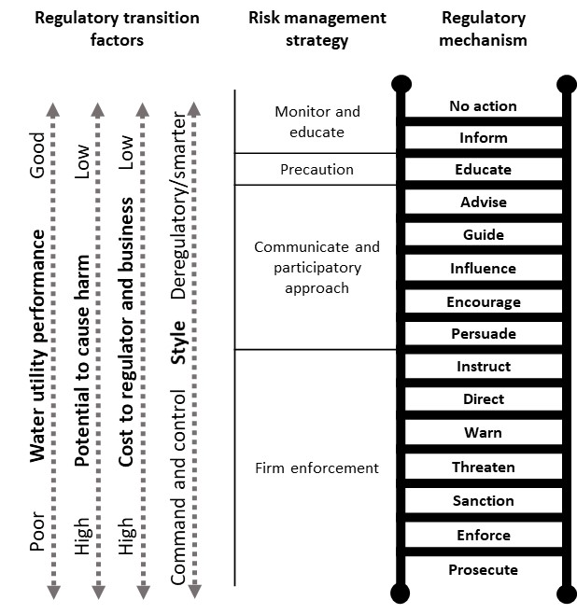
The regulatory ladder of interventions, risk management strategies and issues for transition between compliance-led and risk-based regulation (adapted from Leinster, 2001)

Keywords Drinking water safety, regulation, risk, Malaysia, England, Wales, case studies

1. Introduction
The United Nations (UN, 2018) reports a rapid rise in the number of people living in urban areas, from 751 million globally in 1950 to 4.2 billion in 2018. By 2050, 68% of the world’s population is expected to live in urban settings. Whilst cities have developed, urban services have not always kept pace, especially with respect to the supply of safe drinking water (Bakker, 2010). One estimate suggests 2.1 billion people lack safely managed drinking water, including 600 million urban inhabitants (WHO and UNICEF, 2017). The UN Sustainable Development Goals (SDGs) seek to deliver clean water and sanitation (SDG 6) and are aligned to the water safety plan (WSP) framework introduced in 2004, codified through the systematic assessment and preventative management of risks at points of critical control (CCPs) between catchments and the consumer (WHO, 2004; IWA, 2004; UN, 2015).
Worldwide, we are witnessing a significant shift from drinking water quality surveillance as a vital sentinel for drinking water quality, to the additional inclusion of proactive, preventative risk management through the adoption of WSPs (WHO, 1976; 2017). Ninety-three countries have implemented WSPs with 76 having scaled-up initial pilot studies to urban and rural settings (WHO and IWA, 2017). The WHO and IWA (2017) report that 46 countries have incorporated WSPs into policy or regulatory instruments, with 23 other countries having formal tools under development (Fig. 1).

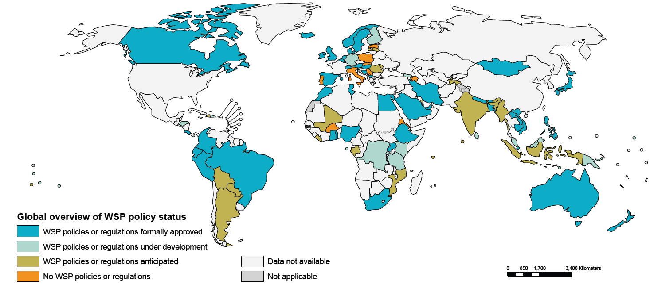
Fig. 1: WSP policy and regulatory status (WHO and IWA, 2017; reproduced under Licence: CC BY-NC-SA 3.0 IGO).

There are existing studies exploring the relationship between WSPs and their enacting policies, regulations and guidance (Viljoen, 2010; Vieira, 2011; Reid et al., 2014; Sinclair et al., 2015; Baum et al., 2016; Gunnarsdottir et al., 2016; Peletz et al., 2016; Zarkin, 2016; Lomboy et al., 2017; Sutherland and Payden, 2017; Bereskie et al., 2018; Roeger and Tavares, 2018; Tsitsifli and Tsoukalas, 2019; Roeger and Tavares, 2020). Mixed results are reported but even with national legislation in place, periodic contamination events and outbreaks of waterborne disease continue to occur, reminding us that safe drinking water is never guaranteed through policy and regulation alone (Fewtrell and Bartram, 2001; Hrudey and Hrudey, 2004; Hrudey and Hrudey, 2019). In their comprehensive review, Roeger and Tavaras (2018) highlight the essential components of political commitment, technical knowledge, good governance and stakeholder collaboration for successful WSP implementation.
The authors have a research interest in the practical implementation of WSPs and the organisational changes required to secure traction for these initiatives within water utilities and among their stakeholders (Jalba et al., 2010; Summerill et al., 2010a; Summerill,et al., 2010b; Summerill, et al., 2011; Summerill et al., 2012; Jalba et al., 2014; Omar et al., 2017). Our studies support others’ findings and address issues beyond WSP design, focussing on conditions that support effective implementation such as capacity building and training (Gottwalt et al., 2018; Ferrero et al., 2019); promotion and adoption of WSPs (Baum and Bartram, 2018; Gunnarsdottir et al., 2020; Jaravani et al., 2019); costs analysis (Chang et al., 2013); human dimension of WSPs (Kot et al., 2014; Parker and Summerill, 2013; Ferrero et al., 2018); inequality (Yang et al., 2013); the effectiveness of WSPs (Mudaliar, 2013; Gelting et al., 2012; Kumpel et al., 2018; Tsoukalas and Tsitsifli, 2018; Schmidt et al., 2019); organisational design and institutional frameworks (Rahman et al., 2011; Kayaga et al., 2018).
Here, we examine the interplay between preventative risk management and regulatory style for water safety planning, given the shift introduced above. This relationship is of research interest because of the modifications in accountability for risk management associated with the shift, the organisational competencies required to assess and manage system improvements and the changes to the portfolio of regulatory instruments (Graphical abstract) required for continued public health protection. Monitoring a compliance point for drinking water quality parameters is a significantly different task from completing a forensic risk analysis for a supply system with the subsequent maintenance of controls at critical control points (CCPs) by a risk-mature utility supported by intelligent regulatory oversight. We were interested in exploring the antecedents of the regulatory shift above, as illuminated by practices in two case study jurisdictions and the views of informed water utility staff, regulatory staff and professional advisors at the heart of water safety planning.

2. Materials and methods
We devised an approach that (i) examined the interactions of different regulatory tools and strategies; (ii) explored the behaviours, attitudes and cultures of various actors adopting WSPs; (iii) investigated the responsiveness of regulatory systems to change; allowing us to (iv) assemble a model to demonstrate the relationships between risk, regulation and water safety for the shift described above.
2.1 Case study-grounded theory
A case study grounded theory approach was deployed with the manual coding of data (Yin, 2014; Corbin and Strauss, 2015; Fig. 2). Case study research allows the exploration of real-life phenomena. Not without its critics (Gomm et al., 2009), Yin (2014) contends it can lead to theory building that is applicable worldwide. Similarly, grounded theory investigates the real world, uncovering concepts grounded in qualitative data and applying them to theories of change. A combination of methods was used (Stake, 1998; Yin, 1984) for two cases: (i) Malaysia; and (ii) England and Wales. Case study selection was based on the different regulatory systems in each jurisdiction: England and Wales, with its independent, risk-based regulatory model for mandatory WSP implementation; and Malaysia with a compliance-dominated but transitionary system in place, with commitments to further reform (Brown et al., 2006). These two jurisdictions, each at a different stage of their evolution with respect to water safety planning, allowed a potential exposé of issues related to regulatory style and organisational maturity. Extensive data was secured through semi-structured interviews, focus group discussions (FGDs) and document reviews as the principal survey instruments. Table 1 summarises the units of analysis deployed, the relationship between the levels of investigation and the baseline data of relevance to the study (Halaweh et al., 2008).
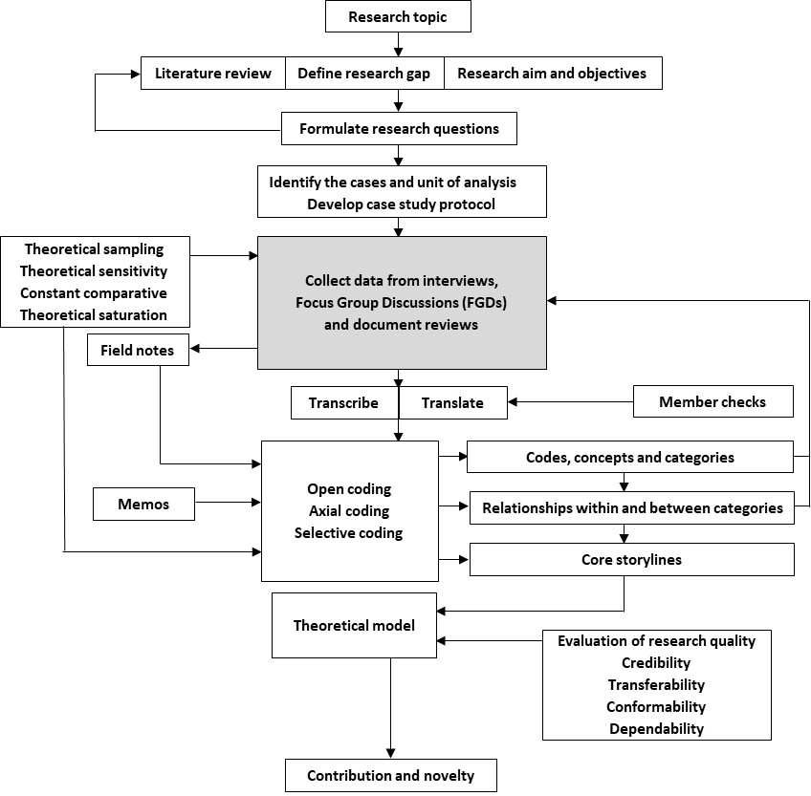
Fig. 2. Schema of the case study grounded theory approach used (after Halaweh et al., 2008).
Table 1. Unit of analysis developed for this research
Level of investigation | Unit of analysis
Country | Malaysia | England and Wales
Sector | Urban public water supplies  - Government  - Private | Urban public water supplies  - Private
Individual | Regulators  - Federal  - State  Water operators  - Senior management  - Executives  - WSP champions  Professional advisors / Independent professionals | Regulators  Water and sewerage operators  Water operators  Professional advisors / Independent professionals

2.2 Case study protocol
Case study protocols, procedures and rules guided the principal researcher (HH) during the interviews. These were formalised within (i) a letter of introduction; (ii) an information sheet; (iii) a consent form; (iv) an interview guide; and (v) a contact list. The interview and FGD guides included leading questions, follow-ups, probes and they targeted regulators, water operators and professional advisors possessing a deep understanding of WSP adoption. All methods were approved by Cranfield University’s ethics committee and pilot interviews tested the feasibility of the interview guide. Participants were reminded that participation was voluntary, with a right to withdraw at any time without penalty. Anonymity was secured using abbreviated code names (Table 2). For example, participant “FRM1” referred to “a male federal regulator number 1”; while PWOF3, “a female private water operator number 3”.

Table 2. Code names for interviews and FGDs
Malaysia
Abbreviation | Full Form | Example
TM | Trial/Mock-up Male | TM1: Trial/Mock-up Male No. 1
TF | Trial/Mock-up Female | TF1: Trial/Mock-up Female No. 1
SRF | State Regulator Female | SRF1: State Regulator Female No. 1
FRM | Federal Regulator Male | FRM1: Federal Regulator Male No. 1
FRF | Federal Regulator Female | FRF1: Federal Regulator Female No. 1
IPM | Professional Advisor /  Independent Professional Male | IPM1: Professional Advisor /  Independent Professional Male No. 1
IPF | Professional Advisor /  Independent Professional Female | IPF1: Professional Advisor /  Independent Professional Female No. 1
GWOF1 | Government Water Operator Female | GWOF1: Government Water Operate Female No. 1
PWOM1 | Private Water Operator Male | PWOM1: Private Water Operator Male No. 1
PWOF1 | Private Water Operator Female | PWOF1: Private Water Operator Female No. 1
S1 | State or Federal Territory X | S1: State or Federal Territory No. 1
Water Utility 1 | Water Utility X | Water Utility 1: Water Utility No. 1
England and Wales
Abbreviation | Full Form | Example
TM | Trial/Mock-up Male | TM1: Trial/Mock-up Male No. 1
RM | Regulator Male | RM1: Regulator Male No. 1
RF | Regulator Female | RF1: Regulator Female No. 1  RF3a & RF3b: Regulator Female No. 3 Session a &  Regulator Female No. 3 Session b
IM | Professional Advisor / Independent Professional Male | IM1: Professional Advisor /  Independent Professional Male No. 1
WOM1 | Water Operator Male | WOM1: Water Operator Male No. 1
WOF1 | Water Operator Female | WOF1: Water Operator Female No. 1
WSU1 | Water and Sewerage Utility | WSU1: Water and Sewerage Utility No. 1
WU1 | Water Utility | WU: Water Utility No. 1

2.3 Theoretical sampling
The number of interviews required in a grounded theory study cannot be firmly established during the study design and is referred to as ‘theoretical’ in the first instance. In practice, code saturation can be achieved at 9 interviews when the researcher has reportedly ‘heard it all’, though meaningful saturation is typically accomplished between 16 and 24 interviews when the researcher ‘understands it all’ (Charmaz, 2014; Aldiabat and Le Navenec, 2018). Initially, participants were sampled through snowballing (Sbaraini et al., 2011). Comprehensive, semi-structured interviews were conducted with 32 participants for the Malaysian case (Table 3). In addition, 6 sequential FGDs (n=53 participants, in total) were held to acquire the desired depth of information (Table 4). For England and Wales, 20 comprehensive, semi-structured interviews were conducted with 23 participants (Table 5). All sessions were recorded and transcribed verbatim. Malaysian transcripts were translated into English because conversations were conducted bilingually.

Table 3. Malaysian interview participants
32 interviews  - 2 trial/mock-up interviews  - 30 interviews | 32 participants  - 2 trial/mock-up participants  - 4 professional advisors / independent professionals  - 14 federal regulators  - 2 state regulators  - 2 government water operators  - 8 private water operators

Table 4. Summary of Malaysian FGD participants
6 FGDs  - FGD 1 (n=11)  - FGD 2 (n=10)  - FGD 3 (n=7)  - FGD 4 (n=5)  - FGD 5 (n=16)  - FGD 6 (n=4) | 53 participants  - 2 professional advisors / independent professionals  - 12 federal regulators  - 13 state regulators  - 2 government water operators  - 24 private water operators

Table 5. A summary of the England and Wales interview participants
20 interviews  - 1 trial/mock-up interview  - 2 group interviews  - 17 interviews | 23 participants  - 1 trial/mock-up participant  - 5 professional advisors / independent professionals  - 7 regulators  - 9 private water and sewerage operators  - 1 private water operator

2.4 Document review
Documents can strengthen or contravene the rigour of findings secured through methodological triangulation (Leech and Onwuegbuzie, 2007). Documents were selected using Caulley’s rules (1983); the most relevant being those close to the events described, including statutory instruments (copies of laws, regulations, guidelines and legal interpretations), programme documents (annual reports, policy documents and newsletters) and primary documents on the constitutional affairs of WSP programmes, such as the minutes of meetings, organisational structures and memos.
2.5. Coding data, constant comparison and writing memos
Coding fragments interview data into smaller conceptual components (Bernard et. al, 2017; Table 6) from which ideas, themes and storylines can be generated (Fig. 2). Open, axial and selective coding can be applied to grounded theory. HH started with a small mass of text and codes, line by line. Useful concepts were identified. The process was repeated, through “open coding” (Corbin and Strauss, 2015). “Axial coding” (Corbin and Strauss 2015) then involved a selection of central codes connecting categories to subcategories. “Selective coding” refined the final categories and related them to one another (excerpt in Table 6). To support coding and maintain methodological rigour, memos captured analytic thoughts, especially for significant or unexpected codes, for comparison in upcoming interviews. A set of supplementary data illustrates the approach for readers from one transcript alone, for which there were 694 open codes, 59 axial codes; and 10 selective codes.

Table 6. Excerpt of coding for the RF3b transcript (Supplementary data for detail)
Raw data from interview | Open coding | Axial coding | Selective coding
“Because our regulations, don’t forget, are written in a way that we have a catch-all standard as well. So, as well as having the parameters for PCV in these schedules, we have a regulation that says there shouldn’t be anything in the water at any concentration that might cause a risk to health. So, that catches everything and we consider that sufficiency is also a risk to health because if you don’t have water coming out of your tap, you have no drinking water which is a risk to health. So, anything that affects pressure supply…any of those things are included in our risk assessments.” PCV, prescribed concentration or values. | - A catch-all standard  - Risk-based regulation  - A catch-all standard  - Comprehensive risk assessment | - Regulatory instruments (standards for drinking water quality)  - Regulatory instruments (risk-based regulation)  - Regulatory instruments (standards for drinking water quality)  - Comprehensiveness | - Regulatory instruments  - Regulatory instruments  - Regulatory instruments  - The comprehensiveness of the risk assessment
“Yeah, they go from catchment to tap, yeah, so.” | - From catchment to tap | - Comprehensiveness | - The comprehensiveness of the risk assessment
“So, they will have their own specific risk assessments, but again it will be generic for the area. So, all hospitals and all schools will be risk assessing roughly the same way, unless they have other information that tells them otherwise, which they can do because they will go and inspect and take samples from public buildings, hospitals, not just hospitals, and schools.” | - Specific risk assessments that is generic for the area | - Risk assessment for buildings | - The comprehensiveness of the risk assessment

3. Results and discussion
We discuss the key themes from this study: (a) the journey in regulatory style from compliance- to risk-based regulation; (b) compliance policy; (c) regulating the risk management activities of utilities; (d) cooperation between regulators; (e) the role of various instruments within the ‘regulatory ladder’ for water safety planning; and (f) practical issues that influenced (a) to (e) above; sections 3.1 to 3.6 below. These themes, which included the portfolio of regulatory instruments, the comprehensiveness of risk assessments and how they are overseen by regulators (Table 6), are familiar to debates on the transition to risk-based regulation (Black, 2005; Black and Baldwin, 2012; Collins et al., 2012; Leinster and Pollard, 2019; Hughes, 2020; Venitsianov et al., 2020). They reflect a cautiousness in the move from ‘command and control’ to risk-informed regulation and the associated issues of institutional competence, organisational cultures and the perceived transfer of power from regulator to regulatee. The governance arrangements and regulatory instruments that contextualise the findings for Malaysia and England and Wales are presented in Figs. 3, 4a,b and 5a,b. A glossary is provided as an endnote.

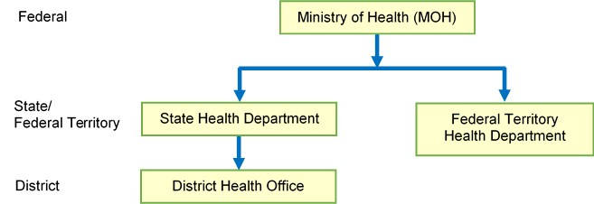
Fig. 3. Drinking water quality surveillance arrangements for Malaysia delivered through a three-tiered administrative hierarchy
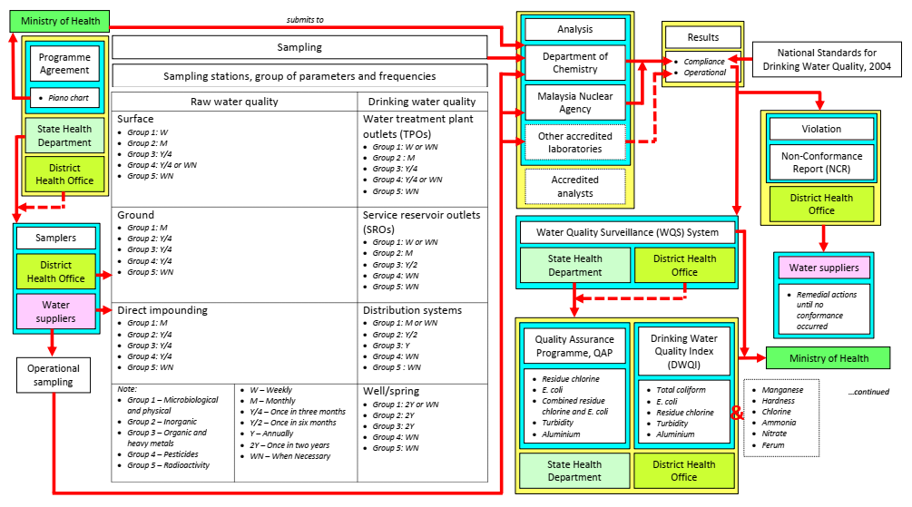
(a)
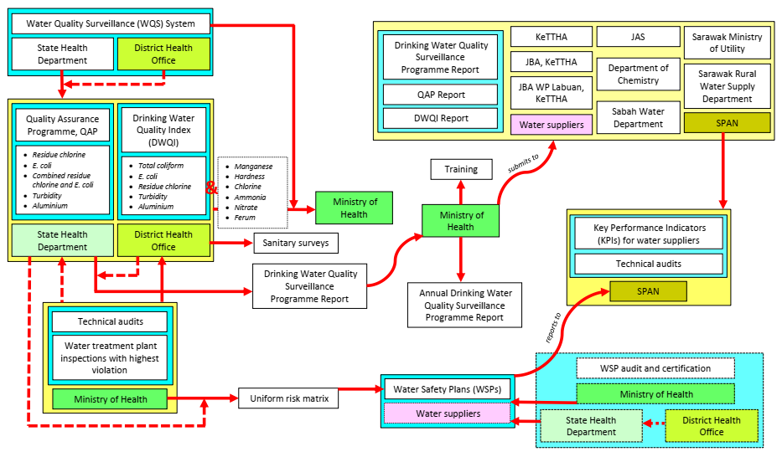
(b)
Fig. 4(a,b). Compliance-based instruments and associated strategies for water services in Malaysia (see Glossary for abbreviations)

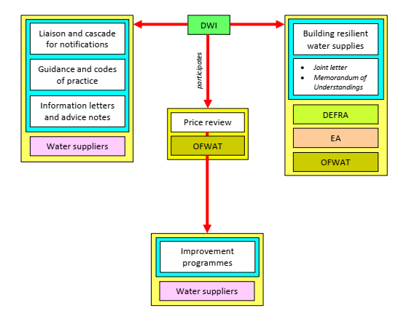
(a)
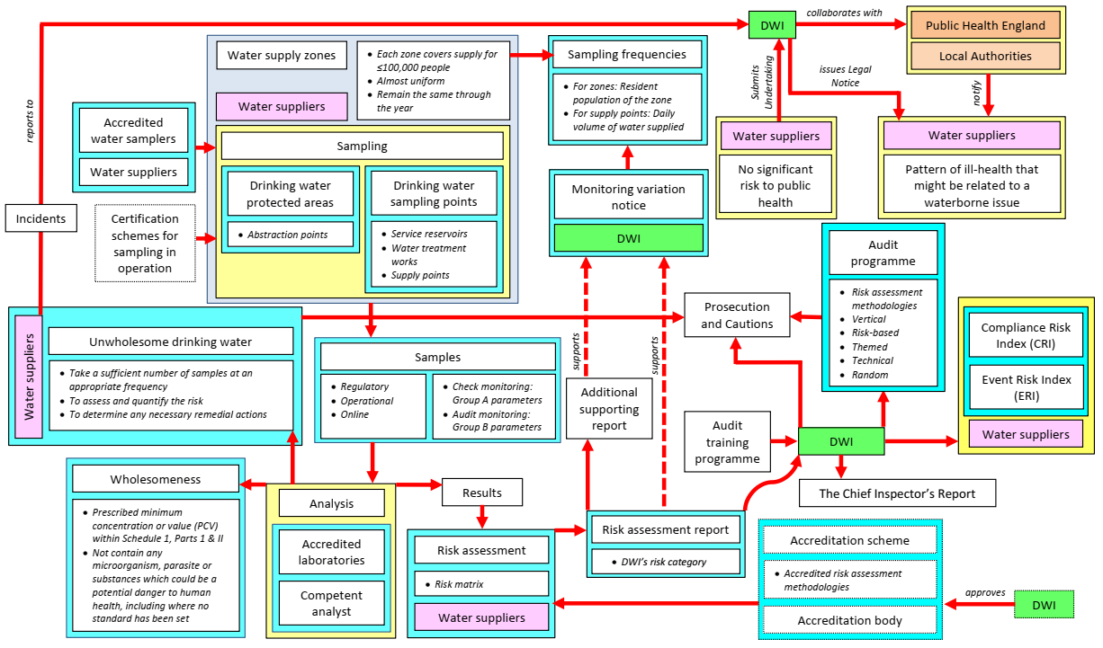
(b)

Fig. 5(a,b). Risk-based instruments and strategies within the context of water services in England and Wales (see Glossary for abbreviations)

3.1 The journey from compliance- to risk-based regulation
Drinking water quality surveillance has historically been compliance-based by reference to accepted drinking water guidelines, with sanitary surveys and enforcement actions in place to correct supply system failures (Horton, 1898; Pillay et al., 1994). These tenets of water quality control (WHO, 1976) remain essential sentinels of public health protection. They are now (WHO, 2017) augmented with the expectation of a preventative, risk- and systems-based interventions from catchment to tap to protect public health. When potential harms are high, a transition to the middle and upper rungs of the regulatory ladder (Graphical abstract) can be hotly debated (Gunningham and Sinclair. 1999; Collins et al., 2012; Hughes, 2020; Venitsianov et al., 2020) and might be anticipated here, given the potential disease burden associated with the supply of poor quality of drinking water. Transition is smoothest among mature, high-performing utilities that understand their supply and organisational systems well and can identify CCPs and specify measures to mitigate risk to acceptable levels; that is potential harms are understood and preventative measures are in place to prevent their realisation. Practical competency in the controls that maintain potable drinking water quality is essential for functional operations (Hrudey et al., 2006; Jayaratne, 2008; WHO and IWA, 2018).
In Malaysia, compliance with drinking water quality is enacted through a three-tiered hierarchy (Fig. 3) and regulated by the Ministry of Health (MOH), requiring compliance from water suppliers through a system of rules and laws: “[…] we want the water quality to comply with the standards,” one private supplier, PWOF2, expressed. The MOH, as the most competent health agency in the country, regulates drinking water quality surveillance outside the national context-specific regulations, relying on directives from the WHO. A Malaysian state regulator, FRM2, proclaimed, “We have monitoring, sampling, analysis, all the sanitary surveys…all that”. A Federal regulator, FRF9, quoted “[…] since then I think all are accepted the drinking water quality standards which we were produced although it is administrative, right? [chuckles] So, people accept it”. There is a limit on MOH’s powers however, FRF9, “[…] definitely we are not so clear what will be happened in the future, with the Act [Drinking Water Quality Act] in place? Except, perhaps from the compliance when there is a violation, we have the basis that we can refer to for any action, right?” In terms of skill sets, the majority of personnel on the ground are samplers and compliance staff (Fig. 4a), FRF9, “Our officers at the State level have a variety of experience. Well experienced and new ones,” but, “The Health Inspectors, they tend to turn over”. These are skilled personnel with their competences reinforced by task repetition. A State regulator, SRM4, offered a mixed view on the range of interventions available to the regulator, suggesting a rather uniform approach, “I believe enforcement is the last step we do. We are ready for the last. But, the [interim] approaches...steps...we are not ready,” inferring a limit to expertise on risk-based approaches.
Enforcement in Malaysia has become an essential means for the regulator to exercise authority over the water sector, rather than as a last resort on a ladder of regulatory mechanisms (Graphical abstract), notwithstanding reforms signalling a more facilitative regulatory style. Command and control regulation, though costly, is viewed as culturally more straightforward to discharge. One danger is that transition towards risk-based regulation, with operators supplying risk assessments to the regulator for review, is seen as conceding regulatory power. Resistance to a more mature approach, or perhaps a lack of regulatory confidence or resources, might find expression in the ‘tick box’ inspection of documentary requirements, such as risk assessments, rather than a forensic analysis of risk management controls at CCPs.
England and Wales have achieved a successful journey to risk-based regulation through a collaborative approach with the water sector. The Drinking Water Inspectorate (DWI) is an independent water quality regulator for England and Wales, part of the ministerial Department of Environment, Food and Rural Affairs (Defra; Fig. 5a). Since 2007, water utilities have progressed towards a mandatory risk-based approach to water safety planning (Fig. 5b,c). Reform has been smooth and “[…] progress has been very good because there is a regulatory requirement” as one independent professional, IM5 said, adding “before Water Safety Plans became required by the regulator, the water companies were looking at Water Safety Plans”. IM5 had led a project for UK Water Industry Research (UKWIR, a water industry research body) before 2004, producing manuals to support the implementation of the risk-based approach in advance of changes to regulation. As IM5 concluded, the regulator is the primary driver, but “there was recognition in parts of the industry,” […] “WSU7 [a specific water utility] was very good on their treatment works, and the way that they did that. WU1 [another utility], as they became, had a very good system for their distribution systems. WSU8 was very, very good on their catchment protection. So they all learned from each other”. Regulator RF1 acknowledged this success “Well the DWI, they’re not a very big organisation, but they’re quite powerful in terms of the water companies and what’s required of them. It’s a legislative requirement; water companies have to do them. So, they don’t have to write a water safety plan; they have to use a water safety planning approach, which is more around the risk assessment. So what they will require is risk assessments. They will require the water companies to make sure that they are managing the risks from source to tap. So, I think it’s pretty well established, but I think that it’s enshrined in legislation. So, I don’t think that there’s a huge risk of them not doing it. And I think, the impression I get is that it’s a useful tool that the water companies have found beneficial…but it was a case of not making it into a document that sits on a shelf that nobody uses. Making it into a tool that is actually dynamic, and that is actually flexible to adjust according to new information and new challenges”.
The DWI has benefited from regulating a mature set of high-performing utilities that adopt risk management as part of their organisational cultures and that have used risk assessments for many years to inform their asset management plans (MacGillivray et al., 2006; WHO and IWA, 2009: Alegre and Coelho, 2012; NALAS, 2014). Building on a philosophy of risk-informed regulation, informed by pre-competitive research, the ‘roll-out’ of WSPs in England and Wales has been smooth and broadly welcomed.
3.2. Compliance policy
Compliance is how regulators assess whether regulatees meet their legislative obligations, or not. Notwithstanding the continued value of drinking water quality surveillance, for WSPs compliance also relates to a utility’s ability to assess their system, identify CCPs and design interventions to manage risk. Sparrow (2011), in his description of the regulatory craft, expresses the agility required of a transformation to risk-based regulation. Risk-based regulators deploy a variety of mechanisms across the regulatory ladder (Graphical abstract) to secure public health and environmental protection (Pollard et al., 2004; Rothstein et al., 2006; Sparrow, 2011).
(a) Drinking water quality indices. Besides developing audit protocols to validate the completeness, effective implementation and efficacy of WSPs (WHO and UNECE, 2019), the DWI in England and Wales also has procedures for verification monitoring to assess whether the drinking water provided by the utilities is wholesome, as evidenced by 100% compliance with the 2016 Water Supply (Water Quality) Regulations (Great Britain. The Water Supply (Water Quality) Regulations 2016). Regulator RF3b emphasised that “[…]mean zonal compliance, which is just a calculation based on compliance results […]” was “[…] a reactive way […]” employed by the DWI before their shift to proactive “[…] risk-based compliance monitoring […]” using the Compliance Risk Index (CRI; Great Britain. DWI, 2018a) and Event Risk Index (ERI; Great Britain. DWI, 2018b). CRI is structured to assign a numerical value to the risk, allocating a figure to the significance of the failing parameter, the proportion of consumers potentially affected and the efficiency of the water utilities' response; while ERI is used to generate a practical measure to quantify risk to the public when an incident occurs. On the basis of this experience, the incorporation of WSPs into law has resulted in improved compliance and informs the prioritisation and targeting of surveillance activities, with WSP outcomes used to justify investment needs (Hackett, 2019; Great Britain. DWI, 2020; Great Britain. OFWAT, 2020).
(b) “Tick box” compliance. As noted in 3.1 above, there may still be a tendency towards a “tick box” compliance of risk-based requirements (i.e. Non-Conformance Report (NCR), Quality Assurance Programme (QAP) and Drinking Water Quality Index (DWQI)), so effort is required to instil an intelligence-led approach to the oversight of risk management actions on the ground. FRF9 explained for WSP implementation in Malaysia, “[…] in the regulations we won’t dictate what we will penalise from their implementation […] Perhaps when there is a violation we would like to see, “Eh! Do they actually have a WSP? So, what have they committed in their WSP?” So based on that reason, when we have to penalise them [apply sanctions] based on the violation, we would take a look at such records”. As inferred, in Malaysia a regulatory intervention can be initiated following a violation of reporting requirements, rather than an absence of valid control measures, say at CCPs. Sparrow (2011) suggests a lack of agility can lead to regulatory failure. This appears to be recognised in part, FRM2 “the WSP is actually tying everything together,” […] “We have monitoring, sampling, analysis, all the sanitary surveys…all that. But if you put everything together actually, it is quite something like WSPs. But all those elements, the five elements [FRM2 referring to the National Drinking Water Quality Surveillance Programme of monitoring; sanitary surveys; data processing and evaluation; remedial action; and institutional examination (MOH, 2004)] were done separately, individually without relating one another. You do a sanitary survey, you do a sanitary survey. You do monitoring, you do monitoring. The result, you look at the result of the monitoring”. Regulators need to recognise WSPs as a synthesised assembly of the water supply system from catchment to tap, with risk-informed interventions to manage the likelihood of system failures at CCPs where, if failure were to occur, they would pose the most significant potential for harm.
3.3 Regulating the risk management activities of water utilities
How then should the risk management efforts of regulatees be overseen? Allan et al. (2013) recognised a regulatory model for one country does not necessarily fit another’s arrangements. The water sector has demonstrated how each country uses its regulatory model for the provision of water services (OECD, 2015).
(a) Risk-based regulatory frameworks. In England and Wales, the Hampton Review (Great Britain. Hampton, 2005) advocated risk-based regulatory frameworks that informed amendments to the Water Supply (Water Quality) Regulations 2000 (Amendment) Regulations 2007 (Great Britain. The Water Supply (Water Quality) Regulations 2000 (Amendment) Regulations 2007). The notable changes concerning WSPs were for Regulations 27 and 28 on the conducting and reporting of risk assessments. The key instrument securing the comparability of risk management actions offered to the regulator by water utilities is a DWI evaluation of risk categories and descriptors (Table 7). This is a high-level means of standardising risk management actions, whereby each prioritised risk is compared to the DWI’s risk category (A to H) by reference to the implementation of control measures.

Table 7: DWI risk categories and descriptions used for risk assessment reporting arrangement by the water companies (after Great Britain. DWI, 2015)
Category | Description
A | Target risk mitigation achieved, verified, and maintained.
B | Additional control measures which will materially reduce risk are being validated.
C | Additional control measures which will materially reduce risk are being delivered.
D | Additional control measures are required to materially reduce risk.
E | Mitigation under investigation.
F | Partial mitigation.
G | No mitigation in place: control point downstream.
H | No mitigation in place and none required.

A water utility operator, WOM1 explained, “It's just how our regulators want to interpret our risks”. The regulator conducts an audit programme, RF3b “We are required to do that by the regulation because any of all of our activities have to be carried out by a risk-based approach”. Water utilities provide the regulator with “a general risk-based database, which takes lots of different bits of information and data, and gives us a risk ranking of all of the assets of each company. […] and we pick the top ones of that list,” which means, “the most risky ones” (RF3b). The audit programme adopts a series of techniques and can “can branch [off] from a water quality event” (FR3b). RF3b categorised audits as “technical audits and they’re driven by a number of different things,” whereby the regulator will “go and proactively do a technical audit on those particular sites, or on that particular subject because it might be something to do with, like, emergency planning”. In parallel, the regulator conducts “themed audits, which take place and themes come from […] where we find there’s a common weakness,” which they “find something more than a couple of times,” and “actually touch on all companies – most companies”. For example, the regulator has started themed audits on disinfection processes and chemicals, which the regulator disseminates the findings from, so the sector takes note and makes improvements. A vertical audit is another technique “where we follow a sampler from the point when, you know, they go out to take the samples, and then, follow the sample through to the laboratory until it gets put on a public record” (RF3b). Since samplers are audited by UKAS (the national accreditation body assessing organisations that provide certification, testing, inspection and calibration services), this type of vertical audit is less of the regulators core business, as said by RF3b, “We don’t do that as much as we use to because of UKAS’s programme, […] I think pretty much covers that. So we do a bit of it, but that’s not one of our core”. Thus, for a country transitioning from compliance- to risk-based regulation, a vertical audit is useful to confirm the competency of samplers, especially if they are outsourced and require accreditation.
(b) Risk matrices. Turning to the assessment of supply system risks, DWI works with a variety of risk matrices from each utility, RF3b, “Whatever gives them visibility of where their risks are and where they need to concentrate their effort. Then, that is fine by us, as long as we get the end outcome, you know, in submissions that they give to us. How they break up their risk assessments is up to them. So, I mean that’s why we never prescribed a particular risk assessment methodology,” this being a UK philosophy to regulatory risk assessment. Risk matrices are not without their critics (Levine, 2012) and differences exist between countries that prescribe a template matrix and those that allow flexibility.
In England and Wales, the regulator provides the freedom to water suppliers to deploy their risk matrices. A senior utility operator, WOM3 confirmed, “So it’s up to you how you do that, and DWI let you do that”. To accommodate the DWI risk categories (Table 7), another operator, WOM5 summarised their risks on three separate semi-quantitative risk matrices for public health, compliance and serviceability, “[…] the reason being is that serviceability, in a very simplistic sense is [an assessment of whether] the asset available to run or not? All right. So, we risk assessed that. Compliance is not just compliance with Drinking Water Regulations, whether it’s compliance with DWI, compliance with any form of regulation that has a compliance value, and there are numerous – hundreds out there, and therefore, we develop three matrices, which sit in the same application, and they sit alongside each other. So, you have this extra level of detail, such that you can have a public health risk, which is not a compliance risk. Not very often, but it – and then you can relate it to serviceability”. IM3 added, “There must be a challenge session of these assessments,” because otherwise they “can be misunderstood and can be out of the context of what I mean is, I won’t say accurate, but it may not reflect the true risk, may have not reflected true risk of that particular item. So, that’s a concern about – there’s a risk to that risk assessment”.
The consequence (or severity) and likelihood (or frequency) must be clearly defined in these matrices, as indicated for the Malaysian risk matrix (Fig. 6a,b). IM3 explained by providing an excellent example in juggling between the consequence, likelihood and a conscientious judgment, “If you are near like Labuan [in Malaysia], the treatment plant is very close to the airport. So, what’s the chance of a plane crashing into the treatment plant and affecting it? It will be catastrophic, right? So, what’s the chance of it crashing to your treatment plant? Oh, once in a lifetime! There’s no risk; frequency is very low. One in ten years? No!!! To me, the probability is very high! Because you are close. You are in the flight path. So, there’s a very high risk there! You cannot say it may happen once in a lifetime, then it is low, no! To me it is very high”.
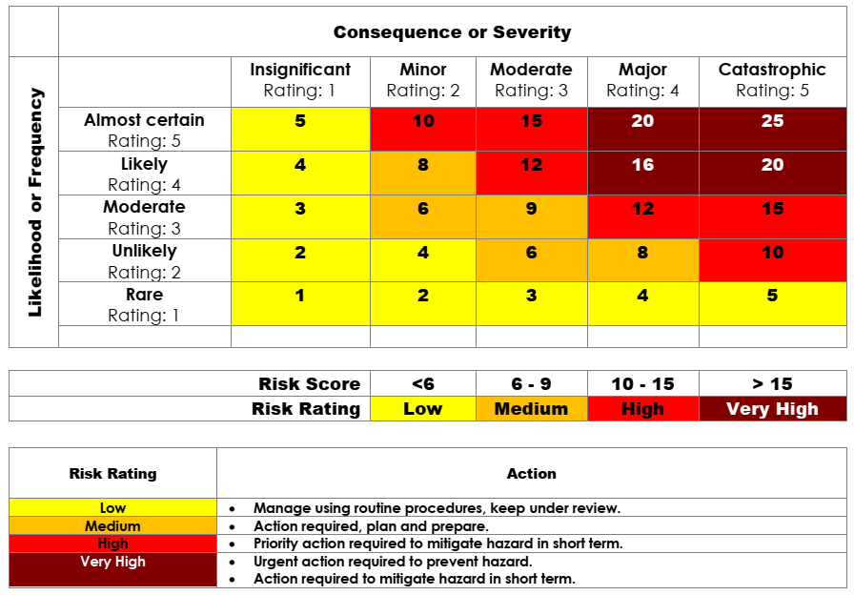
Fig. 6a. Malaysian uniform semi-quantitative risk matrix and the risk rating (Malaysia. MOH, 2012)

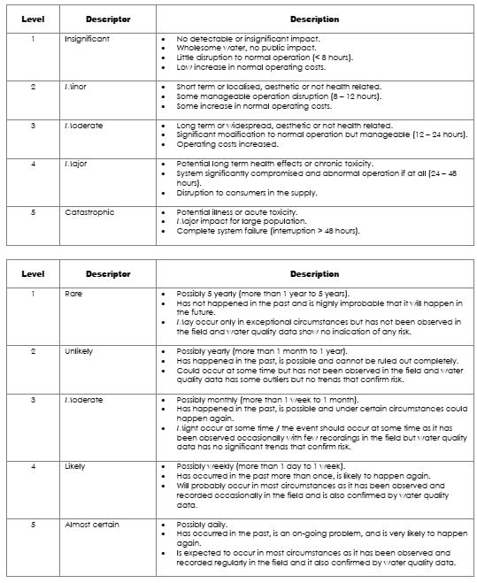
Fig. 6b. Malaysian uniform semi-quantitative risk matrix – the description of consequence or severity as well as the likelihood or frequency (Malaysia. MOH, 2012)

3.4 Cooperation between regulators
The regulatory landscape within the water sector in England and Wales is somewhat complex. The DWI (drinking water quality) is joined by OFWAT (financial, customer value) and the Environment Agency (EA; environmental quality) who also have significant loci on the activities of water utilities (Great Britain. Defra, 2018; Great Britain. OFWAT, 2019; Great Britain. EA, 2020). Defra (Great Britain. Defra, 2012) sets out a ‘Statement of Obligations’, the Government’s understanding of the major environmental statutory obligations applied to water utilities over a five-year price review period. A joint letter from Defra, OFWAT, DWI and the EA sets out the future ambition of building resilient water supplies (Great Britain. Defra, 2018) and the co-ordinated leadership across the Government and its regulatory bodies to support this aim (Great Britain. DWI, 2018c). RF3a, a DWI regulator, described the mutual support on the “outputs of all the risk assessments and the inputs to the business planning process”. For the water industry “they saw the process of risk assessment for water quality as a useful way of actually stacking up their water quality risks against all the other risks that they have to manage as a business, […] because all of those have to be put into their business plans for OFWAT to get approved, so they can get their funding”. The Business Plan is a vehicle for utilities to evidence their financial requests for risk management concerning drinking water quality and environmental improvement. The DWI is involved directly in the financial review led by OFWAT (Great Britain. DWI, 2020). A similar understanding exists with the EA, RF1 explaining, “[…] we’re just going into an Asset Management Plan. Ummm…new period where water companies want to bid for money so that they go to our water regulator, OFWAT, and put their Business Plan forward to say what they want to spend money on in the coming, sort of…2019 to 2024. […] So we provide all the guidance from the EA on the catchment work that we would be supportive of, to protect water quality for drinking waters. And DWI, they provide guidance on what they would expect from water companies, to ensure compliance with either legal instrument that they’ve got in place”. RF3a emphasised that “[…] it’s very well embedded and we are now in a process whereby we are in a risk management zone, you know, we are now about improving all of the risk management processes that we have in place, rather than being in a stage where we’re doing initial risk assessment and finding out where the gaps of information and data are. We’re sort of in that stage where we’re in the proper cycle”.
The cycle referred to by RF3a is a programme to improve drinking water quality established by the DWI (Great Britain. DWI, 2013) that captures 1) enforcement for violations of drinking water standards; 2) enforcement for issues arising out of DWI’s investigations of drinking water quality incidents or through regulatory audits; and 3) identification of critical health risks through a risk assessment of a water supply system. DWI retains powers to ensure these actions are implemented (Great Britain. DWI, 2013). In terms of the role of WSPs in the Business Plans, WOM1 who represented a WSP team in his utility explained, “[…] for starters, having an active safety plan that is always being reviewed and manipulated – “manipulated” is a bad word – but you know our change, we've always got a resource of data and interpretation of the data. So, we've got easy access to information if another part of the business requires it. So, we can inform the Business Plan a bit more effectively, but it's more to do with strategy. The strategy team are more into developing that because they need it to fit in with the company's strategy. They will define how much money we have and how we are going to spend it, and where it needs to be spent. Then it’s our asset integration. We’re the ones that prioritise that and make sure that’s channelled in the correct way”.
3.5. Regulatory instruments and the regulatory ladder
The insights from this study are summarised in Fig. 7, the ladder of interventions available to regulators, with generic examples mapped across to the WSP context. Also depicted is a mapping to accepted strategies for risk management (Pollard et al., 2004) and factors associated with the regulatory transition (Fig. 7; arrows) discussed above.
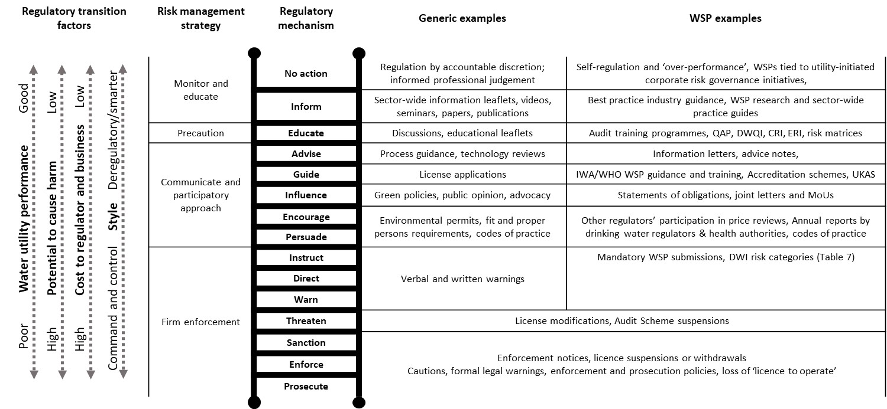
Fig. 7. The regulator ladder contextualised for WSPs

FRF9 (Malaysia) recognised the need for risk maturity and financial capacity where the risk-based approach is deemed mandatory, “So this is the same with WSP. If you want to make it mandatory, you’ve got to prepare them, so no surprise. We have to consider those poor suppliers, because we have poor and rich suppliers. So we have to balance. The poor ones, they couldn’t afford if we make it mandatory on the spot. That’s why like Water Utility 5B asked us to increase the minimum standard. We said, “We can’t. You are rich, you are able to do it. What about State 1 and State 9? They are so poor that even the minimum standard they cannot comply? So we have to be balanced. We have to strike the balance, so what is the comfortable level everybody can comply”.
3.6 Practical issues for water safety plans
WHO (2017) emphasises the need for a comprehensive preventive risk management framework for public health protection from catchment to the consumer; one that includes policy formulation and standard-setting, risk-based approaches and surveillance.
(a) Stakeholder issues. A sophisticated and mature set of arrangements is inferred that can address both point and diffuse sources of pollution in catchments. The management of diffuse pollution in supply catchments is a good indicator of organisational maturity because it requires high degrees of behavioural change and multiagency engagement. Engagement with catchment stakeholders takes place in many forms, including on voluntary initiatives for pesticide controls, for example, as IM3 commented, “[A] sort of national initiative to work with farmers and with the manufacturers of pesticides”. These initiatives involve substantive capacity-building, often taking years; WOF4 “[…] speaking to them and trying to get an understanding of risks in the catchments that they’re seeing, and thinking about how I can apply that to the water safety plan. Some of this stuff doesn’t need to be reported to the DWI, they don’t require that, but for us, I think it’s useful to know and to have that contact, and to maintain that level of knowledge”. From the regulator’s viewpoint, RF3b explained it is necessary for water utilities to “actually defines the catchment […] and that actually tell us, you know, what the catchment is represented by. And then, in that catchment, they identify who are the stakeholders that they need to be involved with […] either the holders of information, or the groups that have an impact on source water quality in that catchment area.” Hence, in this case, RF3b concluded, “the water company is responsible for identifying who those people are and getting the information that they need from those groups and those people in order to form their risk assessment”.
(b) Customer awareness. WOF2 declared “the safety plan responsibility is up to the kitchen tap actually,” […] “the first draw-off point, so that’s where our sampling takes place, and some of that will be risk-based.” WOF2 pointed out that “It’s probably one of the areas for development in safety planning that – where looking after customers in their homes – quite a lot of risks get introduced by plumbing that we can’t control and whatnot.” As a result, “Education in water quality is one of our – it’s on our sort of radar’s growth areas for drinking water safety plan thinking really, which we, as an industry, don’t really do a lot of – because we advise people a lot on efficiency, but we haven’t really done so on quality.” As stated by regulator RF3b, “For the customer side, so, beyond the boundary of the – ummm, property and the tap, it is possible to do some site-specific, or zone-specific risk assessments.” However, it is “very difficult because for the most part, water quality zones are made up of varying types of property”, adding “it would be very rare to find a water quality zone where all the properties suffer from the same problems”. As a result, “you tend to have a generic risk assessment for a water quality zone, which will cover all eventualities. And then, what water companies will do is they will obviously alter the likelihood of certain issues depending on what their compliance and operational monitoring tell them about that zone”. She admits that compared to the catchment area, “There aren’t really that many other stakeholders in the customer’s side, although from a communication point of view, there are certainly stakeholders because depending on the water quality issues that might be faced in a zone”. However, proactive communication is one of many means to engage with the targeted groups, RF3b, “with, say, local health authorities, or with certain vulnerable groups, such as pregnant mothers […] because if you do have a zone, which is say, more prone to lead issues because there might be very old housing stock”. RF3b concluded, “You will find that the risk assessments are more generic. They’re not just for a household, they’ll be for more likely a water quality zone”.
(c) Organisational maturity. Organisational maturity among water utilities and their regulators emerges as a critical requirement to support the shift to risk-based regulation. Capacity-building and training is essential to build competency and confidence. WSPs in Malaysia have been in place since 2010 for rural water supplies and since 2011 for urban public water utilities, starting with demonstration projects (MOH, 2012). FRM2, one of the senior federal regulators commented openly, “Only last five years when we come in, when we recognise the importance of WSPs, we started by attending the international training in Singapore, for example. And then, with more assistance initially from WHO, we have training in Ipoh way back in 2010. And from there on we gained more experience, and I think by now, we should be able to go on our own”. FRF9 believed implementation is not yet comprehensive from source to tap, “This is my personal opinion. I think it seems okay when we asked the water companies to do it; they do it. But, in terms of full implementation, I don’t think – we don’t achieve that yet. We are not there yet. Because, how we want to see, we claimed this company had implemented WSPs? If they didn’t have anything to show that they did it,” and as she adds that progress is just moderate: “They are progressing, progressing. But to say it is speeding, I don’t think so”.
(d) Comprehensive coverage. Coverage is also an issue. In Malaysia, not all systems are equipped with WSPs (FRM2), “In Malaysia, more than 450 treatment water systems in Malaysia. And, we suppose to equip all those numbers of the treatment plant or system with WSP. We start from almost zero last three years. But I think now we are achieving a number of about 50, 60 or 70…numbers. So I think it is very good progress, but of course, we have to look into the quality of the plan. […] So in general, it is improving, expanding, getting better and then there are more efforts in the pipeline to ensure that this achievement will be attained within the shortest timeframe hopefully, I hope within the next five years, the whole country, all treatment plants will have the WSP. WSP will be part and parcel of the water business in the country”.
(e) Affordability. Since the majority of the water suppliers in Malaysia are State-owned, it is also appropriate to consider the States’ relative access to funds to drive change. States such as State 3, State 4, State 5 and State 8 are considered affluent, while State 1 and State 9 are regarded as poorer in comparison (Box 1). Compared to slow track and significant scrutiny utilities, fast track water utilities in more prosperous States are fairly ahead in implementing WSPs.
“[…] there are States which already done it, for example State 5. And State 4 too, they do it just by themselves. That were for the demonstration projects earlier, but after that, they continue doing it. Then they do it again, they continue to add, add, add [interruption by third party] continue back, that the states. Like State 4, of course they were parts of the demonstration projects, they took their own initiative to expand them. We don’t in fact, saying, “Okay, after this it is not a demonstration project anymore.” Like I feel, those states which continue, it is voluntary. Their own effort. Like State 4, right? Most of their plants now are started to implement. They have started documenting their WSPs.” - FRF9

“[…] the State 8 case – is actually because State 8 they have been implemented – the earliest, one of the earliest many years ago, so they can see the benefits and they have made decisions based on WSP document.” - FRM2

“For the demonstration projects, there are a few which continue. But, there are states like in State 1, they definitely not working, it is not working. We try to help. Just focus on them. […] But, like in State 1, they said they can’t. They don’t have the capacity to do it. Okay, now they are in a transition period from Water Supply Authority to State 1 Water Company. Maybe after this we can try to approach them again since before this, there were few similar states, they said they didn’t have a capability to do it.” - FRF9

“That is with Water Utility 9. Water Utility 9, previously they were not into it. But, now it seems like they have tried to implement for each district. But, the progress is a bit slow. They have new management too, right…for Water Utility 9?” - FRF9

Box 1. Interview citations on the WSP progress in different states based on affluence

Box 1. Discourse of the ability to pay for WSP implementation among Malaysian utilities

FRF6, referring to asset ownership, “Like State 3 and State 4, although they already migrated to licence, but […] some of their treatment plants, are not handed over to WAHCO since the treatment plants are free from debt. That’s why we have to issue them facility licence since they own the asset”. Contrarily for poorer States like State 9, FRF6 noted the capability of the water supplier to pay for operational expenditure, “Water Utility 9, they even don’t have money to pay for the staff salary. The State needs to inject recently for 50 millions or something. They even have no sufficient fund to pay for salary”.

4. Conclusions
We have considered the interplay between risk management and regulatory styles for WSPs in Malaysia and in England and Wales, as the philosophy of regulation shifts from a compliance-led to a risk-informed approach. The analysis has revealed the tensions that accompany this transition and expose the antecedents of a successful shift. To an extent, the analysis reasserts generalised observations elsewhere on which we have commented (Leisnter and Pollard. 2019) but here for the water safety plan context. Nevertheless, there are important points for water safety regulation that is in transition. The transition is easier for risk-mature utilities and regulators that have confidence in the identification (water utilities) and oversight (regulators) of system controls that mitigate risk at CCPs in their WSPs. This transition is not a binary switch from drinking water quality surveillance to ‘arm’s length’ risk-based regulation. A ladder of regulatory mechanisms is available and the upper rungs of it help grow competency and confidence among utilities through best practice, audit, guidance and training (Fig. 7).
Regulatory failure, the absence of control over intended regulatory outcomes, can occur if naïve compliance policies are applied to risk assessments and WSPs submitted for regulatory review. The actual test of preventative risk management, indeed resilience, is proactive utility vigilance over risk and the maintenance of active control at CCPs by water utilities.
The journey to preventative risk management requires that drinking water utilities act proactively to manage risks in the absence of operational water quality failures. There is a shift in accountability from the regulator to the operator best supported by a facilitative regulatory style, defined by Holley and Gunningham (2006) as embodying regulatory flexibility, the empowerment of local communities and devolved, collaborative decision-making. This said, because of the potential harm from exposures, the backstop of firm enforcement and its associated penalties remain essential.
Malaysia’s WSP regulation is in transition. A series of practical issues will determine the pace of future change, including engagement with stakeholders, customer awareness, the speed and extent of ‘roll-out’, organisational maturity among utilities and regulators and affordability.

Acknowledgements
HH was supported by the Ministry of Health Malaysia’s Federal Training Award; SJTP by an EPSRC consortium award (EP/K012347/1), the International Centre for Infrastructure Futures. The authors thank the Director-General of Health Malaysia for permission to publish; the DWI for their prior review; multiple participants and organisations that took part; and the PhD panel support of Prof. Peter Jarvis and Prof. Ian Jennions (Cranfield). The opinions expressed herein are the authors’ alone with no conflicts of interest. The underlying materials can be accessed via the Cranfield University repository at .

Glossary
CCP Critical Control Point
CRI Compliance Risk Index
Defra Department for Environment Food and Rural Affairs
DWI Drinking Water Inspectorate
DWQI Drinking Water Quality Index
EA Environment Agency
ERI Event Risk Index
FGD Focus Group Discussion
IWA International Water Association
JAS Jabatan Alam Sekitar or Department of Environment
JBA, KeTTHA Jabatan Bekalan Air or Water Supply Department under KeTTHA
JBA WP Labuan Labuan Federal Territory Water Supply Department
KeTTHA Kementerian Tenaga, Teknologi Hijau dan Air or the Ministry of Energy, Green Technology and Water, with the water component transfers to the restructured Ministry of Water, Land and Natural Resources (Kementerian Air, Tanah dan Sumber Asli) during the Seventh Prime Minister Cabinet in 2018 and the rest of the components to the Ministry of Energy, Science, Technology, Environment and Climate Change (MESTECC, or Kementerian Tenaga, Sains, Teknologi, Alam Sekitar dan Perubahan Iklim) and subsequently to the Ministry of Science, Technology and Innovation (MOSTI, or Kementerian Sains, Teknologi dan Inovasi) in 2020 under the Eighth Prime Minister Cabinet
MOH Ministry of Health
NCR Non-Conformance Report
OFWAT Water Services Regulation Authority
QAP Quality Assurance Programme
SDGs Sustainable Development Goals
SPAN Suruhanjaya Perkhidmatan Air Negara or National Water Services
Commission
UKAS UK’s National Accreditation body
UN United Nations
UNICEF The United Nations Children's Fund
WAHCO Water Asset Holding Company
WHO World Health Organisation
WQS Water Quality Surveillance System
WSPs Water Safety Plans

Supplementary data for this paper is available at Elsevier web address to follow

5. References
Aldiabat, K. M. and Le Navenec, C. (2018) “Data Saturation: The Mysterious Step in Grounded Theory Method”, The Qualitative Report, 23(1), pp. 245-261. Available at: https://nsuworks.nova.edu/tqr/vol23/iss1/18/ (Accessed: 16 March 2018).
Allan, R., Jeffrey, P, Clarke, M. and Pollard, S. (2013) “The impact of regulation, ownership and business culture on managing corporate risk within the water industry”, Water Policy, 15(3), pp. 458-478, DOI: 10.2166/wp.2013.175. Available at: https://dspace.lib.cranfield.ac.uk/bitstream/handle/1826/8610/Impact_of_Regulation_Ownership_and_Business_Culture-2013.pdf?sequence=1 (Accessed: 3 December 2016).
Alegre, H. and Coelho, S. T. (2012) “Infrastructure Asset Management of Urban Water Systems”, in Ostfeld, A. (ed.), Water Supply System Analysis – Selected Topics. Croatia: InTech.
Bakker, K. (2010) Privatizing water: Governance failure and the world’s urban water crisis. London: Cornell University Press.
Baum, R., Bartram, J. and Hrudey, S. (2016) “The Flint Water Crisis Confirms That U.S. Drinking Water Needs Improved Risk Management”, Environmental Science and Technology, 50, pp. 5436-5437, DOI: 10.1021/acs.est.6b02238. Available at: https://pubs.acs.org/doi/pdf/10.1021/acs.est.6b02238 (Accessed: 15 March 2018).
Baum, R. and Bartram, J. (2018) “A systematic literature review of the enabling environment elements to improve implementation of water safety plans in high-income countries”, Journal of Water and Health, 16(1), pp. 14-24, DOI: 10.2166/wh.2017.175. Available at: https://pubmed.ncbi.nlm.nih.gov/29424714/ (Accessed: 1 December 2016).
Black, J. (2005) “The Emergence of Risk-Based Regulation and the New Public Risks Management in the United Kingdom”, Public Law, pp. 512-549. Available at: http://eprints.lse.ac.uk/15809/ (Accessed: 5 December 2016).
Black, J. and Baldwin, R. (2012) “When risk-based regulation aims low: a strategic framework”, Regulation and Governance, 6(2), pp. 131-148, DOI: 10.1111/j.1748-5991.2011.01124.x. Available at: http://eprints.lse.ac.uk/44427/1/When_Risk-Based_Regulation_Aims_Low.pdf (Accessed: 21 November 2016).
Bereskie, T., Delpla, I., Rodriguez, M. J. and Sadiq, R. (2018) “Drinking-water management in Canadian provinces and territories: a review and comparison of management approaches for ensuring safe drinking water”, Water Policy, 20, pp. 565-595, DOI: 10.2166/wp.2018.040. Available at: https://iwaponline.com/wp/article/20/3/565/38700/Drinking-water-management-in-Canadian-provinces (Accessed: 8 October 2018).
Bernard, H. R., Wutich, A. and Ryan, G. W. (2017) Analyzing qualitative data: systematic approaches, 2nd ed. Thousand Oaks, California: Sage Publications.
Brown, A. C., Stern, J., Tenenbaum, B. and Gencer, D. (2006) Handbook for Evaluating Infrastructure Regulatory Systems. Washington, D.C.: The World Bank. Available at: https://openknowledge.worldbank.org/handle/10986/7030 (Accessed: 13 May 2016).
Caulley, D. N. (1983) “Document Analysis in Program Evaluation”, Evaluation and Program Planning, 6(1), pp. 19-29. Available at: http://www.sciencedirect.com/science/article/pii/0149-7189(83)90041-1 (Accessed: 29 August 2018).
Chang, Z. K., Chong, M. L. and Bartram, J. (2013) “Analysis of Water Safety Plan costs from case studies in the Western Pacific Region”, Water Science and Technology: Water Supply, 13(5), pp. 1358-1366, DOI: 10.2166/ws.2013.146. Available at: https://iwaponline.com/ws/article/13/5/1358/27292/Analysis-of-Water-Safety-Plan-costs-from-case (Accessed: 1 November 2013).
Charmaz, K. (2014) Constructing grounded theory, 2nd ed. Thousand Oaks, California: Sage Publications.
Collins, A., Ohandja, D-G., Hoare, D. and Voulvoulis, N. (2012) “Implementing the Water Framework Directive: a transition from established monitoring networks in England and Wales”, Environmental Science and Policy, 17, pp. 49-61, DOI: 10.1016/j.envsci.2011.11.003. Available at: https://www.sciencedirect.com/science/article/abs/pii/S1462901111001742 (Accessed: 28 July 2020).
Corbin, J. and Strauss, A. (2015) Basics of qualitative research: techniques and procedures for developing grounded theory, 4th ed. Los Angeles: Sage Publications.
Eisenhardt, K. M. (1989) “Building Theories from Case Study Research”, The Academy of Management Review, 14(4), pp. 532-550. Available at: http://links.jstor.org/sici?sici=0363-7425%28198910%2914%3A4%3C532%3ABTFCSR%3E2.0.CO%3B2-R (Accessed: 19 September 2017).
Ferrero, G., Bichai, F. and Rusca, M. (2018) “Experiential Learning through Role-Playing: Enhancing Stakeholder Collaboration in Water Safety Plans”, Water, 10(227), pp. 1-11, DOI: 10.3390/w10020227. Available at: https://www.mdpi.com/2073-4441/10/2/227 (Accessed: 9 August 2018).
Ferrero, G., Setty, K., Rickert, B., George, S., Rinehold, A., DeFrance, J. and Bartram, J. (2019) “Capacity building and training approaches for water safety plans: A comprehensive literature”, International Journal of Hygiene and Environmental Health, 222(4), pp. 615-627, DOI: 10.1016/j.ijheh.2019.01.011. Available at: https://www.sciencedirect.com/science/article/pii/S1438463918308927 (Accessed: 28 February 2019).
Fewtrell, L. and Bartram, J. (2001) “Water Quality: Guidelines, Standards and Health: Assessment of risk and risk management for water-related infectious disease”, London: International Water Association. Available at: https://apps.who.int/iris/bitstream/handle/10665/42442/924154533X.pdf?sequence=1&isAllowed=y (Accessed: 13 September 2019).
Gelting, R. J., Delea, K. and Medlin, E. (2012) “A conceptual framework to evaluate the outcomes and impacts of water safety plans”, Journal of Water, Sanitation and Hygiene for Development, 2(2), pp. 103-111, DOI: 10.2166/washdev.2012.078. Available at: https://iwaponline.com/washdev/article/2/2/103/30013/A-conceptual-framework-to-evaluate-the-outcomes (Accessed: 3 September 2013).
Great Britain. Hampton, P. (2005) Reducing administrative burdens: effective inspection and enforcement. London: HM Treasury. Available at: http://news.bbc.co.uk/nol/shared/bsp/hi/pdfs/bud05hampton_150305_640.pdf (Accessed: 19 October 2016).
Great Britain. The Water Supply (Water Quality) Regulations 2000 (Amendment) Regulations 2007 (2007) London: Her Majesty’s Stationery Office. Available at: http://www.legislation.gov.uk/uksi/2007/2734/contents/made (Accessed: 22 January 2019).
Great Britain. DWI (2013) Improvement programmes. Available at: http://www.dwi.gov.uk/stakeholders/improvement-programmes/index.htm (Accessed: 28 January 2016).
Great Britain. DWI (2015) Information Letter 01/2015: Regulation 28 reporting requirements. Available at: http://www.dwi.gov.uk/stakeholders/information-letters/2015/01-2015.pdf (Accessed: 20 June 2016).
Great Britain. The Water Supply (Water Quality) Regulations 2016 (2016) London: Her Majesty’s Stationery Office. Available at: https://www.legislation.gov.uk/uksi/2016/614/contents/made (Accessed: 28 July 2020).
Great Britain. Defra (2012) Statement of Obligations: Information for Water and Sewerage Undertakers and regulators on Statutory Environmental and Drinking Water Provisions Applicable to the Water Sector in England. Available at: https://www.gov.uk/government/publications/statement-of-obligations (Accessed: 22 January 2019).
Great Britain. Defra (2018) Building resilient water suppliers – a joint letter. Available at: http://www.dwi.gov.uk/stakeholders/price-review-process/Building-resilient-water-supplies-letter.pdf (Accessed: 28 January 2019).
Great Britain. DWI (2018a) DWI Compliance Risk Index (CRI). Available at: http://www.dwi.gov.uk/stakeholders/price-review-process/CRI_Def.pdf (Accessed: 12 April 2018).
Great Britain. DWI (2018b) DWI Event Risk Index (ERI). Available at: http://www.dwi.gov.uk/stakeholders/price-review-process/ERI_def.pdf (Accessed: 12 April 2018).
Great Britain. DWI (2018c) Memorandum of Understanding between United Kingdom Drinking Water Regulators and the Environment Protection Agency. Available at: http://dwqr.scot/media/37469/mou-uk-and-ireland-2018-revision-final.pdf (Accessed: 16 April 2018).
Great Britain. DWI (2020) Price review process. Available at: http://www.dwi.gov.uk/stakeholders/price-review-process/index.htm (Accessed: 28 July 2020).
Great Britain. OFWAT (2019) Price reviews. Available at: https://www.ofwat.gov.uk/regulated-companies/price-review/ (Accessed: 28 January 2019).
Great Britain. EA (2020) Environment Agency. Available at: https://www.gov.uk/government/organisations/environment-agency (Accessed: 28 July 2020).
Great Britain. OFWAT (2020) 2019 price review: Final determinations. Available at: https://www.ofwat.gov.uk/regulated-companies/price-review/2019-price-review/final-determinations/ (Accessed: 28 July 2020).
Gomm, R., Hammersley, M. and Foster, P. (2009) “Case Study and Generalization”, in Gomm, R., Hammersley, M. and Foster, P. (eds.), Case Study Method. London: Sage Publications, pp. 98-115, DOI: 10.4135/9780857024367.
Gottwalt, J. Riepl, D., Abecker, A., Brauer, F., Fischer, T. and Sturm, S. (2018) “Prototype of a Web-based Software Application Supporting the Water Safety Plan (WSP) Concept”, in Bungartz, H-J., Kranzlmüller, V. W. and Weismüller, V. W. (eds.) Advances and New Trends in Environmental Informatics: Managing Disruption, Big Data and Open Science. Switzerland: Springer, pp. 241-260, DOI: 10.1007/978-3-319-99654-7.
Gunnarsdottir, M. J., Gardarsson, S. M., Jonsson, G, S. and Bartram, J. (2016) “Chemical quality and regulatory compliance of drinking water in Iceland”, International Journal of Hygiene and Environmental Health, 219, pp. 724-733, DOI: 10.1016/j.ijheh.2016.09.011, https://www.sciencedirect.com/science/article/abs/pii/S1438463916301754 (Accessed: 21 September 2017).
Gunnarsdottir, M. J., Gardarsson, S. M., Figueras, M. J., Puigdomènech, C., Juárez, R., Saucedo, G., Arnedo, M. J., Santos, R., Monteiro, S., Avery, L., Pagaling, E., Allan, R., Abel, C., Eglitis, J., Hambsch, B., Hügler, M., Rajkovic, A., Smigic, N., Udovicki, B., Arbrechtsen, H-J., López-Avilés, A. and Hunter, P. (2020) “Water safety plan enhancements with improved drinking water quality detection techniques”, Science of the Total Environment, 698, pp. 1-11, DOI: 10.1016/j.scitotenv.2019.134185. Available at: https://www.sciencedirect.com/science/article/pii/S0048969719341622 (Accessed: 1 January 2020).
Gunningham, N. and Sinclair, D. (1999) “Regulatory Pluralism: Designing Policy Mixes for Environmental Protection,” Law and Policy, 21(1), pp. 49-76. Available at: http://www.greeneconomics.net/Gun-RegulPlural.pdf (Accessed: 1 December 2016).
Hackett, R. (2019) “DWI reports CRI and ERI rises for 2018”, WWT, 17 July 2019. Available at: https://wwtonline.co.uk/news/dwi-reports-cri-and-eri-rises-for-2018 (Accessed: 18 August 2019).
Halaweh, M., Fidler, C. and McRobb, S. (2008) “Integrating the Grounded Theory Method and Case Study Research Methodology Within IS Research: A Possible “Road Map”, International Conference on Information Systems (ICIS). Paris, France, 14 – 17 December 2008. ICIS 2008 Proceedings. Available at: https://aisel.aisnet.org/icis2008/165/ (Accessed: 19 September 2017).
Holley, C. and Gunningham, N. (2006) “Environment Improvement Plans: Facilitative regulation in practice”, Environmental and Planning Law, 23, pp. 448-464. Available at: https://www.researchgate.net/profile/Neil_Gunningham2/publication/228203454_Environment_Improvement_Plans_Facilitative_Regulation_in_Practice/links/5afb8bd0a6fdccacab192331/Environment-Improvement-Plans-Facilitative-Regulation-in-Practice.pdf (Accessed: 15 July 2020).
Horton, R. (1898), “The Chemical Examination of Water”, Proceedings of the Institute of Sanitary Engineers, pp. 24-35.
Hrudey, S. E and Hrudey, E. J. (2004) Safe Drinking Water: Lessons from Recent Outbreaks in Affluent Nations. London: IWA Publishing.
Hrudey, S. E., Hrudey, E. J. and Pollard, S. J. T. (2006) “Risk management for ensuring safe drinking water”, Environment International, 32, pp. 948-957, DOI: 10.1016/j.envint.2006.06.004. Available at: https://pubmed.ncbi.nlm.nih.gov/16839605/ (Accessed: 10 December 2019).
Hrudey, S. E. and Hrudey, E. J. (2019) “Common themes contributing to recent drinking water disease outbreaks in affluent nations”, Water Supply, 19(6), pp. 1767-1777, DOI: 10.2166/ws/2019.051. Available at: https://iwaponline.com/ws/article/19/6/1767/66605/Common-themes-contributing-to-recent-drinking (Accessed: 11 December 2019).
Hughes, S. (2020) “Flint, Michigan, and the Politics of Safe Drinking Water in the United States”, Cambridge University Press, pp. 1-14, DOI: 10.1017/5153759272000136X. Available at: https://www.cambridge.org/core/services/aop-cambridge-core/content/view/C050EC460617454E732622783A2A524E/S153759272000136Xa.pdf/flint_michigan_and_the_politics_of_safe_drinking_water_in_the_united_states.pdf (Accessed: 28 July 2020).
IWA (2004) The Bonn Charter for Safe Drinking Water. London: IWA. Available at: https://www.who.int/wsportal/bonn/en/ (Accessed: 24 November 2015).
Jalba, D. I., Cromar, N. J., Pollard, S. J. T., Charrois, J. W., Bradshaw, R. and Hrudey, S. E. (2010) “Safe drinking water: Critical components of effective inter-agency relationships”, Environmental International, 36, pp. 51-59, DOI: 10.1016/j.envint.2009.09.007. Available at: https://europepmc.org/article/med/19854512 (19 November 2015).
Jalba, D. I., Cromar, N. J., Pollard, S. J. T., Charrois, J. W., Bradshaw, R. and Hrudey, S. E. (2014) “Effective drinking water collaborations are not accidental: interagency relationships in the international water utility sector”, Science of the Total Environment, 470-471, pp. 934-944, DOI: 10.1016/j.scitotenv.2013.10.046. Available at: https://www.sciencedirect.com/science/article/pii/S004896971301190X (Accessed: 19 November 2015).
Jaravani, F. G., Durrheim, D. N., Judd, J., Oelgemöller, M, Butler, M. and Massey, P. D. (2019) “Improving drinking water safety in recreational parks through policy changes and regulatory support in the Hunter New England region, NSW, Australia,” Australasian Journal of Environmental Management, 26(4), pp. 1-21, DOI: 10.1080/14486563.2019.1671238. Available at: https://www.tandfonline.com/doi/abs/10.1080/14486563.2019.1671238 (Accessed: 21 November 2019).
Jayaratne, A. (2008) “Application of a risk management system to improve drinking water safety”, Journal of Water and Health, 6(4), pp. 547-557, DOI: 10.2166/wh.2008.061. Available at: https://pubmed.ncbi.nlm.nih.gov/18401120/ (Accessed: 3 September 2013).
Kayaga, S. M., Kingdom, W. and Jalakam, A. (2018) “Organisational design for improved performance of urban water utilities in developing countries”, Utilities Policy, 50, pp. 49-59, DOI: 10.1016/j.jup.2017.10.001. Available at “https://www.sciencedirect.com/science/article/abs/pii/S0957178716300182 (Accessed: 15 July 2019).
Kot, M., Castleden, H. and Gagnon, G. A. (2014) “The human dimension of water safety plans: a critical review of literature and information gaps,” Environmental Reviews, 23(1), pp. 24-29, DOI: 10.1139/er-2014-0030. Available at: https://www.researchgate.net/publication/270638861_The_human_dimension_of_water_safety_plans_A_critical_review_of_literature_and_information_gaps (Accessed: 18 August 2015).
Kumpel, E., Delaire, C., Peletz, R., Kisiangani, J., Rinehold, A., De France, J., Sutherland, D. and Khush, R. (2018) “Measuring the Impacts of Water Safety Plans in the Asia-Pacific Region”, International Journal of Environmental Research and Public Health, 15(1223), pp. 1-18, DOI: 10.3390/ijerph15061223. Available at: https://pubmed.ncbi.nlm.nih.gov/29890783/ (Accessed: 15 July 2019).
Leech, N. L. and Onwuegbuzie, A. J. (2007) “An Array of Qualitative Data Analysis Tools: A Call for Data Analysis Triangulation”, School Psychology Quarterly, 22(4), pp. 557-584, DOI: 10.1037/1045-3830.22.4.557. Available at: https://www.semanticscholar.org/paper/An-array-of-qualitative-data-analysis-tools%3A-A-call-Leech-Onwuegbuzie/d35d781a0686a9cbffa05664f946c8f6ac57c50f (Accessed: 18 September 2018).
Leinster, P. (2001) “Towards a risk-based approach to environmental regulation in the UK”, National Society of Clean Air Annual Conference: Smarter Regulation: New Developments in Environmental Regulation of Industry. London, 27 June 2001. National Society for Clean Air and Environmental Protection.
Leinster, P and Pollard, S. (2019) Effective Environmental Regulation, the Use of Risk-based Permitting, Compliance Approaches and Associated Charging Schemes. Chapter 17. In: G. Russell and C Hodges (eds.) Regulatory delivery, Volume 10 in Civil Justice Systems, Hart Publishing, Oxford, UK, ISBN 9781509918584, pp. 285-294.
Levine, E. S. (2012) “Improving risk matrices: The advantages of logarithmically scaled axes”, Journal of Risk Research, 15(2), pp. 209-222, DOI: 10.1080/13669877.2011.634514. Available at: https://www.tandfonline.com/doi/abs/10.1080/13669877.2011.634514 (Accessed: 26 January 2019).
Lomboy, M., Riego de Dios, J., Magtibay, B., Quizon, R., Molina, V., Fadrilan-Camacho, V., See, J., Enoveso, A., Barbosa, L. and Agravante, A. (2017) “Updating national standards for drinking-water: a Philippine experience”, Journal of Water and Health, 15(2), pp. 288-295), DOI: 10.2166/wh.2016.177. Available at: https://pubmed.ncbi.nlm.nih.gov/28362309/ (Accessed: 21 September 2018).
MacGillivray, B. H., Hamilton, P. D., Strutt, J. E. and Pollard, S. J. T. (2006) “Risk analysis strategies in the water utility sector: an inventory of applications for better and more credible decision-making”, Critical Reviews in Environmental Science and Technology, 36(2), pp. 85-139, DOI: 10.1080/10643380500531171. Available at: https://dspace.lib.cranfield.ac.uk/bitstream/handle/1826/2641/Risk%20analysis%20strategies%20water%20quality%20sector%202006.pdf?sequence=1 (Accessed: 28 July 2020).
Malaysia. MOH (2004) Manual Kawalan Mutu Air Minum (KMAM) (Accessed: 25 January 2019).
Malaysia. MOH (2012) Kronologi dan Hala Tuju (Accessed: 22 October 2012).
Mudaliar, M. M. (2013) “Success or failure: demonstrating the effectiveness of a Water Safety Plan”, Water Science and Technology: Water Supply, 12(1), pp. 109-116, DOI: 10.2166/ws.2011.106. Available at: https://iwaponline.com/ws/article/12/1/109/25214/Success-or-failure-demonstrating-the-effectiveness (Access: 3 September 2013).
NALAS (2014) Report on International Asset Management Practices. GIZ/ORF. Available at: http://uom.me/en/wp-content/uploads/2015/12/Report-on-International-AM-Practices.pdf (Accessed: 28 July 2020).
OECD (2015) The Governance of Water Regulators: OECD Studies on Water. Paris: OECD Publishing, Paris. DOI: 10.1787/9789264231092-en.
Omar, Y. Y., Parker, A., Smith, J. A. and Pollard, S. J. T. (2017) “Risk management for drinking water safety in low and middle income countries – cultural influences on water safety plan (WSP) implementation in urban water utilities”, Science of the Total Environment, 576, pp. 895-906, DOI: 10.1016/j.scitotenv.2016.10.131. Available at: https://pubmed.ncbi.nlm.nih.gov/27842293/ (Accessed: 31 October 2017).
Parker, A. and Summerill, C. (2013) “Water safety plan implementation in East Africa: motivations and barriers”, Waterlines, 32(2), pp. 113-124, DOI: 10.3361/1756-3488.2013.013. Available at: https://dspace.lib.cranfield.ac.uk/handle/1826/8636 (Accessed: 3 September 2013).
Peletz, R., Kumpel, E., Bonham, M., Rahman, Z. and Khush, R. (2016), “To What Extent is Drinking Water Tested in Sub-Saharan Africa? A Comparative Analysis of Regulated Water Quality Monitoring”, International Journal of Environmental Research and Public Health, 13(275), pp. 1-14, DOI: 10.3390/ijerph13030275. Available at: https://www.ncbi.nlm.nih.gov/pmc/articles/PMC4808938/ (Accessed: 21 September 2017).
Pillay, M. S., Selim, M. I. and Siru, D. (1994) “Drinking-water quality monitoring and surveillance”, Waterlines, 13(2), pp. 8-10.
Pollard, S. J. T., Strutt, J. E., Macgillivray, B. H., Hamilton, P. D. and Hrudey, S. E. (2004) “Risk Analysis and Management in the Water Utility Sector: A Review of Drivers, Tools and Techniques”, Trans IChemE, 82(B6), pp. 453-462, DOI: 10.1205/psep.82.6.453.53207. Available at: https://www.sciencedirect.com/science/article/abs/pii/S0957582004712021 (Accessed: 28 July 2020).
Rahman, Z., Crocker, J., Chang, K. Khush, R. and Bartram, J. (2011), “A comparative assessment of institutional frameworks for managing drinking water quality”, Journal of Water, Sanitation and Hygiene Development, 1(4), pp. 242-258, DOI: 10.2166/washdev.2011.002. Available at: https://iwaponline.com/washdev/article/1/4/242/28803/A-comparative-assessment-of-institutional (Accessed: 9 June 2017).
Reid, D. C., Abramowski, K., Beier, A., Janzen, A., Lok, D., Mack, H., Radhakrishnan, H., Rahman, M. M., Schroth, R. and Vatcher, R. (2014) “Implementation of Alberta’s drinking water safety plans”, Water Quality Research Journal of Canada, 49(1), pp. 5-9, DOI: 10.2166/wqrjc.2013.063. Available at: https://iwaponline.com/wqrj/article/49/1/5/21561/Implementation-of-Alberta-s-drinking-water-safety (Accessed: 1 December 2016).
Roeger, A. and Tavares, A. F. (2018) “Water safety plans by utilities: A review of research on implementation”, Utilities Policy, 53, pp. 15-24, DOI: 10.1016/j.jup.2018.06.001. Available at: https://www.sciencedirect.com/science/article/abs/pii/S0957178717302576 (Accessed: 24 June 2018).
Roeger, A. and Tavares, A. F. (2020) “Do Governance Arrangements Affect the Voluntary Adoption of Water safety Plans? An Empirical Study of Water Utilities in Portugal”, Water Resources Management, 34, pp. 1757-1772, DOI: 10.1007/s11269-020-02527-2. Available at: https://www.researchgate.net/publication/339458657_Do_Governance_Arrangements_Affect_the_Voluntary_Adoption_of_Water_Safety_Plans_An_Empirical_Study_of_Water_Utilities_in_Portugal (Accessed: 21 June 2020).
Rothstein, H., Irving, P., Walden, T. and Yearsley, R. (2006) “The risks of risk-based regulation: Insights from the environmental policy domain”. Environment International, 32, pp. 1056-1065, DOI: 10.1016/j-envint.2006.06.008. Available at: https://www.researchgate.net/publication/6942588_The_risks_of_risk-based_regulation_Insights_from_the_environmental_policy_domain (Accessed: 5 December 2016).
Sbaraini, A., Carter, S. M., Evans, R. W. and Blinkhorn, A. (2011) “How to do a grounded theory study: a worked example of a study of dental practices”. BMC Medical Research Methodology, 11(128), pp. 1-10, DOI: 10.1186/1471-2288-11-128.
Schmidt, I., Rickert, B., Schmoll, O. and Rapp, T. (2019) “Implementation and evaluation of the water safety plan approach for buildings”, Journal of Water and Health, 17(6), pp. 870-883, DOI: 10.2166/wh.2019.046. Available at: https://iwaponline.com/jwh/article/17/6/870/70401/Implementation-and-evaluation-of-the-water-safety (Accessed: 7 January 2020).
Sinclair, M., O’Toole, J., Gibney, K. and Leder, K. (2015) “Evolution of regulatory targets for drinking water quality”, Journal of Water and Health, 13(2), pp. 413-426, DOI: 10.2166/wh.2014.242. Available at: https://iwaponline.com/jwh/article/13/2/413/28337/Evolution-of-regulatory-targets-for-drinking-water (Accessed: 21 September 2018).
Sparrow, M. (2011) The Regulatory Craft: Controlling Risks, Solving Problems, and Managing Compliance. Washington D.C.: Brookings Institutions Press.
Stake, R. E. (1998) “Case studies”, in Denzin, N. K. and Lincoln, Y. S. (eds.), Strategies of qualitative inquiry. Thousand Oaks, California: Sage Publications, pp. 86-109.
Summerill, C., Smith, J., Webster, J. and Pollard, S. (2010a), “An international review of the challenges associated with securing “buy-in’ for water safety plans within providers of drinking water supplies”, Journal of Water and Health, 8(2) pp. 387-398. Available at: https://www.ncbi.nlm.nih.gov/pubmed/20154401 (Accessed: 6 April 2016).
Summerill, C., Pollard, S. J. T. and Smith, J. A. (2010b) “The role of organizational culture and leadership in water safety plan implementation for improved risk management”, Science of the Total Environment, 408, pp. 4319-4327, DOI: 10.1016/j.scitotenv.2010.06.043. Available at: https://www.sciencedirect.com/science/article/pii/S0048969710006480 (Accessed: 7 January 2020).
Summerill, C., Pollard, S. J. T., Smith, J. A., Breach, B. and Willims, T. (2011) “Securing executive buy-in for preventative risk management – lessons from water safety plans”, Water Science and Technology: Water Supply, 11(6), pp. 682-691, DOI: 10.2166/ws.2011.074. Available at: https://iwaponline.com/ws/article/11/6/682/25215/Securing-executive-buy-in-for-preventative-risk (Accessed: 18 June 2013).
Summerill, C., Omar, Y. and Pollard, S. (2012) “Developing a supportive organisational culture”, in Breach. B. (ed.), Drinking Water Quality Management from Catchment to Consumer: A Practical Guide for Utilities Based on Water Safety Plans. London: IWA Publishing, pp. 13-27.
Sutherland, D. and Payden (2017) “Observations and lessons learnt from more than a decade of water safety planning in South-East Asia”, WHO South-East Asia Journal of Public Health, 6(2), pp. 27-33, DOI: 10.4103/2224-3151.213788. Available at: https://pubmed.ncbi.nlm.nih.gov/28857060/ (Accessed: 21 September 2017).
Tsitsifli, S. and Tsoukalas, D. S. (2019) “Water Safety Plans and HACCP implementation in water utilities around the world: benefits, drawbacks and critical success factors”, Environmental Science and Pollution Research, pp. 1-13, DOI: 10.1007/s11356-019-07312-2. Available at: https://link.springer.com/article/10.1007/s11356-019-07312-2#citeas (Accessed: 7 January 2020).
Tsoukalas, D. S and Tsitsifli, S. (2018) “A Critical Evaluation of Water Safety Plans (WSPs) and HACCP Implementation in Water Utilities”, Proceedings, 2(600), pp. 1-8, DOI: 10.3390/proceedings2110600. Available at: https://www.mdpi.com/2504-3900/2/11/600 (Accessed: 16 September 2019).
UN (2015) Resolution adopted by the General Assembly on 25 September 2015: A/RES/70/1 Transforming our world: the 2030 Agenda for Sustainable Development. Available at: http://www.un.org/en/development/desa/population/migration/generalassembly/docs/globalcompact/A_RES_70_1_E.pdf (Accessed: 26 August 2018).
UN (2018) World Urbanization Prospects: The 2018 Revision – Key Facts. Available at: https://population.un.org/wup/Publications/Files/WUP2018-KeyFacts.pdf (Accessed: 15 July 2020).
Venitsianov, E., Adzhienko, G., Yasinsky, S. and Kozlova, M. (2020) “Actual issues of assessment and regulation of surface water quality”, E3S Web of Conferences, 163, pp. 1-6, DOI: 10.1051/e3sconf/202016306012. Available at: https://www.e3s-conferences.org/articles/e3sconf/pdf/2020/23/e3sconf_vc2020_06012.pdf (Accessed: 28 July 2020).
Vieira, J. M. P. (2011) “A strategic approach for Water Safety Plans implementation in Portugal”, Journal of water and Health, 9(1), pp. 107-116, DOI: 10.2166/wh.2010.150. Available at: https://pubmed.ncbi.nlm.nih.gov/21301119/ (Accessed: 1 December 2016).
Viljoen, F. C. (2010) “The World Health Organization’s water safety plan is much more than just an integrated drinking water quality management plan”, Water Science and Technology – WST, 61(1), pp. 173-179, DOI: 10.2166/wst.2020.792. Available at: https://pubmed.ncbi.nlm.nih.gov/20057103/ (Accessed: 3 September 2013).
WHO (1976) Surveillance of drinking-water quality. Geneva: World Health Organization. Available at: http://www.who.int/iris/handle/10665/41802 (Accessed: 19 November 2015).
WHO (2004) Guidelines for Drinking-water Quality: Third Edition: Volume 1: Recommendations. Geneva: World Health Organization. Available at: https://www.who.int/water_sanitation_health/publications/gdwq3/en/ (Accessed: 15 July 2013).
WHO (2017) Guidelines for Drinking-water Quality: Fourth Edition Incorporating the First Addendum. Geneva: World Health Organization. Available at: https://www.who.int/water_sanitation_health/publications/drinking-water-quality-guidelines-4-including-1st-addendum/en/ (Accessed: 7 June 2018).
WHO and IWA (2009) Water Safety Plan Manual: Step-by-step risk management for drinking-water suppliers. Geneva: World Health Organization. Available at: https://apps.who.int/iris/handle/10665/75141 (Accessed: 12 August 2016).
WHO and IWA (2017) Global status report on Water Safety Plans: A review of proactive risk assessment and risk management practices to ensure the safety of drinking-water. Geneva: World Health Organization. Available at: http://www.who.int/iris/handle/10665/255649 (Accessed: 11 April 2018). Licence: CC BY-NC-SA 3.0 IGO
WHO and IWA (2018) Strengthening Operations and Maintenance through Water Safety Planning: A Collection of Case Studies. Geneva: World Health Organization. Available at: https://wsportal.org/wp-content/uploads/sites/3/2018/09/WSP-OM-document.pdf (Accessed: 28 July 2020)
WHO and UNECE (2019) Strengthening drinking-water surveillance using risk-based approaches. Copenhagen: WHO Regional Office for Europe. Available at: https://www.euro.who.int/en/publications/abstracts/strengthening-drinking-water-surveillance-using-risk-based-approaches-2019 (Accessed: 2 November 2019).
WHO and UNICEF (2017) Progress on Drinking Water, Sanitation and Hygiene: Updates and SDG Baselines. UNICEF and WHO. Available at: https://www.unicef.org/publications/index_96611.html (Accessed: 11 April 2018).
Yang, H., Bain, R., Bartram, J., Gundry, S., Pedley, S. and Wright, J. (2013) “Water Safety and Inequality in Access to Drinking-water between Rich and Poor Households”, Environmental Science and Technology, 47, pp. 1222-1230, DOI: 10.1021/es303345p. Available at: https://pubmed.ncbi.nlm.nih.gov/23276231/ (Accessed: 3 September 2013).
Yin, R. K. (1984) Case study research, Thousand Oaks, California: Sage Publications.
Yin, R. K. (2014) Case Study Research Design and Methods, 5th ed. Thousand Oaks, California: Sage Publications.
Zarkin, M. (2016) “Policy Learning Mechanisms and the Regulation of US Drinking Water”, Public Organization Review, 17, pp. 275-291, DOI: 10.1007/s11115-015-0341-z. Available at: https://link.springer.com/article/10.1007/s11115-015-0341-z (Accessed: 27 May 2017).

