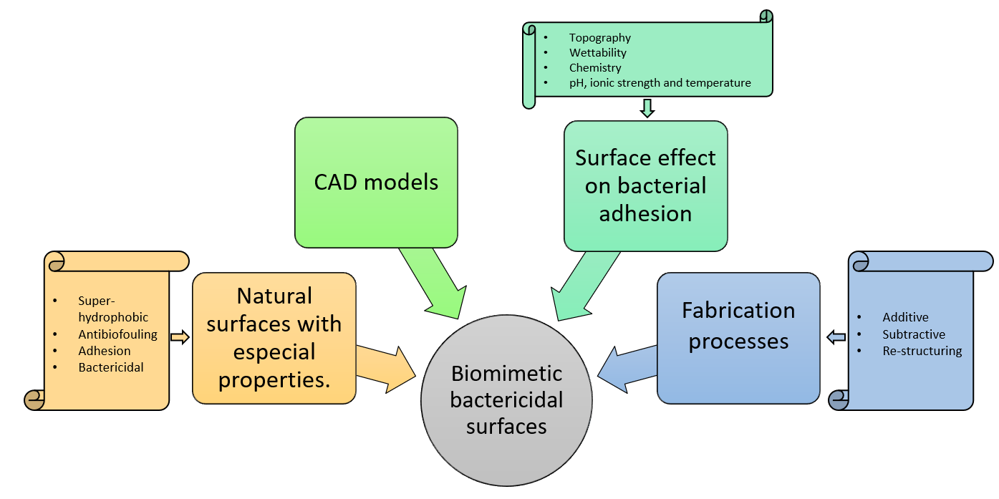
Figure 1: Schematic representation of the various points discussed in this review paper

Table I: Type of surface depending on the CA
Type of surface | Contact angle (CA)
Superhydrophobic | CA>150°
Hydrophobic | 150°>CA>90°
Hydrophilic | 90°>CA>10°
Superhydrophilic | CA<10°

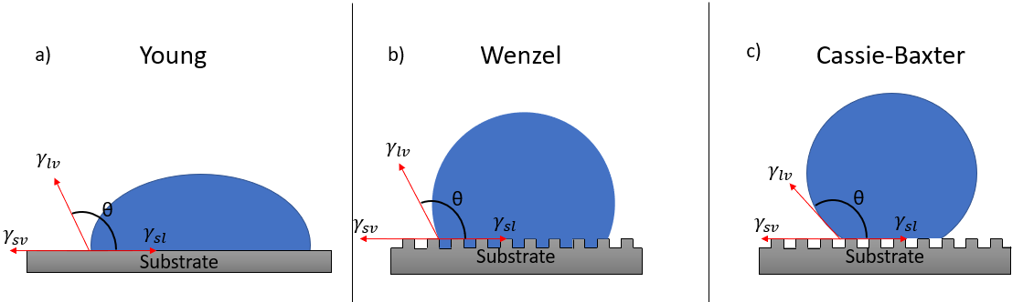
Figure 2: Models used to measure the contact angle of the surface. a) Young, b) Wenzel and c) Cassie-Baxter model

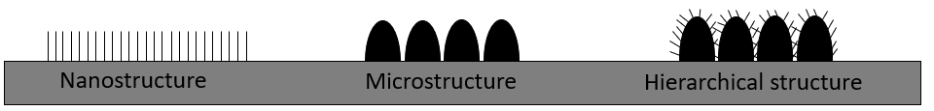
Figure 3 Different levels of structures, from nanostructures to hierarchical structures.
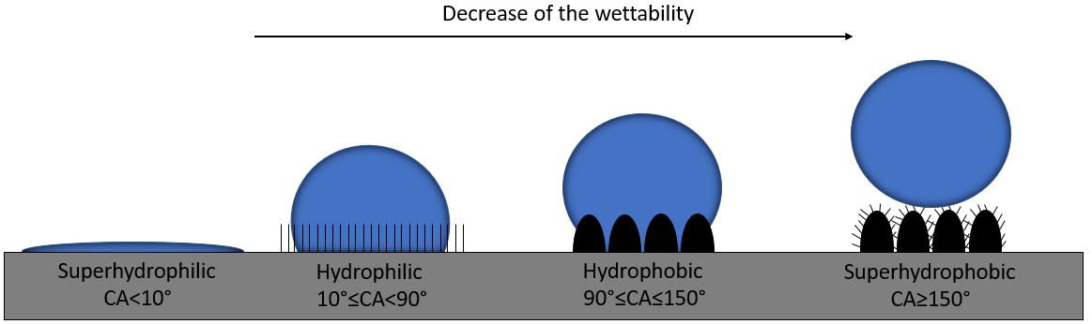
Figure 4 Different surface structures, starting smooth surface (left), nanostructure, microstructure and hierarchical structure (right). Adapted from ²¹

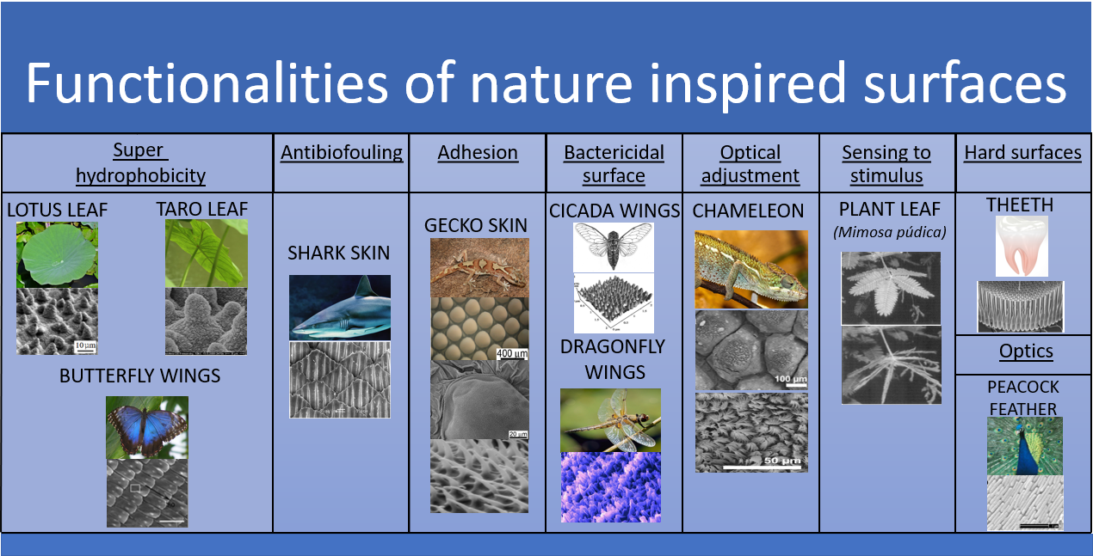
Figure 5: Functionalities of some of the nature inspired surfaces and some of their most studied examples.

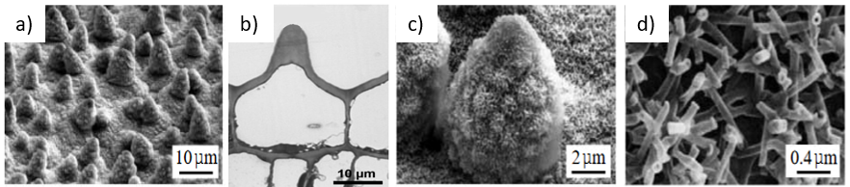
Figure 6 a) Microstructure of the lotus leaf. Adapted from³³ b) Cross section of the micropapillae. Adapted from ³⁴ c) Micropapillae covered with epicuticular waxes. Adapted from ³³ c) branch like nanostructures. Adapted from ³³
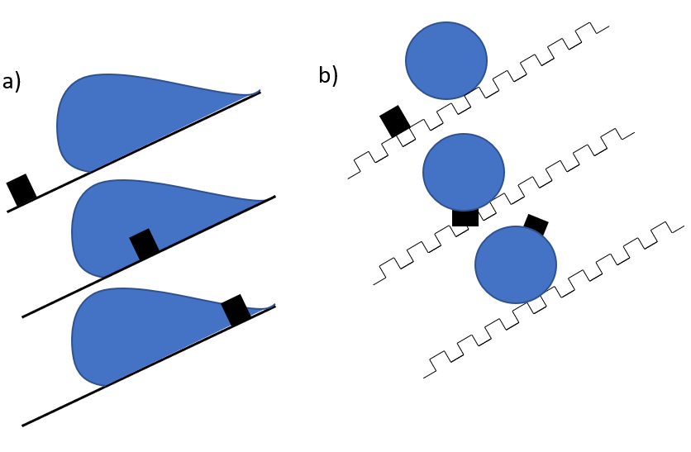
Figure 7 Schematic illustration of the lotus leaf self-cleaning effect a) ideal smooth surfaces b) rough surfaces (black mark indicates a roll off point)
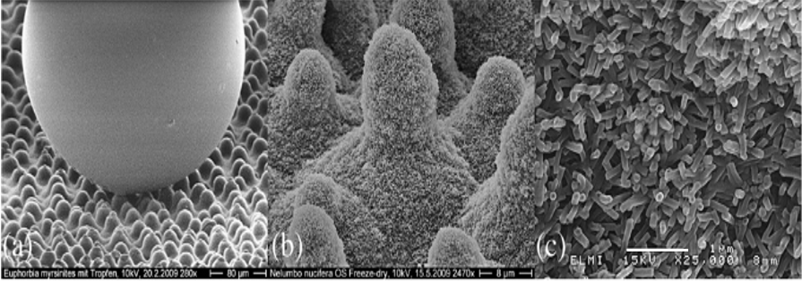
Figure 8: a) SEM image of the taro leaf with a water droplet showing the superhydrophobic properties b) taro leaf bump-like microstructure and c) Bumps covered by epicuticular waxes. Adapted from ³⁸. Scale bars are a) 80 µm b) 8 µm c) 1 µm.

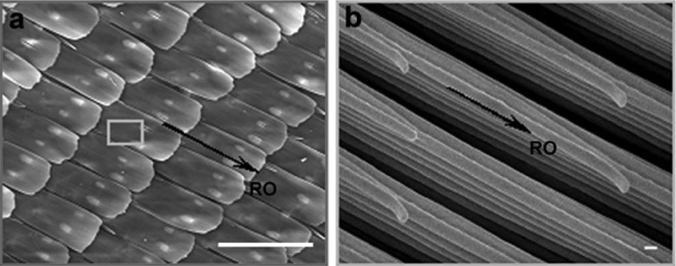
Figure 9 a) Butterfly wing scales and b) nanostripes. Adapted from ⁴⁴.
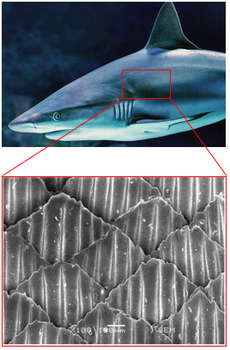
Figure 10 Shark skin riblet based microstructure.
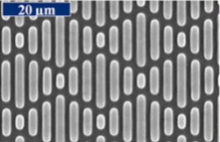
Figure 11 Scanning electron micrograph of the top view Sharklet AFTM microstructure. Adapted from⁴⁶.
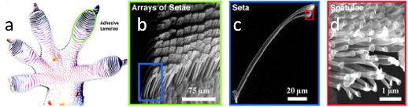
Figure 12 a) Gecko foot. b) Group of setae c) a single seta and d) Group of spatulae Adapted from⁵¹.
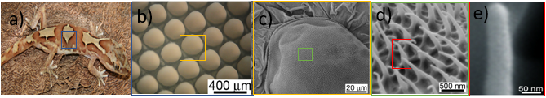
Figure 13: a) Lucasium steindachneri gecko b) Optical image of the abdominal part of gecko c) Topographical SEM image of the scales. d) Group of spinules in the top of the scales. e) magnification of the spinules at the nanometer scale. Adapted from 9.

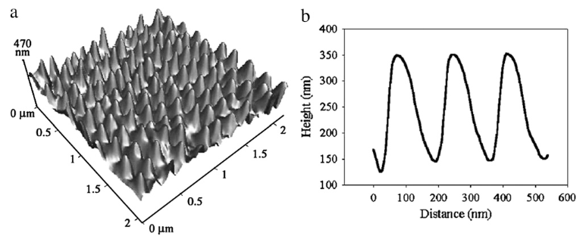
Figure 14: a) AFM three-dimensional image of cicada wing and b) corresponding height and width profile. Adapted from ⁵⁵.
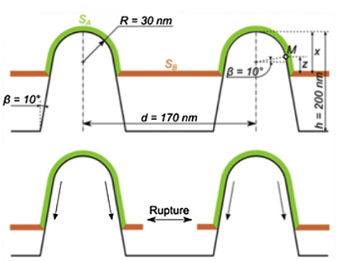
Figure 15: Model of cicada wing and bacteria explaining rupture of bacteria. Adapted from ⁵⁷.

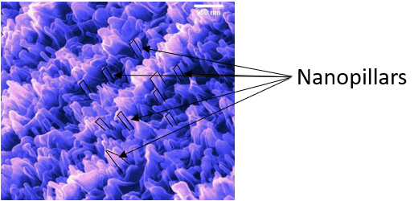
Figure 16: Pillar like nanostructure of the dragonfly wings. Adapted from ¹³
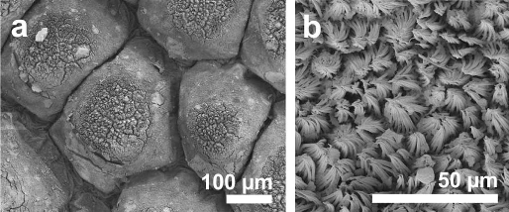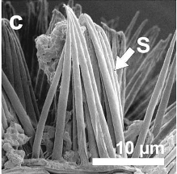
Figure 17 Scanning electron micrographs of the chameleo calyptratus a) Microstructure of the chameleon with a scale-like microstructure. b) Setae covering the scale-like microstructure. c) Cross-section of the scale with the setae (S). Adapted from ⁶³.
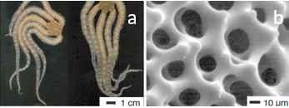
Figure 18 a) Brittle star image and b) SEM image of its microstructure. Adapted from ⁶⁸.
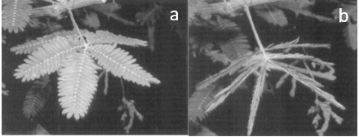
Figure 19 Leaves of the Mimosa pudica a) open and b) close. Adapted from ⁷⁰.
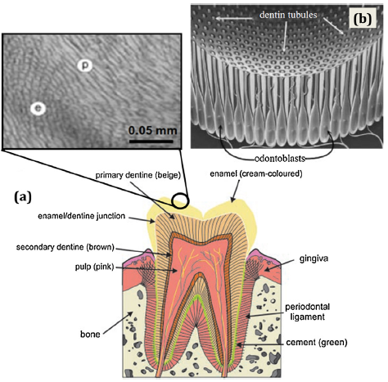
Figure 20 a) The main structure of human teeth, b) Tubular structure of the dentin. Adapted from ²².
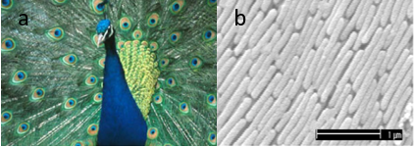
Figure 21 a) Peacock with its feathers. Adapted from ⁸¹. b) longitudinal cross section of the barbs. Adapted from ⁸².

Table II Natural dimensions of most promising antibacterial surfaces based on the literature.
Natural surface | Wettability (°) | Microstructure |  |  | Nanostructure |  |  |  | Reference
 |  | Height (µm) | Base (µm) | Spacing (µm) | Height (nm) | Base (nm) | Spacing (nm)
Lotus leaf | >150 | - | Ø5-Ø9 | - | - | Ø120 | - | ²²
Lotus leaf | 164 | 13 | Ø10 | - | 780 | Ø400 | - | ¹⁰
Lotus leaf | >150 | 10.4±0.8 | 8±2.4 | 19.5±12.5 | 530±150 | Ø100±30 | - | ⁸⁴
Shark skin | - | 200-500 | 100-300 | 100-300 | - |  |  |  | ³⁵
Shark skin | - | 8 | - | 60 | - |  |  |  | ⁸⁵
Gecko dorsal | 151-155 | 50 | Ø100-Ø190 | 50 | Up to 4000 | - | - | ⁹
Gecko dorsal | - | - | 160 | 210 | 3000 | Ø350-Ø400 | 500 | ⁸⁶
Cicada wing | 144±7 | Not hierarchical |  |  | 200 | Ø170 | 200 | ⁵⁵
Cicada wing | - | Not hierarchical |  |  | 300 | Ø90 | 170 | ⁸⁷
Cicada wing | 146 | Not hierarchical |  |  | 146-157 | Ø82-148 | 44-177 | ³⁶
Cicada wing | 159 | Not hierarchical |  |  | 200 | Ø60 top and Ø100 base | 170 | ⁵⁴
Dragonfly wings | - | Not hierarchical |  |  | 350 | Ø80 | 150 | ⁸⁷
Dragonfly wings | 153 | Not hierarchical |  |  | 240 | 50-70 | 200 | ⁸⁸
Dragonfly wings | - | Not hierarchical |  |  | Small: 189±67  Tall: 311±52 | Small: 37±6  Tall: 57±8 | - | ¹³
Dragonfly wings | - | Not hierarchical |  |  | 79.63-188.31 | Ø83.25-Ø195.08 | - | ⁸⁹

Table III Some bio-mimicked antibacterial surfaces and obtained outcomes.
Bio-inspiration | Fabrication process | Material | Surface type | Dimensions | Bactericidal effect | Reference
Dragonfly wing | Hydrothermal etching | Titanium | Nanowires | Ø40.2±20 nm | P. Aeruginosa: 50% death.  S. Aureus: 20% death | ⁵⁹
Dragonfly wings | Reactive ion etching and CVD | Black silicon | Nanopillars | Ø20 nm-Ø80 nm  Spacing: 200 nm- 1800 nm | Effective against gram positive and gram-negative bacteria. | ⁸⁸
Dragonfly wings | Ion etching | Silicon | Nanopillars | Ø220 nm and 4 µm height | 83% of gram negative (E. Coli) and 86% of gram positive (S. Aureus) bacteria were killed | ⁹⁰
Cicada wing | Hydrothermal method | TiO₂ | Nanowires | Ø100 nm  and  Ø10 µm-15 µm  Heights: 3 µm | P Aeruginosa: More than 50% death  S. Aureus: Less than 5% death | ⁹¹
Cicada wing | Glancing angle sputter deposition | TiO₂ on silicon substrate | Nanopillars | Ø33±7 nm  Peak-peak: 158±105 nm | E. coli: 50% death  S. Aureus: Successfully colonized. | ⁹²
Cicada wing | Nanoimprinting lithography | PMMA | Nanopillars | Ø150 nm, 400 nm height and 150 nm spacing | - | ⁹³
Cicada wing | Thermal oxidation | Ti6Al4V | Nanospikes | Ø20 nm | Enhance the bactericidal activity against E. Coli | ⁹⁴
Lotus leaf | Femtosecond laser | Titanium | Microbumps | Ø10 µm-Ø20 µm grains and 200 nm undulations | Lower adhesion of P. aeruginosa than polishes but increase of S. Aureus. | ³⁷
Lotus leaf | Femtosecond laser | Titanium | Microbumps | Ø10 µm-Ø20 µm grains and 200 nm undulations | S. Aureus, S. Epidermidis and P. Maritimus were able to attach to the surface. | ⁹⁵
Gecko skin | Template process | Epoxy resin | Nanoairs | 2 µm-4 µm length  2 µm height  500 nm spacing and base | S. Mutan: First 3 days lower adhesion than original skin. After 7 days more than natural skin  P. Gingivalis: Higher adhesion than natural skin. | ⁵³
Shark skin | Photolithography + ion etching | PDMSe | Grooves | 2 µm width and spacing  3 µm height | Decrease of bacterial adhesion than smooth surface and avoid of biofilm formation. | ⁴⁶

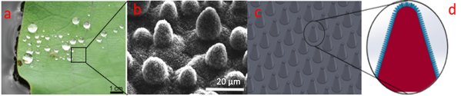
Figure 22 a) Natural lotus leaf. Adapted from⁸⁴ b) Lotus leaf microstructure. Adapted from ²⁷ c) Lotus leaf microstructure model (Proposed CAD model corresponding to SEM image) d) lotus leaf micropapillae (red colour) with nanobranches (blue colour) (Proposed CAD model corresponding to SEM image). Scale bar is 20µm.
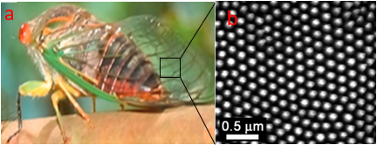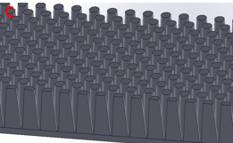
Figure 23 a) cicada. Adapted from ²⁹ b) cicada wing SEM picture. Adapted from ⁸⁷. c) cicada wing nanostructure model (Proposed CAD model corresponding to SEM image).
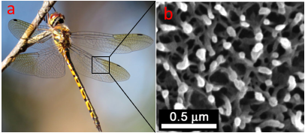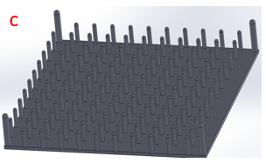
Figure 24 ) dragonfly insect. Adapted from ⁹⁶ b) SEM image of a dragonfly wing Adapted from ⁸⁷ c) Dragonfly wing model (Proposed CAD model corresponding to SEM image)

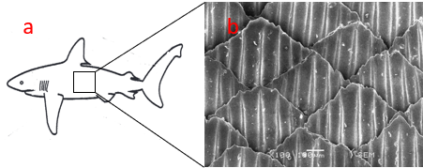
Figure 25 : a) shark animal. Adapted from ⁹⁸ b) SEM of the shark skin microstructure Adapted from ⁴⁵ c) model of the shark skin based on the Sharklet AFTM (Proposed CAD model corresponding to SEM image).
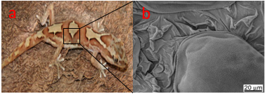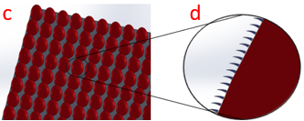
Figure 26 a) gecko animal b) SEM image of the dorsal part of the gecko animal. Adapted from ⁹ c) scales at the micro level creating the first level of the hierarchical structures (Proposed CAD model corresponding to SEM image) d) cross-section view of the scales (red colour) and the nanohairs (blue colour) creating the second level of the hierarchical structure (Proposed CAD model corresponding to SEM image).

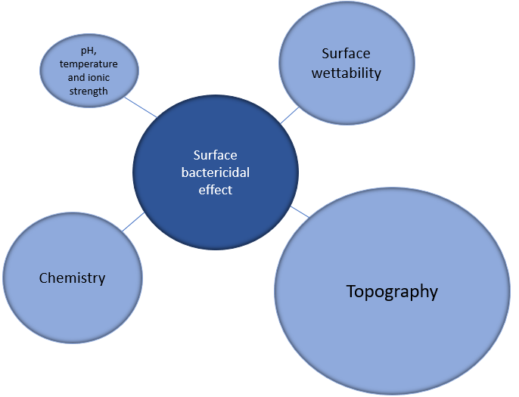
Figure 27: Illustration of the bactericidal effect and its root causes.

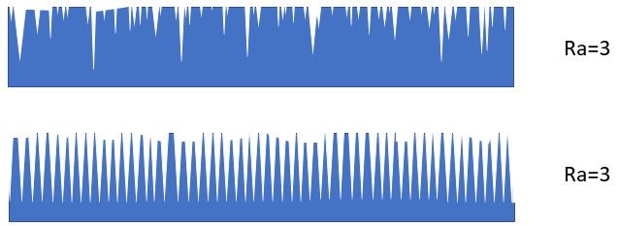
Figure 28 Same surface Ra but the morphology of this is not the same.

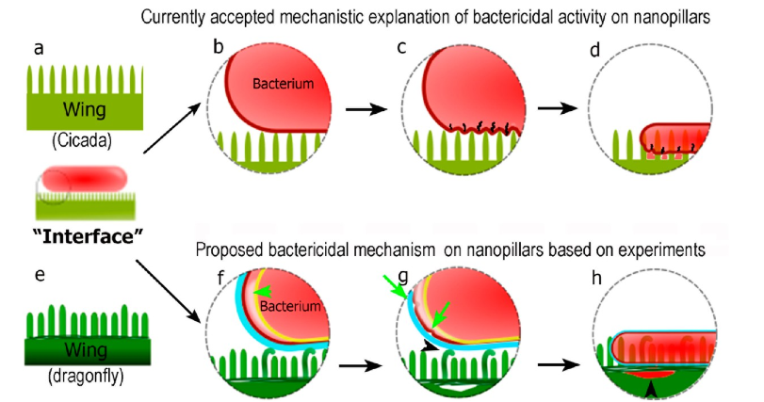
Figure 29 Representation of the bactericidal mechanisms of the nanopillars. a)-d) currently accepted mechanism between the interaction of bacteria-nanopillars. e)-h) proposed mechanism by Bandara et al .¹³. a) Cicada wing nanostructure with all pillar at the same height. b) bacterium approaching the nanostructure. c) bacterial membrane starts rupturing between the pillar like structures due to stretching. d) The bacteria get ruptured and the cytoplasm starts leaking leading to bacterial death. e) dragonfly wing illustration with variable lengths pillars. f) The approaching bacterium bends the taller pillars, but it doesn’t puncture the membrane. g) after adhesive forces are applied into the bacterial surface, the two membranes (EPS in blue and outer membrane in red) start separating. h) finally, the bacterium dies on the nanopillars and the cytosol leaks out. Adapted from ¹³.

Table V Bactericidal efficacy of different nanoparticles
Nanoparticle | Dosses | Bacterial response | Manufacturing process | References
3 sizes of Ag | 0.01 M | S. Mutans reduction. Bactericidal response depends on the size. | Gallic acid in an aqueous chemical reduction method | ¹³⁸
Ag | 4.26% using EDS | Remarkable antibacterial effect against S. Aureus and E. Coli | Silanization method | ¹³⁹
Ti nanotubes + Ag | 0.5 M, 1 M, 1.5 M and 2 M | Significant reduction of the osteoblast cells. | Immersion in a silver nitrate solution | ¹⁴⁰
Ag+ + hydroxyapatite | 296 mg/ml | More than 99% of S. Aureus and E. Coli were killed after 24 h | Dipping | ¹⁴¹
Ag | 25-100 mg/l | Conclude 3 step process of P. Aeruginosa bacterial wall rupturing | - | ¹³³
Ag and ZnO | 10 mM | Small reduction of B. Subtilis bacteria reproduction | - | ¹⁴²

Table VI: Antibacterial mechanism for antibacterial metals, their characteristics, and potential applications
Antibacterial mechanism | Corresponding antibacterial material | Characteristics | Prospective applications
Slow release metal ion sterilisation | Copper, silver, metal ion phosphate antibacterial materials, etc. | High chemical activity provides long term and efficient slow release antibacterial materia | Widely used in medical applications, stainless steel, water treatment. Prevent bask in liquid coatings and fabrics. But these materials tarnish easily and are expansive, which limits their applications
Slow release metal ion sterilisation and photocatalytic sterilisation | Hydroxyapatite, Ag-carrying phosphate antibacterial materials, etc. | Phosphoric acid double salt has a strong adsorption function, large specific surface area, nontoxic, stable chemical properties; good combination of efficiency and lasting slowrelease performance
Slow release metal ion sterilization, photo-catalytic sterilization and reactive oxygen species antibacterial mechanism | ZnO materials, TiO2 materials | Stable chemical properties, under UV irradiation show broad spectrum antimicrobial properties, good pH stability, nontoxic, abundant raw material sources, low cost. | Used in fiber, plastic, ceramic, coating, biomedical and other fields

Table VII: Antimicrobial activity of metal oxide nanoparticles
Metal oxide NPs | Test organism | Antimicrobial action
Aluminium oxide (Al₂O₃) NPs | Escherichia coli | Growth inhibition of Escherichia coli
Antimony trioxide (Sb₂O₃) NPs | Escherichia coli, Bacillus subtilis and Staphylococcus aureus | Toxic to all the three microbes
Bismuth oxide (Bi₂O₃) NPs | Pseudomonas aeruginosa, Acinetobacter baumannii and Escherichia coli | No effect against all tested microbes
Calcium oxide (CaO) NPs | Lactobacillus plantarum | Higher bactericidal activity
Cerium oxide (CeO) NPs | Escherichia coli, Shewanella oneidensis and Bacillus subtilis | No effect on Shewanella oneidensis
Cobalt oxide (Co₃O₄) NPs | Staphylococcus aureus and Escherichia coli | Showed antimicrobial activity on tested bacteria
Copper oxide (CuO) NPs | MRSA, Staphylococcus epidermis, Pseudomonas aeruginosa, Proteus sp. Staphylococcus aureus, Bacillus subtilis, Escherichia coli; fish pathogens: Aeromonas hydrophila, Pseudomonas fluorescens, Flavobacterium sp. and Branchiophilum sp | Active against all the tested microbes
Magnetite (Fe₃O₄) NPs | Escherichia coli | Concentration-dependent bacteriostatic action
Iron oxide (FeO) NPs | Staphylococcus aureus, Shigella flexneri, Escherichia coli, Bacillus licheniformis, Bacillus subtilis, Brevibacillus brevis, Vibrio cholerae, Pseudomonas aeruginosa, Staphylococcus aureus and Staphylococcus epidermis | Moderate antibacterial activity against 6 Gram-positive and 2 Gram-negative bacteria
Magnesium oxide (MgO) nanowires | Escherichia coli and Bacillus spp. | Lower bacteriostatic activity
Titanium dioxide (TiO₂) NPs | MRSA | Exhibited antimicrobial effect on tested isolates
Zinc oxide (ZnO) NPs | MSSA, MRSA and MRSE, Streptococcus agalactiae, Staphylococcus aureus, Escherichia coli, Bacillus subtilis, Salmonella paratyphi, Staphylococcus aureus, Pseudomonas aeruginosa, Mycobacterium smegmatis, Mycobacterium bovis, Klebsiella pneumoniae, Enterobacter aerogenes, Candida albicans, Malassezia pachydermatis, Bacillus megaterium, Bacillus pumilus and Bacillus cereus | Active on tested microbes
Zinc/iron oxide composite NPs | Escherichia coli and Staphylococcus aureus | Exhibited greater antibacterial activity with higher Zn/Fe weight ratio
ZnO-loaded PA6 nanocomposite | Staphylococcus aureus and Klebsiella pneumoniae | Dose-dependent antibacterial action
Nanosilver-decorated TiO₂ nanofibres | Staphylococcus aureus and Escherichia coli | Increased antimicrobial effect
Hybrid CH-α-Fe₂O₃ nanocomposite | Staphylococcus aureus and Escherichia coli | Improved antibacterial activity
Zinc-doped CuO nanocomposite | Escherichia coli, Staphylococcus aureus and MRSA | Remarkable biocidal activity
PEI-capped ZnO NPs | Escherichia coli | Exhibited better antibacterial activity
Chitosan-based ZnO NPs | Candida albicans, Micrococcus luteus and Staphylococcus aureus | Showed biofilm inhibition against Micrococcus luteus and Staphylococcus aureus
Carvone functionalized iron oxide | Staphylococcus aureus and Escherichia coli | Inhibited colonization and biofilm formation
Silver-decorated titanium dioxide (TiO₂ : Ag) NPs | MRSA and Candida sp. | Conferred antimicrobial effect on tested microbes
Graphene oxide modified ZnO NPs | Escherichia coli, Bacillus subtilis, Salmonella typhimurium and Escherichia faecalis | Excellent antibacterial activity
NPs: nanoparticles; MRSA: methicillin-resistant Staphylococcus aureus; MRSE: methicillin-resistant Staphylococcus epidermidis; MSSA: methicillin-sensitive Staphylococcus aureus; PEI: polyethyleneimine.

Table VIII: State of the art of bactericidal treatments based on silver ion implantation:
Ion | Substrate | Plasma ion source | Bias/Acceleration voltage (kV) | Dose  ions/cm² | Bacteria tested  In vivo studies | Reference
Ag | Ti | ECR | 2 | 1.5·10¹⁶ | S. aureus | ¹⁵⁴
Ag | Ti | Cathodic arc | 30 | - | E. coli, S. aureus | ¹⁵⁵
Ag | Ti | Cathodic arc | 20 | - | In vivo positive response | ¹⁵³
Ag | Ti | MEVVA | 40 | 10¹⁶ | S. aureus | ¹⁵⁶
Ag | Ti | Cathodic arc | 15 | - | F. nucleatum, S. aureus | ¹⁵¹
Ag | TiO₂-Ti | MEVVA | 70 | 10¹⁷ – 2·10¹⁸ | S. aureus | ¹⁵⁷
Ag | 316LVM | Cathodic arc | 30 | - | E. coli, P. aeruginosa, S. aureus, S. epidermis | ¹⁴⁷
Ag | TiO₂ | MEVVA | 40 | (0,5-10)·10¹⁶ | E. coli | ¹⁵⁸
Ag | Ti | Cathodic arc | 30 | - | In vivo positive response  Osseoconductive treatment | ¹⁵⁹
Ag | TiO₂-Ti | Cathodic arc | 0,5-1 | - | P. gingivalis, A. actinomycetemcomitans.  In vivo positive response | ¹⁴⁸
Ag | CrN-316L | Kaufman ion source | 100 | 5·10¹⁶-10¹⁷ | E. coli, S. aureus | ¹⁶⁰
Ag | TiO₂-Ti | MEVVA | 65 | (1-20)·10¹⁷ | S. aureus | ¹⁶¹
Ag | AISI 420 | MEVVA | 50 | 10¹⁷ | E. coli | ¹⁶²
Ag | Ti | Cathodic arc | 15 | - | S. mutans. P. gingivalis, C. albicans | ¹⁴⁹
Ag | Ti | ---- | 15 | 10¹⁶ | A. actinomycetum, F. nucleatum, C. rectus, P. micros, B. forsythus | ¹⁵⁰
Ag | Ti | Cathodic arc | 30 | - | E. coli, S. aureus | ¹⁶³
Ag | 317L, TiN-317L | MEVVA | 70 | 5·10¹⁶ – 5·10¹⁸ | S. aureus | ¹⁶⁴
Ag | Pyrolytic carbon | MEVVA | 70 | 5·10¹⁴- 5·10¹⁸ | E. coli, S. aureus | ¹⁶⁵
Ag/Zn, Ag+Zn | Ti | Cathodic arc | 30 | - | E. coli, S. aureus.  In vivo positive response | ¹⁶⁶
Ag, Ag+Mg | Ti | Cathodic arc | 30-40 | - | E. coli | ¹⁶⁷
Ag/Ca, Ag+Ca | Ti alloy | MEVVA | 50 | 10¹⁷ | E. coli, S. aureus | ¹⁶⁸
Ag/Zn, Ag+Zn | Ti | Cathodic arc | 30 | - | E. coli, S. aureus  In vivo positive response | ¹⁵²
Ag+Cu | AISI 420 | MEVVA | 50 | 2·10¹⁷ | S. aureus, A. niger | ¹⁶⁹
Ag/Cu | Ti6Al4V | CHORDIS | 2-20 | 10¹⁵-10¹⁷ | E. coli, S. aureus | ¹⁷⁰
Ag/Cu | Polyethylene | Cathodic arc | 5 | - | E. coli | ¹⁷¹
Ag/Cu | 317L, Ti, TiAlNb | MEVVA | 80 | 10¹⁷ | S. aureus | ¹⁷²

Figure 30: Overview of the manufacturing techniques classification.
Table IX Classification of additive type surface modification techniques ^{36,211}
Additive processing
Chemical processes | Chemical conversion coating | Patterned chromating
 |  | Patterned phosphating
 | Chemical deposition coatings | Chemical vapour deposition (CVD)
 |  | Patterned autocatalytic plating
 |  | Anodising
 |  | *Electro-deposition
 |  | Sol-gel
 | Patterned precipitation coating
Physical deposition | Inkjet
 | Patterned curing
 | Physical vapour deposition (PVD)
 | Painting
 | *Deposition of micro- or nanoparticles
 | *Self-assembling in polycrystalline films
 | Vacuum casting
*Considered as an Ultra Precision manufacturing technique.
Table X Additive manufacturing processes employed to suppress the bacterial adhesion
Additive process | Material employed | Bacterial response | Reference
Anodization | Grade 2 Ti and Ti6Al4V | Successful bactericidal activity of the anodized samples | ¹²⁹
Nanoimprint lithography | PMMA | 50% decrease of E. Coli bacteria compared to polished ones | ²²⁷
Electrodeposition | Au nanoparticles | All structures Au nanoparticles exhibit great bactericidal activity against S. Aureus | ²²⁸
Physical vapour deposition | Titanium coated with copolymers | Decrease of the S. Aureus bacteria. | ²²⁹
Spraying deposition | Titanium anodized substrate coated with polylactide. | 0.5% of PLA concentration showed the best inhibition rate to S. Aureus. | ²³⁰
Lyophilization method | Titanium nanotubes loaded with gentamicin | Reduction of s. Aureus and enhance the osteoblast | ²³¹
Physical vapour deposition | Grade 2 Ti with silver coating | Reduce the bacterial adhesion of S. Epidermidis and K. Pneumoniae. | ²²¹
Chemical vapour deposition | Silicone elastomer | Decrease of S. Aureus bacteria compare with uncoated sample | ²³²
Ag and Cu Ion implantation | 317L, Pure Ti, TiAlNb | Improve the antibacterial properties of the substrates | ^{170,172}

Table XI Classification of the removal of material surface modification techniques ^{36,211} by subtractive routes
*Removing material
Beam based methods | Laser methods | Laser texturing (LT)
 |  | Masked excimer laser
 |  | Laser honing
 |  | Focused ion beam
 |  | CNC focused laser
 |  | Femtosecond laser
 | Electrical discharge machining (EDM) | Electrical discharge texturing (EDT)
 |  | Micro EDM
 | Ion beam texturing
Chemical etching | Masking methods | Chemical texturing
 |  | Electrochemical texturing
 | Non-masking methods | Self-assembling
 |  | Maskless laser assisted etching
 |  | Maskless electrochemical texturing
 |  | Anisotropic etching
Mechanical | CNC ultrasonic machining
 | Mechanical honing
 | Precision Grinding
 | Free abrasive machining
 | Microcutting
 | Patterned erosion

.
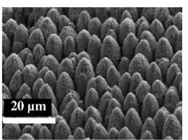
Figure 31 Femtosecond laser processed cone type structure on titanium material ²⁴³.

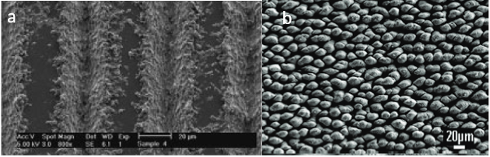
Figure 32 a) Ti6Al4V sample with 50 µm separation tracks. Adapted from ²⁴⁶ and b) laser processed titanium sample inspired from a lotus leaf. Adapted from ³⁷.

Table XII Subtractive manufacturing processes employed to create bactericidal surfaces
Subtractive process | Material employed | Bacterial response | Reference
Femtosecond laser | Ti6Al4V | Similar bactericidal (S. Aureus) response between nanopillars and LIPSS. | ¹¹⁹
Femtosecond laser | Ti6Al4V | Colonisation of S. Aureus on all the laser treated surfaces but rejection of P. Aeruginosa and S. Mutans on nanopillar like structure. | ²⁴⁵
Nanosecond laser | Ti6Al4V | Biofilm formation of E. Coli and S. Aureus on non-treated surface but bacterial attachment was not avoided. | ²⁵³
CW laser | Ti6Al4V, CoCrMo and CpTi (Grade 2) | The most bactericidal surface was observed on the CpTi against S. Aureus which exhibits the lowest CA (31.9°) | ¹²⁰
Machining vs Sand blasting + acid etching | Pure Ti | Machined samples showed better bactericidal activity S. Sanguinis than acid treated ones. | ²⁵⁴
Polishing vs grit blasting vs plasma sprayed vs satin | Ti6Al4V | Polished surface showed lowest S. epidermidis adhesion continued by plasma spraying, grit-blasting and sating. | ¹⁰⁰
Chemical oxidation | Grade 2 Ti | Avoid bacterial adhesion of S. Aureus and E. coli compared to smooth one. | ²⁵⁵
Plasma glow discharge | PVC | Significant decrease of the P. Aeruginosa bacteria. | ²⁵⁶
Plasma treatment | Polymeric suture materials | Reduction of E.Coli bacteria depends on the available contact area. | ²⁵⁷

Table XIII Classification of the re-structuring surface modification techniques ^{36,211}.
Re-structuring
Mechanical | Shot blasting
 | Embossing | Vibrorolling
 |  | Patterned embossing tools
 |  | Lithography
 |  | Wrinkling*
 |  | Photolithography
Chemical | Molecular migration
 | UV contraction
*Considered as an Ultra Precision manufacturing technique.
Table XIV Impact of the surface properties of different manufacturing techniques.
Technique | Surface property impact |  |  |  | Reference
 | Chemistry | Wettability | Topography | Other
Femtosecond laser | Medium | Strong | Strong (nanoscale, microscale) | No surface damage | ^{37,119,245,260}
Nanosecond laser | Medium | Strong | Medium (microscale) | Surface damage | ^{253,261}
Ion Implantation | Strong | Weak | Weak | - | ^{171,172}
Anodization | Weak | Weak | Weak | - | ¹²⁹
Chemical oxidation | Strong | Strong | Strong (nanoscale) | - | ²⁵⁵
PVD | Strong | - | Medium (microscale) | - | ^{221,229}
CVD | Strong | Medium | Medium (microscale) | - | ²³²

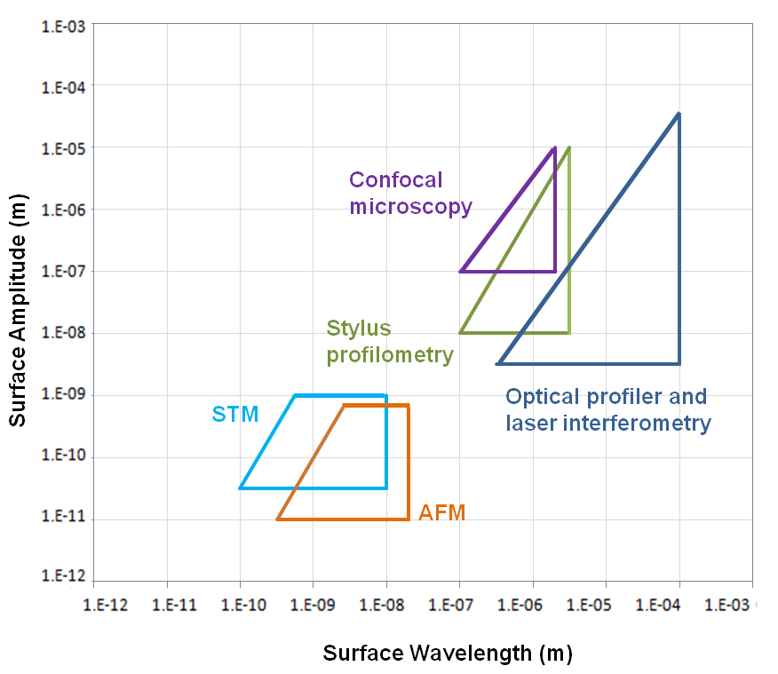
Figure 33: Stedman diagram: Typical resolutions of some common metrology used to asseses surface modified fabrication methods. Adapted from ²⁶⁴.
References
¹ S. Goel, S. Hawi, G. Goel, V.K. Thakur, A. Agrawal, C. Hoskins, O. Pearce, T. Hussain, H.M. Upadhyaya, G. Cross, and A.H. Barber, Mater. Today Chem. 17, 100300 (2020).
² D. Adamovic, B. Ristic, and F. Zivic, in Biomater. Clin. Pract. Adv. Clin. Res. Med. Devices, edited by F. Zivic, S. Affatato, M. Trajanovic, M. Schnabelrauch, N. Grujovic, and K.L. Choy (Springer International Publishing, Cham, 2018), pp. 47–99.
³ F.A. Shah, P. Thomsen, and A. Palmquist, Acta Biomater. 84, 1 (2019).
⁴ W.F. Oliveira, P.M.S. Silva, R.C.S. Silva, G.M.M. Silva, G. Machado, L.C.B.B. Coelho, and M.T.S. Correia, J. Hosp. Infect. 98, 111 (2018).
⁵ J.W. Costerton, L. Montanaro, and C.R. Arciola, Int. J. Artif. Organs 28, 1062 (2005).
⁶ Y. Kirmanidou, M. Sidira, M.-E. Drosou, V. Bennani, A. Bakopoulou, A. Tsouknidas, N. Michailidis, and K. Michalakis, BioMed Res. Int. (2016).
⁷ X. Liu, P.K. Chu, and C. Ding, Mater. Sci. Eng. R Rep. 47, 49 (2004).
⁸ L. Feng, S. Li, Y. Li, H. Li, L. Zhang, J. Zhai, Y. Song, B. Liu, L. Jiang, and D. Zhu, Adv. Mater. 14, 1857 (2002).
⁹ G.S. Watson, D.W. Green, L. Schwarzkopf, X. Li, B.W. Cribb, S. Myhra, and J.A. Watson, Acta Biomater. 21, 109 (2015).
¹⁰ B. Bhushan and Y.C. Jung, Prog. Mater. Sci. 56, 1 (2011).
¹¹ X. Zhang, L. Wang, and E. Levänen, RSC Adv. 3, 12003 (2013).
¹² A. Tripathy, P. Sen, B. Su, and W.H. Briscoe, Adv. Colloid Interface Sci. 248, 85 (2017).
¹³ C.D. Bandara, S. Singh, I.O. Afara, A. Wolff, T. Tesfamichael, K. Ostrikov, and A. Oloyede, ACS Appl. Mater. Interfaces 9, 6746 (2017).
¹⁴ A.T. Poortinga, R. Bos, W. Norde, and H.J. Busscher, Surf. Sci. Rep. 47, 1 (2002).
¹⁵ M. Hermansson, Colloids Surf. B Biointerfaces 14, 105 (1999).
¹⁶ C. Desrousseaux, V. Sautou, S. Descamps, and O. Traoré, J. Hosp. Infect. 85, 87 (2013).
¹⁷ K.L. Mittal, Contact Angle, Wettability and Adhesion (CRC Press, 2009).
¹⁸ A. Cunha, Multiscale Femtosecond Laser Surface Texturing of Titanium and Titanium Alloys for Dental and Orthopaedic Implants, 2015.
¹⁹ T. Sun, L. Feng, X. Gao, and L. Jiang, Acc. Chem. Res. 38, 644 (2005).
²⁰ K. Koch, B. Bhushan, and W. Barthlott, Prog. Mater. Sci. 54, 137 (2009).
²¹ K. Koch, B. Bhushan, and W. Barthlott, Soft Matter 4, 1943 (2008).
²² A. Malshe, K. Rajurkar, A. Samant, H.N. Hansen, S. Bapat, and W. Jiang, CIRP Ann. 62, 607 (2013).
²³ J. Genzer and K. Efimenko, Biofouling 22, 339 (2006).
²⁴ A. Marmur, Biofouling 22, 107 (2006).
²⁵ A.B.D. Cassie and S. Baxter, Trans. Faraday Soc. 40, 546 (1944).
²⁶ D. Patel, V. Jain, and J. Ramkumar, Proc. Inst. Mech. Eng. Part B J. Eng. Manuf. 232, 941 (2018).
²⁷ G. Carbone and L. Mangialardi, Eur. Phys. J. E 16, 67 (2005).
²⁸ J. Sun and B. Bhushan, Tribol. Int. 129, 67 (2019).
²⁹ J. Hasan, R.J. Crawford, and E.P. Ivanova, Trends Biotechnol. 31, 295 (2013).
³⁰ S. Nishimoto and B. Bhushan, RSC Adv. 3, 671 (2013).
³¹ W. Barthlott and C. Neinhuis, Planta 202, 1 (1997).
³² P.-Y. Chen, J. McKittrick, and M.A. Meyers, Prog. Mater. Sci. 57, 1492 (2012).
³³ K. Koch, B. Bhushan, Y. Chae Jung, and W. Barthlott, Soft Matter 5, 1386 (2009).
³⁴ H.J. Ensikat, P. Ditsche-Kuru, C. Neinhuis, and W. Barthlott, Beilstein J. Nanotechnol. 2, 152 (2011).
³⁵ Bhushan Bharat, Philos. Trans. R. Soc. Math. Phys. Eng. Sci. 367, 1445 (2009).
³⁶ A. Jaggessar, H. Shahali, A. Mathew, and P.K.D.V. Yarlagadda, J. Nanobiotechnology 15, 64 (2017).
³⁷ E. Fadeeva, V.K. Truong, M. Stiesch, B.N. Chichkov, R.J. Crawford, J. Wang, and E.P. Ivanova, Langmuir 27, 3012 (2011).
³⁸ Y.Y. Yan, N. Gao, and W. Barthlott, Adv. Colloid Interface Sci. 169, 80 (2011).
³⁹ L.P. Biró, Mater. Sci. Eng. B 169, 3 (2010).
⁴⁰ V. Saranathan, C.O. Osuji, S.G.J. Mochrie, H. Noh, S. Narayanan, A. Sandy, E.R. Dufresne, and R.O. Prum, Proc. Natl. Acad. Sci. 107, 11676 (2010).
⁴¹ Vukusic P., Sambles J. R., Lawrence C. R., and Wootton R. J., Proc. R. Soc. Lond. B Biol. Sci. 266, 1403 (1999).
⁴² Y. Ding, S. Xu, and Z.L. Wang, J. Appl. Phys. 106, 074702 (2009).
⁴³ Yoshioka Shinya and Kinoshita Shuichi, Proc. R. Soc. Lond. B Biol. Sci. 271, 581 (2004).
⁴⁴ Y. Zheng, X. Gao, and L. Jiang, Soft Matter 3, 178 (2007).
⁴⁵ D.-Y. Zhao, Z.-P. Huang, M.-J. Wang, T. Wang, and Y. Jin, J. Mater. Process. Technol. 212, 198 (2012).
⁴⁶ K.K. Chung, J.F. Schumacher, E.M. Sampson, R.A. Burne, P.J. Antonelli, and A.B. Brennan, Biointerphases 2, 89 (2007).
⁴⁷ J.F. Schumacher, M.L. Carman, T.G. Estes, A.W. Feinberg, L.H. Wilson, M.E. Callow, J.A. Callow, J.A. Finlay, and A.B. Brennan, Biofouling 23, 55 (2007).
⁴⁸ J.F. Schumacher, N. Aldred, M.E. Callow, J.A. Finlay, J.A. Callow, A.S. Clare, and A.B. Brennan, Biofouling 23, 307 (2007).
⁴⁹ V. Tinnemann, L. Hernández, S.C.L. Fischer, E. Arzt, R. Bennewitz, and R. Hensel, Adv. Funct. Mater. 29, 1807713 (2019).
⁵⁰ B. Bhushan, J. Adhes. Sci. Technol. 21, 1213 (2007).
⁵¹ W.R. Hansen and K. Autumn, Proc. Natl. Acad. Sci. 102, 385 (2005).
⁵² K. Autumn, Y.A. Liang, S.T. Hsieh, W. Zesch, W.P. Chan, T.W. Kenny, R. Fearing, and R.J. Full, Nature 405, 681 (2000).
⁵³ X. Li, G.S. Cheung, G.S. Watson, J.A. Watson, S. Lin, L. Schwarzkopf, and D.W. Green, Nanoscale 8, 18860 (2016).
⁵⁴ E.P. Ivanova, J. Hasan, H.K. Webb, V.K. Truong, G.S. Watson, J.A. Watson, V.A. Baulin, S. Pogodin, J.Y. Wang, M.J. Tobin, C. Löbbe, and R.J. Crawford, Small 8, 2489 (2012).
⁵⁵ G.S. Watson, S. Myhra, B.W. Cribb, and J.A. Watson, Biophys. J. 94, 3352 (2008).
⁵⁶ J. Hasan, H.K. Webb, V.K. Truong, S. Pogodin, V.A. Baulin, G.S. Watson, J.A. Watson, R.J. Crawford, and E.P. Ivanova, Appl. Microbiol. Biotechnol. 97, 9257 (2013).
⁵⁷ S. Pogodin, J. Hasan, V.A. Baulin, H.K. Webb, V.K. Truong, T.H. Phong Nguyen, V. Boshkovikj, C.J. Fluke, G.S. Watson, J.A. Watson, R.J. Crawford, and E.P. Ivanova, Biophys. J. 104, 835 (2013).
⁵⁸ D. E. Mainwaring, S. Ha Nguyen, H. Webb, T. Jakubov, M. Tobin, R. N. Lamb, A. H.-F. Wu, R. Marchant, R. J. Crawford, and E. P. Ivanova, Nanoscale 8, 6527 (2016).
⁵⁹ C.M. Bhadra, V. Khanh Truong, V.T.H. Pham, M. Al Kobaisi, G. Seniutinas, J.Y. Wang, S. Juodkazis, R.J. Crawford, and E.P. Ivanova, Sci. Rep. 5, 16817 (2015).
⁶⁰ K. Modaresifar, S. Azizian, M. Ganjian, L.E. Fratila-Apachitei, and A.A. Zadpoor, Acta Biomater. 83, 29 (2019).
⁶¹ A.A. Voevodin and J.S. Zabinski, Thin Solid Films 370, 223 (2000).
⁶² J. Teyssier, S.V. Saenko, D. van der Marel, and M.C. Milinkovitch, Nat. Commun. 6, 6368 (2015).
⁶³ M. Spinner, G. Westhoff, and S.N. Gorb, Sci. Rep. 4, 5481 (2014).
⁶⁴ H.-H. Chou, A. Nguyen, A. Chortos, J.W.F. To, C. Lu, J. Mei, T. Kurosawa, W.-G. Bae, J.B.-H. Tok, and Z. Bao, Nat. Commun. 6, 8011 (2015).
⁶⁵ M. Vatankhah-Varnosfaderani, A.N. Keith, Y. Cong, H. Liang, M. Rosenthal, M. Sztucki, C. Clair, S. Magonov, D.A. Ivanov, A.V. Dobrynin, and S.S. Sheiko, Science 359, 1509 (2018).
⁶⁶ K.B. Karsten, G.W. Ferguson, T.C. Chen, and M.F. Holick, Physiol. Biochem. Zool. 82, 218 (2009).
⁶⁷ H. Toyota, K. Takahara, M. Okano, T. Yotsuya, and H. Kikuta, Jpn. J. Appl. Phys. 40, L747 (2001).
⁶⁸ J. Aizenberg, A. Tkachenko, S. Weiner, L. Addadi, and G. Hendler, Nature 412, 819 (2001).
⁶⁹ P.B. Applewhite, Behav. Biol. 7, 47 (1972).
⁷⁰ H.S. Patil and S. Vaijapurkar, J. Bionic Eng. 4, 19 (2007).
⁷¹ M. Ueda, H. Shigemori, N. Sata, and S. Yamamura, Phytochemistry 53, 39 (2000).
⁷² A.R.G. Lang and J.E. Begg, J. Appl. Ecol. 16, 299 (1979).
⁷³ H.A. Lowenstam, P.E.D. of G. and P.S.H. a Lowenstam, and S. Weiner, On Biomineralization (Oxford University Press, 1989).
⁷⁴ S. Mann, Biomineralization: Principles and Concepts in Bioinorganic Materials Chemistry (Oxford University Press, 2001).
⁷⁵ J. Moradian‐Oldak, H.B. Wen, G.B. Schneider, and C.M. Stanford, Periodontol. 2000 41, 157 (2006).
⁷⁶ P. Lucas, P. Constantino, B. Wood, and B. Lawn, BioEssays 30, 374 (2008).
⁷⁷ P. Vukusic and J.R. Sambles, Nature 424, 852 (2003).
⁷⁸ Ingram A.L and Parker A.R, Philos. Trans. R. Soc. B Biol. Sci. 363, 2465 (2008).
⁷⁹ S. Kinoshita and S. Yoshioka, ChemPhysChem 6, 1442 (2005).
⁸⁰ P. Vukusic and I. Hooper, Science 310, 1151 (2005).
⁸¹ S.C. Burgess, A. King, and R. Hyde, Opt. Laser Technol. 38, 329 (2006).
⁸² J. Zi, X. Yu, Y. Li, X. Hu, C. Xu, X. Wang, X. Liu, and R. Fu, Proc. Natl. Acad. Sci. 100, 12576 (2003).
⁸³ D’Alba Liliana, Saranathan Vinodkumar, Clarke Julia A., Vinther Jakob A., Prum Richard O., and Shawkey Matthew D., Biol. Lett. 7, 543 (2011).
⁸⁴ G. Watson, D. Green, B. Cribb, C. Brown, C. Merritt, M. Tobin, J. Vongsvivut, M. Sun, A.-P. Liang, and J. Watson, ACS Appl. Mater. Interfaces 9, (2017).
⁸⁵ X. Pu, G. Li, and Y. Liu, ChemBioEng Rev. 3, 26 (2016).
⁸⁶ D.W. Green, K.K.-H. Lee, J.A. Watson, H.-Y. Kim, K.-S. Yoon, E.-J. Kim, J.-M. Lee, G.S. Watson, and H.-S. Jung, Sci. Rep. 7, 41023 (2017).
⁸⁷ G.S. Watson, J.A. Watson, S. Hu, C.L. Brown, B. Cribb, and S. Myhra, Int. J. Nanomanufacturing 5, 112 (2009).
⁸⁸ E.P. Ivanova, J. Hasan, H.K. Webb, G. Gervinskas, S. Juodkazis, V.K. Truong, A.H.F. Wu, R.N. Lamb, V.A. Baulin, G.S. Watson, J.A. Watson, D.E. Mainwaring, and R.J. Crawford, Nat. Commun. 4, 2838 (2013).
⁸⁹ R. Selvakumar, K.K. Karuppanan, and R. Pezhinkattil, Micron 43, 1299 (2012).
⁹⁰ J. Hasan, S. Raj, L. Yadav, and K. Chatterjee, RSC Adv. 5, 44953 (2015).
⁹¹ T. Diu, N. Faruqui, T. Sjöström, B. Lamarre, H.F. Jenkinson, B. Su, and M.G. Ryadnov, Sci. Rep. 4, 7122 (2014).
⁹² C. Sengstock, M. Lopian, Y. Motemani, A. Borgmann, C. Khare, P.J.S. Buenconsejo, T.A. Schildhauer, A. Ludwig, and M. Köller, Nanotechnology 25, 195101 (2014).
⁹³ G. Zhang, J. Zhang, G. Xie, Z. Liu, and H. Shao, Small 2, 1440 (2006).
⁹⁴ T. Sjöström, A.H. Nobbs, and B. Su, Mater. Lett. 167, 22 (2016).
⁹⁵ V.K. Truong, H.K. Webb, E. Fadeeva, B.N. Chichkov, A.H.F. Wu, R. Lamb, J.Y. Wang, R.J. Crawford, and E.P. Ivanova, Biofouling 28, 539 (2012).
⁹⁶ E. Conover, Sci. News (2018).
⁹⁷ A. Sakamoto, Y. Terui, C. Horie, T. Fukui, T. Masuzawa, S. Sugawara, K. Shigeta, T. Shigeta, K. Igarashi, and K. Kashiwagi, FEMS Microbiol. Lett. 361, 10 (2014).
⁹⁸ D.W. Bechert, M. Bruse, and W. Hage, Exp. Fluids 28, 403 (2000).
⁹⁹ E.E. Mann, M.R. Mettetal, R.M. May, M.C. Drinker, B.C. Stevenson, V.L. Baiamonte, J.M. Marso, E.A. Dannemiller, A.E. Parker, S.T. Reddy, and M.K. Sande, J. Microbiol. Exp. 1, (2014).
¹⁰⁰ Y. Wu, J.P. Zitelli, K.S. TenHuisen, X. Yu, and M.R. Libera, Biomaterials 32, 951 (2011).
¹⁰¹ V.K. Truong, R. Lapovok, Y.S. Estrin, S. Rundell, J.Y. Wang, C.J. Fluke, R.J. Crawford, and E.P. Ivanova, Biomaterials 31, 3674 (2010).
¹⁰² E.P. Ivanova, V.K. Truong, H.K. Webb, V.A. Baulin, J.Y. Wang, N. Mohammodi, F. Wang, C. Fluke, and R.J. Crawford, Sci. Rep. 1, 165 (2011).
¹⁰³ F. Aykent, I. Yondem, A.G. Ozyesil, S.K. Gunal, M.C. Avunduk, and S. Ozkan, J. Prosthet. Dent. 103, 221 (2010).
¹⁰⁴ R.L. TAYLOR, J. VERRAN, G.C. LEES, and A.J.P. WARD, J. Mater. Sci. Mater. Med. 9, 17 (1998).
¹⁰⁵ Y.H. An and R.J. Friedman, J. Biomed. Mater. Res. 43, 338 (1998).
¹⁰⁶ E.W. McAllister, L.C. Carey, P.G. Brady, R. Heller, and S.G. Kovacs, Gastrointest. Endosc. 39, 422 (1993).
¹⁰⁷ A.S. Baker and L.W. Greenham, J. Bone Joint Surg. Am. 70, 1551 (1988).
¹⁰⁸ L.R. Hilbert, D. Bagge-Ravn, J. Kold, and L. Gram, Int. Biodeterior. Biodegrad. 52, 175 (2003).
¹⁰⁹ I. Yoda, H. Koseki, M. Tomita, T. Shida, H. Horiuchi, H. Sakoda, and M. Osaki, BMC Microbiol. 14, 234 (2014).
¹¹⁰ R.J. Crawford, H.K. Webb, V.K. Truong, J. Hasan, and E.P. Ivanova, Adv. Colloid Interface Sci. 179–182, 142 (2012).
¹¹¹ A. Zabala, L. Blunt, W. Tato, A. Aginagalde, X. Gomez, and I. Llavori, MATEC Web Conf. 165, 14013 (2018).
¹¹² B. Ercan, E. Taylor, E. Alpaslan, and T.J. Webster, Nanotechnology 22, 295102 (2011).
¹¹³ W.-Q. Yu, X.-Q. Jiang, L. Xu, Y.-F. Zhao, F.-Q. Zhang, and X. Cao, J. Biomed. Mater. Res. B Appl. Biomater. 99B, 207 (2011).
¹¹⁴ A.I. Hochbaum and J. Aizenberg, Nano Lett. 10, 3717 (2010).
¹¹⁵ M. Lorenzetti, I. Dogša, T. Stošicki, D. Stopar, M. Kalin, S. Kobe, and S. Novak, ACS Appl. Mater. Interfaces 7, 1644 (2015).
¹¹⁶ K. Anselme, P. Davidson, A.M. Popa, M. Giazzon, M. Liley, and L. Ploux, Acta Biomater. 6, 3824 (2010).
¹¹⁷ S. Wu, F. Zuber, K. Maniura-Weber, J. Brugger, and Q. Ren, J. Nanobiotechnology 16, 20 (2018).
¹¹⁸ X. Li and T. Chen, Phys. Rev. E 93, 052419 (2016).
¹¹⁹ A. Cunha, A.-M. Elie, L. Plawinski, A.P. Serro, A.M. Botelho do Rego, A. Almeida, M.C. Urdaci, M.-C. Durrieu, and R. Vilar, Appl. Surf. Sci. 360, 485 (2016).
¹²⁰ C.-W. Chan, L. Carson, G.C. Smith, A. Morelli, and S. Lee, Appl. Surf. Sci. 404, 67 (2017).
¹²¹ S.D. Puckett, E. Taylor, T. Raimondo, and T.J. Webster, Biomaterials 31, 706 (2010).
¹²² L.G. Harris and R.G. Richards, Injury 37, S3 (2006).
¹²³ P. Tang, W. Zhang, Y. Wang, B. Zhang, H. Wang, C. Lin, and L. Zhang, J Nanomater. 2011, 2:1 (2011).
¹²⁴ J.H. Lee, G. Khang, J.W. Lee, and H.B. Lee, J. Colloid Interface Sci. 205, 323 (1998).
¹²⁵ H. Yang and Y. Deng, J. Colloid Interface Sci. 325, 588 (2008).
¹²⁶ D. Campoccia, L. Montanaro, H. Agheli, D.S. Sutherland, V. Pirini, M.E. Donati, and C.R. Arciola, Int. J. Artif. Organs 29, 622 (2006).
¹²⁷ L. Visai, L. De Nardo, C. Punta, L. Melone, A. Cigada, M. Imbriani, and C.R. Arciola, Int. J. Artif. Organs 34, 929 (2011).
¹²⁸ B. Del Curto, M.F. Brunella, C. Giordano, M.P. Pedeferri, V. Valtulina, L. Visai, and A. Cigada, Int. J. Artif. Organs 28, 718 (2005).
¹²⁹ C. Giordano, E. Saino, L. Rimondini, M.P. Pedeferri, L. Visai, A. Cigada, and R. Chiesa, Colloids Surf. B Biointerfaces 88, 648 (2011).
¹³⁰ C.-C. Chu and D.F. Williams, Am. J. Surg. 147, 197 (1984).
¹³¹ M.J. Hajipour, K.M. Fromm, A. Akbar Ashkarran, D. Jimenez de Aberasturi, I.R. de Larramendi, T. Rojo, V. Serpooshan, W.J. Parak, and M. Mahmoudi, Trends Biotechnol. 30, 499 (2012).
¹³² S.Y. Liau, D.C. Read, W.J. Pugh, J.R. Furr, and A.D. Russell, Lett. Appl. Microbiol. 25, 279 (1997).
¹³³ J.R. Morones, J.L. Elechiguerra, A. Camacho, K. Holt, J.B. Kouri, J.T. Ramírez, and M.J. Yacaman, Nanotechnology 16, 2346 (2005).
¹³⁴ I. Sondi and B. Salopek-Sondi, J. Colloid Interface Sci. 275, 177 (2004).
¹³⁵ X.-H.N. Xu, W.J. Brownlow, S.V. Kyriacou, Q. Wan, and J.J. Viola, Biochemistry 43, 10400 (2004).
¹³⁶ G. Borkow and J. Gabbay, (2009).
¹³⁷ A.K. Chatterjee, R. Chakraborty, and T. Basu, Nanotechnology 25, 135101 (2014).
¹³⁸ L.F. Espinosa-Cristóbal, G.A. Martínez-Castañón, R.E. Martínez-Martínez, J.P. Loyola-Rodríguez, N. Patiño-Marín, J.F. Reyes-Macías, and F. Ruiz, Mater. Lett. 63, 2603 (2009).
¹³⁹ L. Juan, Z. Zhimin, M. Anchun, L. Lei, and Z. Jingchao, Int. J. Nanomedicine 5, 261 (2010).
¹⁴⁰ L. Zhao, H. Wang, K. Huo, L. Cui, W. Zhang, H. Ni, Y. Zhang, Z. Wu, and P.K. Chu, Biomaterials 32, 5706 (2011).
¹⁴¹ A. Mo, J. Liao, W. Xu, S. Xian, Y. Li, and S. Bai, Appl. Surf. Sci. 255, 435 (2008).
¹⁴² R. Sinha, R. Karan, A. Sinha, and S.K. Khare, Bioresour. Technol. 102, 1516 (2011).
¹⁴³ S. Parham, D.H.B. Wicaksono, S. Bagherbaigi, S.L. Lee, and H. Nur, J. Chin. Chem. Soc. 63, 385 (2016).
¹⁴⁴ Y.N. Slavin, J. Asnis, U.O. Häfeli, and H. Bach, J. Nanobiotechnology 15, 65 (2017).
¹⁴⁵ S.M. Dizaj, F. Lotfipour, M. Barzegar-Jalali, M.H. Zarrintan, and K. Adibkia, Mater. Sci. Eng. C 44, 278 (2014).
¹⁴⁶ S. Stankic, S. Suman, F. Haque, and J. Vidic, J. Nanobiotechnology 14, 73 (2016).
¹⁴⁷ H. Qin, H. Cao, Y. Zhao, G. Jin, M. Cheng, J. Wang, Y. Jiang, Z. An, X. Zhang, and X. Liu, ACS Appl. Mater. Interfaces 7, 10785 (2015).
¹⁴⁸ S. Mei, H. Wang, W. Wang, L. Tong, H. Pan, C. Ruan, Q. Ma, M. Liu, H. Yang, L. Zhang, Y. Cheng, Y. Zhang, L. Zhao, and P.K. Chu, Biomaterials 35, 4255 (2014).
¹⁴⁹ Y. Zheng, J. Li, X. Liu, and J. Sun, Int. J. Nanomedicine 7, 875 (2012).
¹⁵⁰ D. Jedrzejczyk, T. Zdziech, and M. Hajduga, Met 2012, 1 (2012).
¹⁵¹ Y. Zhu, H. Cao, S. Qiao, M. Wang, Y. Gu, H. Luo, F. Meng, X. Liu, and H. Lai, Int. J. Nanomedicine 10, 6659 (2015).
¹⁵² G. Jin, H. Qin, H. Cao, S. Qian, Y. Zhao, X. Peng, X. Zhang, X. Liu, and P.K. Chu, Biomaterials 35, 7699 (2014).
¹⁵³ H. Cao, W. Zhang, F. Meng, J. Guo, D. Wang, S. Qian, X. Jiang, X. Liu, and P.K. Chu, ACS Appl. Mater. Interfaces 9, 5149 (2017).
¹⁵⁴ I. Lampé, D. Beke, S. Biri, I. Csarnovics, A. Csik, Z. Dombrádi, P. Hajdu, V. Hegedűs, R. Rácz, I. Varga, and C. Hegedűs, Int. J. Nanomedicine 14, 4709 (2019).
¹⁵⁵ G. Wang, W. Jin, A.M. Qasim, A. Gao, X. Peng, W. Li, H. Feng, and P.K. Chu, Biomaterials 124, 25 (2017).
¹⁵⁶ C. Zhu, N.-R. Bao, S. Chen, and J.-N. Zhao, Appl. Surf. Sci. 389, 7 (2016).
¹⁵⁷ X. Hou, D. Mao, H. Ma, Y. Ai, X. Zhao, J. Deng, D. Li, and B. Liao, Mater. Lett. 161, 309 (2015).
¹⁵⁸ X. Hou, H. Ma, F. Liu, J. Deng, Y. Ai, X. Zhao, D. Mao, D. Li, and B. Liao, J. Hazard. Mater. 299, 59 (2015).
¹⁵⁹ S. Qiao, H. Cao, X. Zhao, H. Lo, L. Zhuang, Y. Gu, J. Shi, X. Liu, and H. Lai, Int. J. Nanomedicine 10, 653 (2015).
¹⁶⁰ J. Osés, J.F. Palacio, S. Kulkarni, A. Medrano, J.A. García, and R. Rodríguez, Appl. Surf. Sci. 310, 56 (2014).
¹⁶¹ P. Zhang, Z. Zhang, and W. Li, J Nanomater. 2013, 2:2 (2013).
¹⁶² R. Chen, H. Ni, H. Zhang, G. Yue, W. Zhan, and P. Xiong, Vacuum 89, 249 (2013).
¹⁶³ H. Cao, X. Liu, F. Meng, and P.K. Chu, Biomaterials 32, 693 (2011).
¹⁶⁴ J. Zhao, H.J. Feng, H.Q. Tang, and J.H. Zheng, Surf. Coat. Technol. 201, 5676 (2007).
¹⁶⁵ H.Q. Tang, T. Liu, X. Liu, H.Q. Gu, and J. Zhao, Nucl. Instrum. Methods Phys. Res. Sect. B Beam Interact. Mater. At. 255, 304 (2007).
¹⁶⁶ G. Jin, H. Qin, H. Cao, Y. Qiao, Y. Zhao, X. Peng, X. Zhang, X. Liu, and P.K. Chu, Biomaterials 65, 22 (2015).
¹⁶⁷ H. Cao, T. Cui, G. Jin, and X. Liu, Surf. Coat. Technol. 256, 9 (2014).
¹⁶⁸ R. Huang, Y. Han, and S. Lu, J. Mater. Chem. B 2, 4531 (2014).
¹⁶⁹ H. Ni, H. Zhang, R. Chen, W. Zhan, K. Huo, and Z. Zuo, Int. J. Miner. Metall. Mater. 19, 322 (2012).
¹⁷⁰ J. Fiedler, A. Kolitsch, B. Kleffner, D. Henke, S. Stenger, and R.E. Brenner, Int. J. Artif. Organs 34, 882 (2011).
¹⁷¹ W. Zhang and P.K. Chu, Surf. Coat. Technol. 203, 909 (2008).
¹⁷² Y.Z. Wan, S. Raman, F. He, and Y. Huang, Vacuum 81, 1114 (2007).
¹⁷³ J. Vetter, Surf. Coat. Technol. 257, 213 (2014).
¹⁷⁴ K. Bewilogua and D. Hofmann, Surf. Coat. Technol. 242, 214 (2014).
¹⁷⁵ R. Hauert, K. Thorwarth, and G. Thorwarth, Surf. Coat. Technol. 233, 119 (2013).
¹⁷⁶ J. Liu, D.A. Sonshine, S. Shervani, and R.H. Hurt, ACS Nano 4, 6903 (2010).
¹⁷⁷ H.W. Choi, R.H. Dauskardt, S.-C. Lee, K.-R. Lee, and K.H. Oh, Diam. Relat. Mater. 17, 252 (2008).
¹⁷⁸ K. Baba, R. Hatada, S. Flege, W. Ensinger, Y. Shibata, J. Nakashima, T. Sawase, and T. Morimura, Vacuum 89, 179 (2013).
¹⁷⁹ W.-C. Lan, S.-F. Ou, M.-H. Lin, K.-L. Ou, and M.-Y. Tsai, Ceram. Int. 39, 4099 (2013).
¹⁸⁰ R. Hatada, S. Flege, A. Bobrich, W. Ensinger, C. Dietz, K. Baba, T. Sawase, T. Watamoto, and T. Matsutani, Appl. Surf. Sci. 310, 257 (2014).
¹⁸¹ M. Cloutier, R. Tolouei, O. Lesage, L. Lévesque, S. Turgeon, M. Tatoulian, and D. Mantovani, Biointerphases 9, 029013 (2014).
¹⁸² T. Juknius, M. Ružauskas, T. Tamulevičius, R. Šiugždinienė, I. Juknienė, A. Vasiliauskas, A. Jurkevičiūtė, and S. Tamulevičius, Materials 9, 371 (2016).
¹⁸³ L. Swiatek, A. Olejnik, J. Grabarczyk, A. Jedrzejczak, A. Sobczyk-Guzenda, M. Kaminska, W. Jakubowski, W. Szymanski, and D. Bociaga, Diam. Relat. Mater. 67, 54 (2016).
¹⁸⁴ G. Zakarienė, A. Novoslavskij, Š. Meškinis, A. Vasiliauskas, A. Tamulevičienė, S. Tamulevičius, T. Alter, and M. Malakauskas, Diam. Relat. Mater. 81, 118 (2018).
¹⁸⁵ M. Janusz, L. Major, M. Kot, M. Dyner, J.M. Lackner, and B. Major, Biotribology 13, 16 (2018).
¹⁸⁶ N.K. Manninen, S. Calderon, I. Carvalho, M. Henriques, A. Cavaleiro, and S. Carvalho, Appl. Surf. Sci. 377, 283 (2016).
¹⁸⁷ L.J. Wang, F. Zhang, A. Fong, K.M. Lai, P.W. Shum, Z.F. Zhou, Z.F. Gao, and T. Fu, Thin Solid Films 650, 58 (2018).
¹⁸⁸ A. Almaguer-Flores, S. Rodil, and R. Olivares-Navarrete, Implant Dent. - Most Promis. Discip. Dent. 263 (2011).
¹⁸⁹ D. Bociaga, P. Komorowski, D. Batory, W. Szymanski, A. Olejnik, K. Jastrzebski, and W. Jakubowski, Appl. Surf. Sci. 355, 388 (2015).
¹⁹⁰ D. Bociąga, W. Jakubowski, P. Komorowski, A. Sobczyk-Guzenda, A. Jędrzejczak, D. Batory, and A. Olejnik, Mater. Sci. Eng. C 63, 462 (2016).
¹⁹¹ F.P. Schwarz, I. Hauser-Gerspach, T. Waltimo, and B. Stritzker, Surf. Coat. Technol. 205, 4850 (2011).
¹⁹² N. Harrasser, S. Jüssen, I.J. Banke, R. Kmeth, R. von Eisenhart-Rothe, B. Stritzker, H. Gollwitzer, and R. Burgkart, AMB Express 5, 77 (2015).
¹⁹³ C. Gorzelanny, R. Kmeth, A. Obermeier, A.T. Bauer, N. Halter, K. Kümpel, M.F. Schneider, A. Wixforth, H. Gollwitzer, R. Burgkart, B. Stritzker, and S.W. Schneider, Sci. Rep. 6, 1 (2016).
¹⁹⁴ N. Harrasser, S. Jüssen, I.J. Banke, R. Kmeth, R. von Eisenhart-Rothe, B. Stritzker, H. Gollwitzer, and R. Burgkart, AMB Express 5, 64 (2015).
¹⁹⁵ N. Harrasser, S. Jüssen, A. Obermeir, R. Kmeth, B. Stritzker, H. Gollwitzer, and R. Burgkart, Biomater. Res. 20, 17 (2016).
¹⁹⁶ A. Mazare, A. Anghel, C. Surdu-Bob, G. Totea, I. Demetrescu, and D. Ionita, Thin Solid Films 657, 16 (2018).
¹⁹⁷ F.R. Marciano, L.F. Bonetti, L.V. Santos, N.S. Da-Silva, E.J. Corat, and V.J. Trava-Airoldi, Diam. Relat. Mater. 18, 1010 (2009).
¹⁹⁸ J.L. Endrino, M. Allen, R.E. Galindo, H. Zhang, A. Anders, and J.M. Albella, MRS Online Proc. Libr. Arch. 950, (2006).
¹⁹⁹ J.L. Endrino, R. Escobar Galindo, H.-S. Zhang, M. Allen, R. Gago, A. Espinosa, and A. Anders, Surf. Coat. Technol. 202, 3675 (2008).
²⁰⁰ J. Endrino, A. Anders, J. Albella, J. Horton, T. Horton, P. Ayyalasomayajula, and M. Allen, J. Phys. Conf. Ser. 252, 012012 (2010).
²⁰¹ S.C.H. Kwok, W. Zhang, G.J. Wan, D.R. McKenzie, M.M.M. Bilek, and P.K. Chu, Diam. Relat. Mater. 16, 1353 (2007).
²⁰² N.M. Chekan, N.M. Beliauski, V.V. Akulich, L.V. Pozdniak, E.K. Sergeeva, A.N. Chernov, V.V. Kazbanov, and V.A. Kulchitsky, Diam. Relat. Mater. 18, 1006 (2009).
²⁰³ R.J. Narayan, H. Wang, and A. Tiwari, MRS Online Proc. Libr. Arch. 750, (2002).
²⁰⁴ M.L. Morrison, R.A. Buchanan, P.K. Liaw, C.J. Berry, R.L. Brigmon, L. Riester, H. Abernathy, C. Jin, and R.J. Narayan, Diam. Relat. Mater. 15, 138 (2006).
²⁰⁵ I.N. Mihailescu, D. Bociaga, G. Socol, G.E. Stan, M.-C. Chifiriuc, C. Bleotu, M.A. Husanu, G. Popescu-Pelin, L. Duta, C.R. Luculescu, I. Negut, C. Hapenciuc, C. Besleaga, I. Zgura, and F. Miculescu, Int. J. Pharm. 515, 592 (2016).
²⁰⁶ P. Písařík, M. Jelínek, J. Remsa, J. Mikšovský, J. Zemek, K. Jurek, Š. Kubinová, J. Lukeš, and J. Šepitka, Mater. Sci. Eng. C 77, 955 (2017).
²⁰⁷ L. Duta, C. Ristoscu, G.E. Stan, M.A. Husanu, C. Besleaga, M.C. Chifiriuc, V. Lazar, C. Bleotu, F. Miculescu, N. Mihailescu, E. Axente, M. Badiceanu, D. Bociaga, and I.N. Mihailescu, Appl. Surf. Sci. 441, 871 (2018).
²⁰⁸ H. Morisaki and H. Tabuchi, Colloids Surf. B Biointerfaces 74, 51 (2009).
²⁰⁹ F. Hamadi, H. Latrache, M. Mabrrouki, A. Elghmari, A. Outzourhit, M. Ellouali, and A. Chtaini, J. Adhes. Sci. Technol. 19, 73 (2005).
²¹⁰ T.R. Garrett, M. Bhakoo, and Z. Zhang, Prog. Nat. Sci. 18, 1049 (2008).
²¹¹ A.A.G. Bruzzone, H.L. Costa, P.M. Lonardo, and D.A. Lucca, CIRP Ann. 57, 750 (2008).
²¹² D. Mijatovic, J.C.T. Eijkel, and A. van den Berg, Lab. Chip 5, 492 (2005).
²¹³ A. Biswas, I.S. Bayer, A.S. Biris, T. Wang, E. Dervishi, and F. Faupel, Adv. Colloid Interface Sci. 170, 2 (2012).
²¹⁴ S. Goel, M. Knaggs, G. Goel, X. Zhou, H. Upadhyaya, V.K. Thakur, G. Bizarri, A. Tiwari, A. Murphy, A. Stukowski, and A. Matthews, Mater. Today Chem. (2020).
²¹⁵ K. Das, S. Bose, and A. Bandyopadhyay, Acta Biomater. 3, 573 (2007).
²¹⁶ J. Gopal, R.P. George, P. Muraleedharan, and H.S. Khatak, Biofouling 20, 167 (2004).
²¹⁷ B. Ercan, K.M. Kummer, K.M. Tarquinio, and T.J. Webster, Acta Biomater. 7, 3003 (2011).
²¹⁸ A. Bendavid, P.J. Martin, L. Randeniya, and M.S. Amin, Diam. Relat. Mater. 18, 66 (2009).
²¹⁹ O. Santos, T. Nylander, R. Rosmaninho, G. Rizzo, S. Yiantsios, N. Andritsos, A. Karabelas, H. Müller-Steinhagen, L. Melo, L. Boulangé-Petermann, C. Gabet, A. Braem, C. Trägårdh, and M. Paulsson, J. Food Eng. 64, 63 (2004).
²²⁰ Y.-Y. Zhao, B. Zhao, X. Su, S. Zhang, S. Wang, R. Keatch, and Q. Zhao, Biofouling 34, 26 (2018).
²²¹ A. Ewald, S.K. Glückermann, R. Thull, and U. Gbureck, Biomed. Eng. OnLine 5, 22 (2006).
²²² K.-C. Park, H.J. Choi, C.-H. Chang, R.E. Cohen, G.H. McKinley, and G. Barbastathis, ACS Nano 6, 3789 (2012).
²²³ T.R. Rautray, R. Narayanan, and K.-H. Kim, Prog. Mater. Sci. 56, 1137 (2011).
²²⁴ D.M. Brunette, P. Tengvall, M. Textor, and P. Thomsen, editors , Titanium in Medicine: Material Science, Surface Science, Engineering, Biological Responses and Medical Applications (Springer-Verlag, Berlin Heidelberg, 2001).
²²⁵ J. Xu, G. Ding, J. Li, S. Yang, B. Fang, H. Sun, and Y. Zhou, Appl. Surf. Sci. 256, 7540 (2010).
²²⁶ S. Mändl, R. Sader, G. Thorwarth, D. Krause, H.-F. Zeilhofer, H.H. Horch, and B. Rauschenbach, Biomol. Eng. 19, 129 (2002).
²²⁷ M.N. Dickson, E.I. Liang, L.A. Rodriguez, N. Vollereaux, and A.F. Yee, Biointerphases 10, 021010 (2015).
²²⁸ S. Wu, F. Zuber, J. Brugger, K. Maniura-Weber, and Q. Ren, Nanoscale 8, 2620 (2016).
²²⁹ L.G. Harris, S. Tosatti, M. Wieland, M. Textor, and R.G. Richards, Biomaterials 25, 4135 (2004).
²³⁰ W.-H. Kim, S.-B. Lee, K.-T. Oh, S.-K. Moon, K.-M. Kim, and K.-N. Kim, Surf. Interface Anal. 40, 202 (2008).
²³¹ K.C. Popat, M. Eltgroth, T.J. LaTempa, C.A. Grimes, and T.A. Desai, Biomaterials 28, 4880 (2007).
²³² C.R. Crick, S. Ismail, J. Pratten, and I.P. Parkin, Thin Solid Films 519, 3722 (2011).
²³³ L. Li, M. Hong, M. Schmidt, M. Zhong, A. Malshe, B. Huis in’tVeld, and V. Kovalenko, CIRP Ann. 60, 735 (2011).
²³⁴ J. Dutta Majumdar and I. Manna, Sadhana 28, 495 (2003).
²³⁵ T.N. Baker, in Surf. Eng. Light Alloys, edited by H. Dong (Woodhead Publishing, 2010), pp. 398–443.
²³⁶ T.L. See, Laser Surface Texturing : Fundamental Study and Applications, Ph.D., University of Manchester, 2015.
²³⁷ F.C. Burns and S.R. Cain, J. Phys. Appl. Phys. 29, 1349 (1996).
²³⁸ M.P. Fiorucci, A.J. López, and A. Ramil, Int. J. Adv. Manuf. Technol. 75, 515 (2014).
²³⁹ B.N. Chichkov, C. Momma, S. Nolte, F. von Alvensleben, and A. Tünnermann, Appl. Phys. A 63, 109 (1996).
²⁴⁰ H. Reimers, J. Gold, B. Kasemo, and D. Chakarov, Appl. Phys. A 77, 491 (2003).
²⁴¹ F.J.C. Braga, R.F.C. Marques, E. de A. Filho, and A.C. Guastaldi, Appl. Surf. Sci. 253, 9203 (2007).
²⁴² M. Trtica, B. Gakovic, D. Batani, T. Desai, P. Panjan, and B. Radak, Appl. Surf. Sci. 253, 2551 (2006).
²⁴³ B.K. Nayak, M.C. Gupta, and K.W. Kolasinski, Appl. Phys. A 90, 399 (2008).
²⁴⁴ W.O. Soboyejo, C. Mercer, S. Allameh, B. Nemetski, N. Marcantonio, and J.L. Ricci, Key Eng. Mater. (2001).
²⁴⁵ S. Shaikh, S. Kedia, D. Singh, M. Subramanian, and S. Sinha, ArXiv180207492 Phys. (2018).
²⁴⁶ J. Chen, S. Mwenifumbo, C. Langhammer, J.-P. McGovern, M. Li, A. Beye, and W.O. Soboyejo, J. Biomed. Mater. Res. B Appl. Biomater. 82B, 360 (2007).
²⁴⁷ A.Y. Fasasi, S. Mwenifumbo, N. Rahbar, J. Chen, M. Li, A.C. Beye, C.B. Arnold, and W.O. Soboyejo, Mater. Sci. Eng. C 29, 5 (2009).
²⁴⁸ A.C. Duncan, F. Weisbuch, F. Rouais, S. Lazare, and C. Baquey, Biosens. Bioelectron. 17, 413 (2002).
²⁴⁹ L. Giner, M. Mercadé, S. Torrent, M. Punset, R.A. Pérez, L.M. Delgado, and F.J. Gil, J. Appl. Biomater. Funct. Mater. 16, 83 (2018).
²⁵⁰ S. Zinelis, Dent. Mater. 23, 601 (2007).
²⁵¹ A.K. Geim, S.V. Dubonos, I.V. Grigorieva, K.S. Novoselov, A.A. Zhukov, and S.Y. Shapoval, Nat. Mater. 2, 461 (2003).
²⁵² S.S. Latthe, C. Terashima, K. Nakata, and A. Fujishima, Molecules 19, 4256 (2014).
²⁵³ D. Patil, S. Aravindan, M. Kaushal Wasson, V. P., and P.V. Rao, J. Micro Nano-Manuf. 6, (2018).
²⁵⁴ R. Bürgers, T. Gerlach, S. Hahnel, F. Schwarz, G. Handel, and M. Gosau, Clin. Oral Implants Res. 21, 156 (2010).
²⁵⁵ F. Variola, S.F. Zalzal, A. Leduc, J. Barbeau, and A. Nanci, Int. J. Nanomedicine 9, 2319 (2014).
²⁵⁶ D.J. Balazs, K. Triandafillu, Y. Chevolot, B.-O. Aronsson, H. Harms, P. Descouts, and H.J. Mathieu, Surf. Interface Anal. 35, 301 (2003).
²⁵⁷ C. Serrano, L. García-Fernández, J.P. Fernández-Blázquez, M. Barbeck, S. Ghanaati, R. Unger, J. Kirkpatrick, E. Arzt, L. Funk, P. Turón, and A. del Campo, Biomaterials 52, 291 (2015).
²⁵⁸ B. Bhushan, Springer Handbook of Nanotechnology (Springer, 2017).
²⁵⁹ R. Jiang, L. Hao, L. Song, L. Tian, Y. Fan, J. Zhao, C. Liu, W. Ming, and L. Ren, Chem. Eng. J. 398, 125609 (2020).
²⁶⁰ X.-Q. Liu, Q.-D. Chen, R. Wang, L. Wang, X.-L. Yu, J.-N. Cao, Y.-M. Zhou, and H.-B. Sun, Adv. Mater. Interfaces 2, 1500058 (2015).
²⁶¹ D.V. Ta, A. Dunn, T.J. Wasley, R.W. Kay, J. Stringer, P.J. Smith, C. Connaughton, and J.D. Shephard, Appl. Surf. Sci. 357, 248 (2015).
²⁶² Richard Leach, Optical Measurement of Surface Topography (Springer, Berlin Heidelberg, 2011).
²⁶³ M. Quinten, A Practical Guide to Surface Metrology (Springer International Publishing, 2019).
²⁶⁴ S. Rosén, T.R. Thomas, and B.-G. Rosén, Surf. Topogr. Metrol. Prop. 2, 014005 (2013).
²⁶⁵ K.J. Stout and L. Blunt, Three Dimensional Surface Topography (Elsevier, 2000).

