Female police officers

Q9 I confirm that I have been informed about the aim and objectives of this research project and agree to give my inputs. I understand that all information that I provide will be treated with the strictest confidence and my name will not be used in any report, publication or presentation. I understand that the information I provide will be used by Cranfield University for the purpose of research only. The data will be stored on a secure network accessed only by authorised users in accordance with the Data Protection Act (1998). I understand that the results of the research may be published in scientific journals, and an anonymised version of the data may be published in support of these results. I understand that I am not required to answer a question if I prefer not to provide a response. I understand that I am free to withdraw from this survey at any stage.
- By ticking this box, I confirm that I am happy to particpate (1)

Q1 What is your primary role?
- Routine Patrol (1)
- Firearms (2)
- Public Order (3)
- Dog Handler (4)
- Mounted Branch (5)
- Traffic (6)
- Other (please specify) (7) ____________________

Q2 How many years have you been wearing body armour?
- < 2 (1)
- 2 to 5 (2)
- 6 to 10 (3)
- 11 to 15 (4)
- 16 to 20 (5)
- >20 (6)

Q3 What size bra do you normally wear?

Q4 What type of bra do you normally wear under your body armour
- No bra (1)
- Sports bra (2)
- Underwired bra (3)
- Padded/push up bra (5)
- Other (please specify) (7) ____________________

Q5 When standing wearing your body armour, how comfortable is it?
- Very Comfortable (1)
- Comfortable (2)
- Uncomfortable (3)
- Very Uncomfortable (4)

Q6 On the images below, please indicate any areas that are uncomfortable or rub when wearing your body armour. (click on image with mouse, maximum of 10 points)
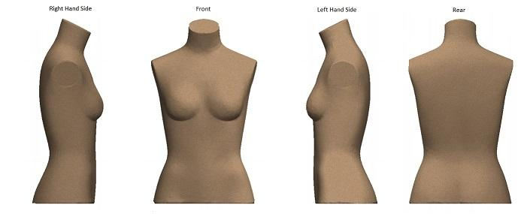

Q7 Whilst wearing your body armour, please rate the following actions (if applicable)
 | Very Easy (1) | Easy (2) | Difficult (3) | Very Difficult (4) | Not applicable (5)
Sitting in a car (passenger) (1)
Driving a car (2)
Walking (3)
Running (4)
Self defence techniques (5)
Using a pistol/TASER (6)
Using a carbide (7)
Riding (horse) (8)
Riding (pedal cycle) (9)
Riding (motorbike) (10)

Q8 Please indicate which items of equipment you routinely carry on either your body armour, or on a belt
 | Body Armour (1) | Belt (2) | Not applicable (3)
Handcuffs (1)
Irritant spray (2)
TASER (3)
Police radio (4)
Police mobile phone (5)
Personal mobile phone (6)
Notebook (7)
Baton (8)
Body worn video (9)
Other (please specify) (10)

