Applying machine learning algorithms in estimating the performance of heterogeneous, multi-component materials as oxygen carriers for chemical looping processes
Yongliang Yan^{a,b}, Tobias Mattisson^{b}, Patrick Moldenhauer^{b}, Edward J. Anthonyª, Peter T. Cloughª*
ª Energy and Power Theme, School of Water, Energy and Environment, Cranfield University, Cranfield, Bedfordshire, MK43 0AL, UK.
^{b} Division of Energy Technology, Department of Space, Earth and Environment, Chalmers University of Technology, 412 96 Gothenburg, Sweden.
* Corresponding Author: Peter T. Clough, Email: P.T.Clough@cranfield.ac.uk, Phone: +44 (0) 1234 754 873
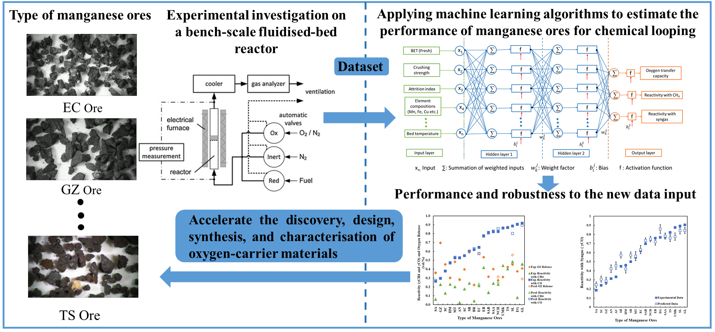
Graphical Abstract

